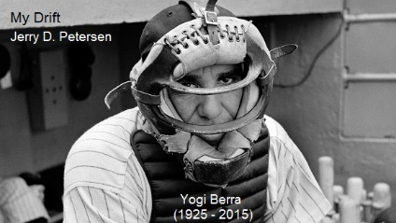

 | Yogi Berra  30 Sep 2015 | 211-2015-18

When I was a kid growing up in Utah in the late 1940s and 1950s, I was a big baseball fan and listened to the games on the radio whenever I could. Back then, television was just getting started and there were not many games on even if you had a TV set. The two best teams were the New York Yankees and the Brooklyn (in 1958 they moved to Los Angeles) Dodgers. My favorite player on the Dodgers was Duke Snider and my favorite player on the Yankees was Mickey Mantle. Yogi Berra was a big part of that Yankee team that was in 14 World Series and won 10 of them. Some people say this was the best baseball team in history.

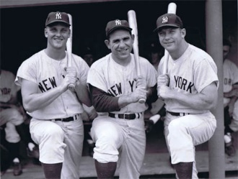 | Yankee greats (from left to right)  Roger Maris  Yogi Berra  Mickey Mantle

Yankees legend Yogi Berra passed away on Tuesday, 22 Sep 2015, at the age of 90.

Yogi Berra - Some Fast Facts
- An 18-time All-Star
- An 10-time World Series Champion
- Played in seventy-five World Series games over the course of his career
- An 3-time American League Most Valuable Player (1951, 1954 and 1955)
- Played 19 seasons in Major League Baseball (MLB) (1946–63, 1965), all but the last for the New York Yankees
- Turned the most double plays in a season by a catcher six times (1949-1952, 1954 & 1956)
- Caught the most games eight times (1950-1957)
- Recorded the most putouts eight times (1950-1952, 1954-1957, 1959)
- Had the most assists three times (1950-1952)
- Had the highest fielding average two times (1958-1959)
- Had his number (#8) retired in 1972 by the New York Yankees
- Ranked 40th on The Sporting News list of the 100 Greatest Baseball Players in Major League history
- Caught both games of a doubleheader one-hundred seventeen times in his career and at least one-hundred games across ten seasons
- Berra rarely strikes out – The most strikeouts he ever had in a season was 38
- As a manager, Berra is one of only six managers to lead both National and American League teams to the World Series
- Was inducted into the National Baseball Hall of Fame in 1972, receiving 85.61% of the votes on his second ballot
- Lastly, here is a fact I bet you didn’t know. Yogi Berra was a nineteen year old Second Class Seaman during World War II, one of a six-man crew on a U.S. Navy rocket boat, and took part in the Normandy Invasion on D-Day at Omaha Beach. He also served in North America and Europe. | 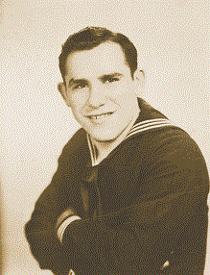

Early Years
Lawrence Peter "Yogi" Berra was born on May 12, 1925 in St. Louis, Missouri. Yogi Berra was raised in "The Hill" section of St. Louis and was neighbors with future catcher Joe Garagiola. His nickname, Yogi, came from a friend who said Berra resembled a Hindu holy man, referred to as a yogi. Berra dropped out of school in the eighth grade in order to help support his family. He did find the time to play American Legion baseball. In 1942, Berra tried out with the St. Louis Cardinals and received an offer to sign for $250 from general manager Branch Rickey. Berra was seeking the same $500 offer that his friend Garagiola received and declined the Cardinals' offer. Berra would later sign with the New York Yankees for the $500 he had been seeking.

Professional Career

Minor leagues
After joining the Yankees, Berra was assigned to the Norfolk Tars of the Class B Piedmont League. In one doubleheader with the organization, Berra is credited with driving in 23 runs in two games. His minor league career was interrupted when he joined the Navy. After that, he returned to the Yankees organization and played with a squad in New London, CT. After a few games there, Berra joined the Newark Bears of the International League.

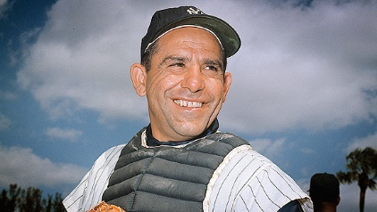

New York Yankees (1946-63)
Berra made his Major League debut in 1946 for the Yankees and hit a home run in his first at-bat against the Philadelphia Athletics. Berra split time behind the plate with a rotation of catchers and hit .280 with 11 home runs and 54 RBI in his first full season with New York.
Starting in 1949, Berra led the New York Yankees in RBI for seven straight seasons. It was also the start of 10 consecutive seasons with at least 20 home runs. During the 1950 season, Berra struck out only 12 times in 597 at-bats. Five times in Berra's career, he had more home runs than strikeouts. He finished the season hitting .322 with 28 home runs and 124 RBI, good enough for third in the American League Most Valuable Player voting. Berra won his first MVP award in 1951 after hitting .297 with 27 home runs and 88 RBI.
Berra hit a career-high 30 home runs in 1952, a mark which he tied in 1956 as well. At the time it was an American League record. In 1954, Berra drove in a career-high 125 runs in route to the MVP award. He also won the MVP in 1955 for the third time in his career. Berra came close to winning his third straight MVP award in 1956 but finished second in the voting behind teammate Mickey Mantle. He excelled during the 1956 World Series and even Don Larsen's perfect game in Game 5. At the plate, Berra hit .360 with three home runs including a pair of two-run home runs in the Yankees 9-0 Game 7 victory.
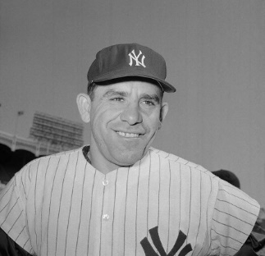 | 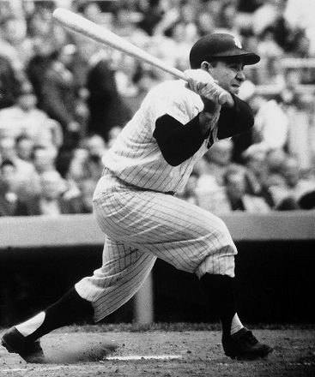
Towards the end of his career, Berra moved from behind the plate to the outfield starting in 1960. Berra's final season with the Yankees came in 1963, where he hit .293 with 8 home runs and 28 RBI.
Berra holds World Series records for most games (75), at-bats (259), hits (71), doubles (10), singles (49) and is third for most home runs (12) behind former Yankees Babe Ruth and Mickey Mantle.
Berra received a plague in Monument Park in 1988 with his slogan, "It ain't over 'til it's over." Due to a fall out with New York Yankees owner George Steinbrenner while Berra was manager, the player wouldn't step foot in Yankee Stadium until he issued an apology. Berra returned to Yankee Stadium on July 19, 1999, the day of David Cone's perfect game.
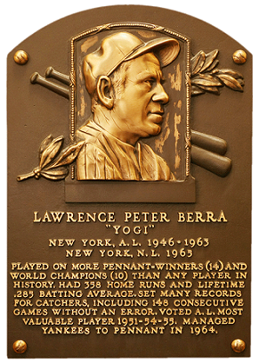
Hall of Fame Plaque

Managerial career
After retiring in 1963, Berra was hired as manager of the New York Yankees. He led the ball club to an American League Pennant and 99-63 record, but the Yankees lost in seven games to the St. Louis Cardinals in the World Series. Berra was fired after just one season. He had lost control of the team and had an infamous incident with Phil Linz: The infielder was playing his harmonica on the bus, and Berra ordered him to stop. Mickey Mantle told Linz to play it louder, and Berra slapped the harmonica out of his hands.
After leaving the Yankees, he was hired as a player-coach for the cross-town rivals New York Mets but played in just four games. Berra was part of Casey Stengel's coaching staff during the Mets' World Series run in 1969 and was named manager of the team following the death of Gil Hodges in 1972. Berra led the Mets to the National League Pennant in 1973 after delivering his famous "It ain't over 'til it's over" quote when the team was stuck in last place. In the World Series, New York blew a 3-2 lead in the series to the Oakland Athletics after Berra decided to pitch Tom Seaver and Jon Matlack on three day's rest. He was eventually fired as manager of the New York Mets in 1975 after a 56-53 start.
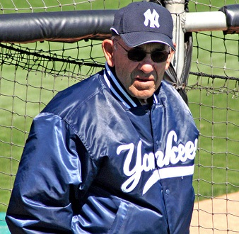 | After his playing days, Berra was a Manager and a Coach.
Berra returned to the Yankees as a coach in 1976, and New York won the World Series in 1977 and 1978. Before the start of the 1984 season, Berra was named manager of the Yankees. He led New York to an 87-75 record and a third place finish in 1984 and was fired after just 16 games during the 1985 season. Yankees owner George Steinbrenner sent a member of his staff, Clyde King, to deliver the news to Berra. Berra vowed to never step foot in Yankee Stadium as long as Steinbrenner owned the team, but the two sides made up in 1999.
The Houston Astros signed Berra as a bench coach in 1986, and he served with the Astros until his retirement in 1992.

Retirement years
Yogi Berra, along with fellow New York Yankee Phil Rizzuto, opened a bowling alley in Clifton, N.J. called Rizzuto-Berra Lanes. The two eventually sold the bowling alley.
Berra has appeared in television commercials since the 1950s, advertising for such products as AFLAC, Stove Top and Yoo-hoo. He also has five books to his credit, most recently in 2003 with "Ten Rings: My Championship Seasons."
Yogi Berra filed a $10 million lawsuit in 2005 against Turner Broadcasting System for using his name in a "Sex and the City" television commercial. The commercial asked viewers the definition of "yogasm," and the possible definitions were: "(a) a type of yo-yo trick, (b) sex with Yogi Berra and (c) what Samantha has with a guy from yoga class." The lawsuit was eventually settled later in the year and Berra received a "substantial" amount.
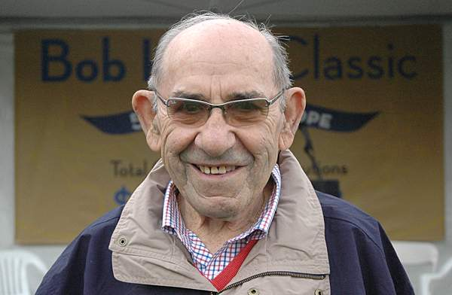

Personal
Yogi Berra married his wife Carmen on Jan. 26, 1949. The couple has three children, and they resided in Montclair, N.J. Berra received an honorary degree in 1996 from Montclair State University in New Jersey. In 1998, Montclair State opened the Yogi Berra Museum and Learning Center.

Berra’s contributions to MLB history are incalculable, but his legacy might be even better remembered for what he contributed to American language. A sportswriters’ favorite, Berra had countless expressions that were memorable because most of them didn’t make any sense. (At the same time, everyone had some truth to it.) Yes, Berra was known for his "Yogi-isms," witty comments about baseball and life. There are now countless of them, and many of them are just attributed to Berra, even if he never actually said them. As he so perfectly put it: “I never said most of the things I said.” Here are 50 of my favorites.
1. When you come to a fork in the road, take it.

2. You can observe a lot by just watching.

3. It ain’t over till it’s over.

4. It’s like déjà vu all over again.

5. No one goes there nowadays, it’s too crowded.

6. Baseball is 90% mental and the other half is physical.

7. A nickel ain’t worth a dime anymore.

8. Always go to other people’s funerals, otherwise they won’t come to yours.

9. We made too many wrong mistakes.

10. Congratulations. I knew the record would stand until it was broken.

11. You better cut the pizza in four pieces because I’m not hungry enough to eat six.

12. You wouldn’t have won if we’d beaten you.

13. I usually take a two-hour nap from one to four.

14. Never answer an anonymous letter.

15. Slump? I ain’t in no slump… I just ain’t hitting.

16. How can you think and hit at the same time?

17. The future ain’t what it used to be.

18. I tell the kids, somebody’s gotta win, somebody’s gotta lose. Just don’t fight about it. Just try to get better.

19. It gets late early out here.

20. If the people don’t want to come out to the ballpark, nobody’s going to stop them.

21. We have deep depth.

22. Pair up in threes.

23. Why buy good luggage, you only use it when you travel.

24. You’ve got to be very careful if you don’t know where you are going, because you might not get there.

25. All pitchers are liars or crybabies.

26. Even Napoleon had his Watergate.

27. Bill Dickey is learning me his experience.

28. He hits from both sides of the plate. He’s amphibious.

29. It was impossible to get a conversation going, everybody was talking too much.

30. I can see how he (Sandy Koufax) won twenty-five games. What I don’t understand is how he lost five.

31. I don’t know (if they were men or women fans running naked across the field). They had bags over their heads.

32. I’m a lucky guy and I’m happy to be with the Yankees. And I want to thank everyone for making this night necessary.

33. I’m not going to buy my kids an encyclopedia. Let them walk to school like I did.

34. In baseball, you don’t know nothing.

35. I never blame myself when I’m not hitting. I just blame the bat and if it keeps up, I change bats. After all, if I know it isn’t my fault that I’m not hitting, how can I get mad at myself?

36. I never said most of the things I said.

37. It ain’t the heat, it’s the humility.

38. If you ask me anything I don’t know, I’m not going to answer.

39. I wish everybody had the drive he (Joe DiMaggio) had. He never did anything wrong on the field. I’d never seen him dive for a ball, everything was a chest-high catch, and he never walked off the field.

40. So I’m ugly. I never saw anyone hit with his face.

41. Take it with a grin of salt.

42. (On the 1973 Mets) We were overwhelming underdogs.

43. The towels were so thick there I could hardly close my suitcase.

44. Little League baseball is a very good thing because it keeps the parents off the streets.

45. Mickey Mantle was a very good golfer, but we weren’t allowed to play golf during the season; only at spring training.

46. You don’t have to swing hard to hit a home run. If you got the timing, it’ll go.

47. I’m lucky. Usually you’re dead to get your own museum, but I’m still alive to see mine.

48. If I didn’t make it in baseball, I won’t have made it workin’. I didn’t like to work.

49. If the world were perfect, it wouldn’t be.

50. A lot of guys go, ‘Hey, Yog, say a Yogi-ism.’ I tell ’em, ‘I don’t know any.’ They want me to make one up. I don’t make ’em up. I don’t even know when I say it. They’re the truth. And it is the truth. I don’t know.

Yogi Berra Hitting Stats
Yr | Age | Team | G | AB | R | H | 2B | 3B | HR | GRSL | RBI | BB | IBB | SO | SH | SF | HBP | GIDP | AVG | OBP | SLG
1946 | 21 | Yankees | 7 | 22 | 3 | 8 | 1 | 0 | 2 | 0 | 4 | 1 | 0 | 1 | 0 | - | 0 | 0 | .364 | .391 | .682
1947 | 22 | Yankees | 83 | 293 | 41 | 82 | 15 | 3 | 11 | 2 | 54 | 13 | 6 | 12 | 0 | - | 0 | 7 | .280 | .310 | .464
1948 | 23 | Yankees | 125 | 469 | 70 | 143 | 24 | 10 | 14 | 0 | 98 | 25 | 5 | 24 | 2 | - | 1 | 9 | .305 | .341 | .488
1949 | 24 | Yankees | 116 | 415 | 59 | 115 | 20 | 2 | 20 | 1 | 91 | 22 | 3 | 25 | 0 | - | 6 | 6 | .277 | .323 | .480
1950 | 25 | Yankees | 151 | 597 | 116 | 192 | 30 | 6 | 28 | 1 | 124 | 55 | 3 | 12 | 0 | - | 4 | 11 | .322 | .383 | .533
1951 | 26 | Yankees | 141 | 547 | 92 | 161 | 19 | 4 | 27 | 1 | 88 | 44 | 4 | 20 | 0 | - | 3 | 16 | .294 | .350 | .492
1952 | 27 | Yankees | 142 | 534 | 97 | 146 | 17 | 1 | 30 | 0 | 98 | 66 | 9 | 24 | 1 | - | 4 | 8 | .273 | .358 | .478
1953 | 28 | Yankees | 137 | 503 | 80 | 149 | 23 | 5 | 27 | 1 | 108 | 50 | 6 | 32 | 1 | - | 3 | 7 | .296 | .363 | .523
1954 | 29 | Yankees | 151 | 584 | 88 | 179 | 28 | 6 | 22 | 1 | 125 | 56 | 6 | 29 | 1 | 7 | 4 | 9 | .307 | .367 | .488
1955 | 30 | Yankees | 147 | 541 | 84 | 147 | 20 | 3 | 27 | 0 | 108 | 60 | 6 | 20 | 2 | 5 | 7 | 13 | .272 | .349 | .470
1956 | 31 | Yankees | 140 | 521 | 93 | 155 | 29 | 2 | 30 | 0 | 105 | 65 | 7 | 29 | 1 | 5 | 5 | 8 | .298 | .378 | .534
1957 | 32 | Yankees | 134 | 482 | 74 | 121 | 14 | 2 | 24 | 0 | 82 | 57 | 10 | 24 | 1 | 4 | 1 | 11 | .251 | .329 | .438
1958 | 33 | Yankees | 122 | 433 | 60 | 115 | 17 | 3 | 22 | 0 | 90 | 35 | 5 | 35 | 0 | 6 | 2 | 6 | .266 | .319 | .471
1959 | 34 | Yankees | 131 | 472 | 64 | 134 | 25 | 1 | 19 | 0 | 69 | 43 | 5 | 38 | 0 | 2 | 4 | 6 | .284 | .347 | .462
1960 | 35 | Yankees | 120 | 359 | 46 | 99 | 14 | 1 | 15 | 1 | 62 | 38 | 6 | 23 | 0 | 4 | 3 | 11 | .276 | .347 | .446
1961 | 36 | Yankees | 119 | 395 | 62 | 107 | 11 | 0 | 22 | 0 | 61 | 35 | 4 | 28 | 0 | 5 | 2 | 7 | .271 | .330 | .466
1962 | 37 | Yankees | 86 | 232 | 25 | 52 | 8 | 0 | 10 | 1 | 35 | 24 | 4 | 18 | 0 | 5 | 2 | 7 | .224 | .297 | .388
1963 | 38 | Yankees | 64 | 147 | 20 | 43 | 6 | 0 | 8 | 0 | 28 | 15 | 2 | 17 | 0 | 1 | 1 | 4 | .293 | .360 | .497
1965 | 40 | Mets | 4 | 9 | 1 | 2 | 0 | 0 | 0 | 0 | 0 | 0 | 0 | 3 | 0 | 0 | 0 | 0 | .222 | .222 | .222
Career |  |  | G | AB | R | H | 2B | 3B | HR | GRSL | RBI | BB | IBB | SO | SH | SF | HBP | GIDP | AVG | OBP | SLG
19 Years |  |  | 2,120 | 7,555 | 1,175 | 2,150 | 321 | 49 | 358 | 9 | 1,430 | 704 | 91 | 414 | 9 | 44 | 52 | 146 | .285 | .348 | .482

bigdrifter44@gmail.com

