 | Welfare in the United States  31 December 2014 | 193-2014-22

Welfare is a subject that makes my blood pressure raise every time I think about it. I’m going to present a bunch of facts, maps, charts, and statistics about welfare and who is getting all this free money the government is handing out. Then we will analyze what is happening here in America and try to come up with some recommendations and solutions.

Did you know that welfare spending is now the largest federal budget item?

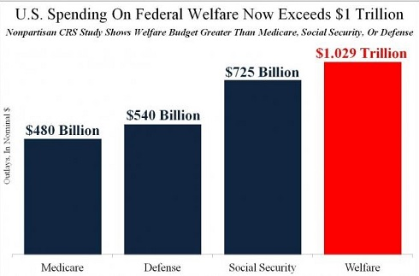
Out of these four major items in the budget, the only one I have major issues with is Welfare. I have some minor issues with Medicare and Social Security. I think the Defense Budget should be raised a little. If our government was not giving over a trillion dollars ($1,000,000,000,000) a year to a lot of lazy people, our taxes would be a lot lower and life here in the United States would be a lot better.

Since Obama took office, defense dollars have been slashed while Welfare, Social Security, Medicare, Medicaid, and Obamacare are so large and growing that they are on track to overwhelm the federal budget. In Fiscal Year 2014, the government spent over $3.5 trillion dollars and got about $3.0 trillion dollars in revenue from us taxpayers. This means our government spent more than they took in resulting in a $506 billion dollar deficit. This adds to our national debt that is over $18 trillion dollars at this moment.

Did you know that our government has 126 overlapping federal welfare programs?
These federal programs provide cash, food, housing, medical care, social services, training, and education aid to poor and low-income Americans (and illegal aliens). Here are the programs that give out the most money:

Medicaid - It provides health care for 29 million low-income adults. The largest share goes toward 11 million parents and other adults. Medicaid pays for 40% of all births in the U.S. Next is 8.8 million people with disabilities. Finally, 8.3 million seniors get Medicaid to pay non-Medicare covered healthcare, and Medicare costs. Medicaid coverage is expanding, thanks to the Affordable Care Act (ACA or Obamacare).

Child's Health Insurance Program (CHIP) - Provide Medicaid for 32 million children, or half of all low-income children. Some states don't have CHIP coverage, although that is being changed by Obamacare.

Food Stamps (SNAP) - The next most controversial (next to Medicaid) program is the Supplemental Nutrition Assistance Program (SNAP). It gives food vouchers to 47.6 million people, or 23 million households, who receive $274.98 a month on average. The total Federal cost is $80 billion in 2014, of which $3.8 billion went for administration expenses.

Special Supplemental Food Program for Women, Infants and Children [WIC] - It provides food or vouchers, education and referrals to help feed pregnant women and children up to age 6. On average, 8.66 million people received WIC each month, of which more than 75% were children or infants.

Child Nutrition Program - This provides free or reduced cost lunches to 30 million children for a total Federal cost of $12 billion dollars.

Supplemental Security Program (SSI) - Provides cash ($720/ month for individuals living alone) to help the aged, blind and disabled with little income to buy food, clothing and shelter. Each month, roughly 8.4 million people received $536 on average. Of those, 7.3 million were blind or disabled. There are a lot of blind and/or disabled people out there running around and playing golf etc.

Earned Income Tax Credit (EITC) - The IRS gives a tax credit for families with at least one child who earn less than $51,567 a year. In 2012, over 27 million received credits of over $63 billion. That's a little more than $2,335/taxpayer. It lifted 6.5 million people out of poverty, half of whom were children. It costs just 1% of the amount paid out to administer it. Unfortunately, nearly one fourth of people receiving it are paid in error (whether honest or fraud.)

Housing Assistance - There are over 1.2 million units of public housing. In addition, the Housing Choice Voucher Program gives certificates administered by local agencies to 2.2 million renters to live in approved units. The subsidy allows them to pay no more than 30% of their income. The Public Housing Agency (PHA) will allows some families to use the voucher to purchase a modest home.

Low-Income Home Energy Assistance Program [LIHEAP]) - This provides $3.4 billion in block grants to the states to provide energy assistance and weatherization programs.

BOTTOMLINE: There are a lot of welfare programs that are being exploited by thousands of people who prefer to cheat the government over going to work at a real job.

Did you know that the vast majority of illegal aliens are on welfare?
Nobody knows for sure but it is estimated that the number of illegal immigrants in the United States is over 12 million. This estimate represents roughly one-third of the entire foreign-born population.

Many illegal aliens are on welfare and will be for life. And far from contributing to our society and economy, illegals depress wages, and the average illegal alien takes in $19,000 more in public benefits each year than they contribute in income, sales taxes and social security contributions combined. Illegal immigration is literally bankrupting this nation.

Here is an example:
Illegal alien and mother of seven, Florida resident, Marita Nelson, receives $240 in food stamps, monthly medications, $700 in Social Security and a housing allowance. And she has been receiving government assistance for over 20 Years – ever since she illegally entered the U.S. by swimming the Rio Grande — which up to 290,000 illegals do every year.
Nelson is single (never married) and our “generous” government is paying child support for all seven children born out of wedlock. She has never held a job and never had to pay taxes. If all these things were not bad enough, she is showing others how to milk the system. You can see her on the following video: https://www.youtube.com/watch?v=jBpEysmJ62Q

How is your blood pressure doing?

Did you know that in 35 states you can get more pay from welfare than working a minimum wage job?

Well, that statement is true! In 35 states, welfare, housing assistance and other benefits pays more than a minimum wage job, according to a new study by the Cato Institute. The study also found that in 13 states, the payout is more than $15 per hour.

Of course, this study doesn’t take into account that not everyone on public assistance receives all of the programs. But if they did, their payout would be significantly higher than even a starting teacher’s salary in 11 states or a computer programmer in 3 states.

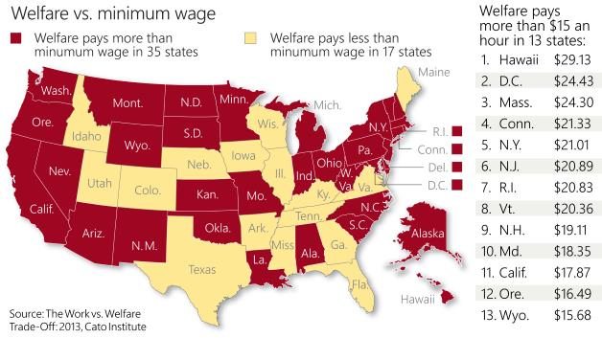

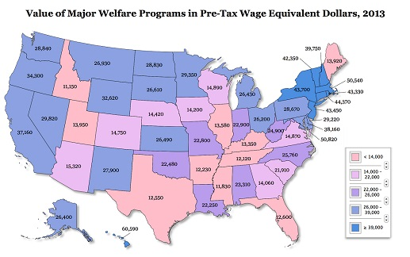

The Work vs Welfare Trade-off
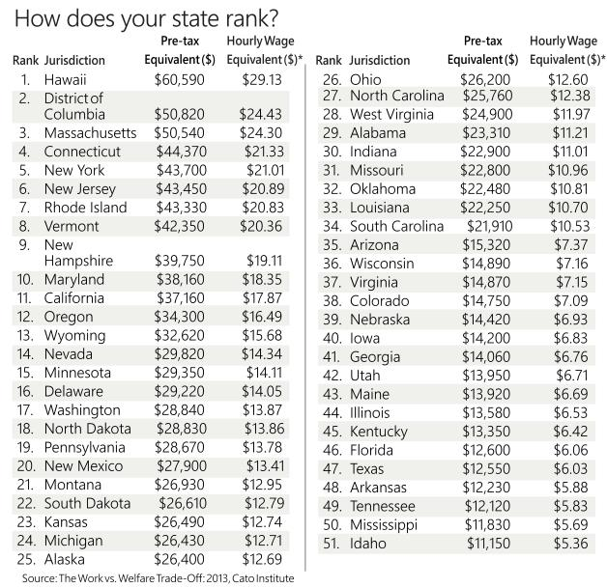

Let me see now, the Hawaii minimum wage is currently $7.25 per hour and will go up to $7.75 per hour on 1 January 2015. What would you rather do, slave away 40 hours a week for minimum wage or go on welfare and do no work and earn $29.13 an hour? Let me do the math for you - $16,120 a year working full-time at minimum wage versus $60,590 doing whatever you want (except work that pays money) drawing a big fat welfare check. Most people getting welfare do not pay any taxes. No wonder there are so many people on welfare in the United States and especially in Hawaii.

Did you know that there 11 states where private sector workers are outnumbered by people who are dependent on the government?
A writer at Forbes Magazine has identified a phenomenon called the financial “death spiral”. Eleven states (California, Maine, New Mexico, Hawaii, Alabama, Mississippi, New York, Illinois, Ohio, Kentucky, and South Carolina) make the list of danger spots for investors where private sector workers are outnumbered by people who are dependent on the government. That number includes state workers and people who are receiving welfare or a pension. These states can look forward to a rising tax burden, deteriorating state finances and an exodus of employers. For example, in California the ratio of “takers versus makers” is 139 to 100. Here is an example: If you own a software company that employs 100 people, you’re supporting 139 other people in the state who are on the “takers” list. It is not quite that bad in Hawaii where 100 private sector workers (makers) support 102 people getting money from the government (takers).

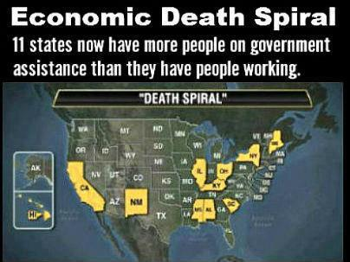

So, how bad is welfare in your state? If there is steam coming out of your ears, go fix yourself a cold drink.

Do you know how many people there are on welfare in the United States?
There are about 112,000,000 people living in households taking federal welfare benefits according to the Census Bureau - that equals about 35.4 percent of all 319,000,000 or so people living in the United States. This does not include those people receiving benefits from other federal programs — such as Social Security, Medicare, unemployment and veterans benefits.

Welfare statistics can be misleading because it is figured and distributed by the number of people in a household. The following chart breaks down population and households by race:

Welfare Stats by Race (2013) | White | Black | Hispanic | Asian | Other
Percent of U.S. Population  Total Number of People  Total Number of Households | 62.6  194,000,000  72,000,000 | 14.1  45,000,000  16,000,000 | 17.1  55,000,000  19,000,000 | 5.3  17,000,000  6,000,000 | 1.8  5,700,000  2,000,000

Do you qualify for getting Food Stamps (the SNAP Program)?
There is a total of about 115 million households in the U.S. About 20% of these households (23 million households) are receiving Food Stamps. There are about 48 million people living in these households. Our Federal Government spend $80 billion dollars of our tax money to support the SNAP or Food Stamp Program in FY 2014.
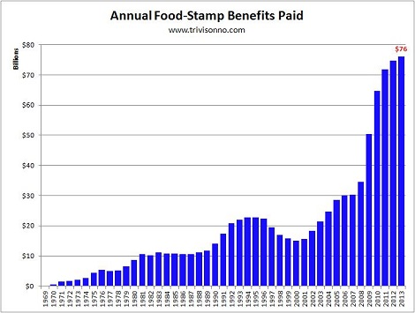

As you can see in the above chart, since Obama became President, Food Stamp benefits paid to people in the U.S. has more than doubled.

Food Stamp eligibility rules require that participants be at or below 130% of the Federal Poverty Level (see chart below). Recent studies show that 49% of all participants are children (age 18 or younger), with almost two-thirds of the children living in single-parent households. In total, 76% of benefits go towards households with children, 16% go to households with disabled persons, and 9% go to households with senior citizens.

2014 Federal Poverty Levels
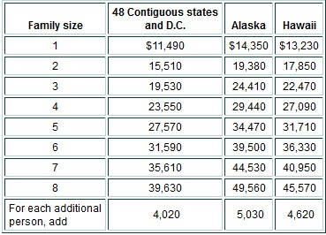

Do you qualify?

How much money do Food Stamp recipients get and what can they buy?
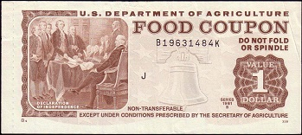 | In 2013, the average Food Stamp client received a monthly benefit of $133.07 and the average household received $274.98. Food Stamps can be used to purchase all food products, not including: beer, wine, liquor, or tobacco; any nonfood items; vitamins and medicines; foods that will be eaten in the store; or hot foods.

No beer!!

More Food Stamp Demographic Data
43% (20,640,000 people) of Food Stamp participants are white, 33% (15,840,000) are black or African-American, 19% (9,120,000) are Hispanic, 2% (960,000) are Asian, and 2% (960,000) are Native Americans or other races. In other words:
- 10.6% of all white people are getting Food Stamps
- 35.2% of all black people are getting Food Stamps
- 16.6% of all Hispanic people are getting Food Stamps
- 5.6% of all Asian people are getting Food Stamps
- 16.8% of all Native Americans or other races that are getting Food Stamps

So, 80 billion dollars is being spent on Food Stamps – how much is being spent on all those other welfare programs?
Let’s do the math.
Total welfare of one trillion 1,000,000,000,000 – 80,000,000,000 = 920,000,000,000
That is $920 billion dollars for you non-math majors.

Remember that our government has 126 overlapping federal welfare programs including:
- 12 programs providing food aid – $80 billion;
- 10 housing assistance programs - $56 billion;
- 10 programs funding social services - $16 billion;
- 9 educational assistance programs – $60 billion;
- 8 programs providing cash assistance – $182 billion;
- 8 vocational training programs - $9 billion;
- 7 medical assistance programs $460 billion;
- 3 energy and utility assistance programs - $6 billion; and,
- 2 child care and child development programs - $23 billion.

Once again, inquiring minds are wondering who is getting all of this free money that hard-working tax payers are providing.
Here is the breakdown:
- 39% Percent of the recipients (households) are Black or African-American
- 38% Percent of the recipients (households) are White
- 16 % Percent of the recipients (households) are Hispanic or Latino
- 2% Percent of the recipients (households) are Asian
- 4% Percent of the recipients (households) are Native Americans or other races

What is the real unemployment rate?
If things were not bad enough, here is some more bad news. Although Obama proudly tells us that 288,000 new jobs were created and the unemployment rate is down to 6.1 percent, the real unemployment rate is more than 20 percent. That 6.1% only represents those people actively seeking jobs – it does not count the 2.4 million people who have given up finding a job, people working low-paying part-time jobs, and most of those people on welfare that we have been talking about. Obama also forgot to tell the American people that full-time jobs plunged by 523,000. What’s increased is part-time jobs which soared by 811,000 to over 28 million.

Just think of all those Americans working part time, no doubt glad to have the work, but they also have lower pay, diminished benefits, and a lack of job security. And then there’s the effect on self-esteem and the stress of managing a household. These American workers want a full time job but are stuck in part-time positions because businesses can hire desirable part-time workers to supplement a core staff of full-time employees, but at lower wages. Another reason for hiring part-time workers is the fact that Obamacare’s employer health insurance mandates do not apply to workers on the job less than 30 hours a week.

Is it true that only 53 percent of Americans pay income tax?
YES

Mitt Romney gave up on winning support from nearly half of the American electorate in the last election, telling wealthy supporters at a private fundraiser that he could not hope to win the votes of the 47 percent of Americans who, he said, do not pay federal income taxes. Mitt told the truth but probably should not have said this in public because Obama, the liberals, the socialists, and the tax dodgers jumped all over this statement claiming that Romney would only be a president for the rich, if elected. Yes, Mitt Romney forgot the first rule of politics, to get elected President in America now days you must lie, cheat, and tell the public what they want to hear. You know – just like Obama did!!

Just to be fair, it is not only poor people who don’t pay income taxes. About 1 percent of the top 1 percent of income earners, those making over a million dollars a year, did not pay any income taxes. That's roughly 15,000 tax filers. Those millionaires and many other high-earners have enough tax shelters to get out of paying taxes.

Alright, alright – that’s enough. I think we all get the ugly picture of what is going on in America today and I don’t like it.

RECOMMENDATIONS AND SOLUTIONS

#1 SCRAP THE AFFORDABLE CARE ACT (OBAMACARE)
This was a bad idea from the start. The Federal Government should not be in the medical insurance business. Socialized medicine will not work in America.

Keep Medicare but do something about all of the fraud that is estimated to be between $60 and $90 billion dollars a year.

#2 GET RID OF ALL FEDERAL WELFARE INCLUDING FOOD STAMPS
The responsibility for providing assistance to qualifying American citizens should be the State Governments. No person should receive more money than a hard working minimum wage worker. No able bodied man or women should get money – help them find a job.

#3 FIX SOCIAL SECURITY LOOP HOLES
Nobody that didn’t pay into Social Security should be getting benefits. How in the world does an illegal immigrant with seven children get a $700 Social Security check every month?

#4 GET RID OF ALL FOREIGN AID – PERIOD!!
The U.S. sends approximately $50 billion dollars ($20 billion for military and $30 billion for economic assistance) overseas in foreign aid to about 130 different countries every year. Here are the top 5 countries getting the most money from the U.S.:
1. Israel $3.1 billion
2. Afghanistan $2.4 billion
3. Pakistan $2.1 billion
4. Iraq $1.7 billion
5. Egypt $1.6 billion

Why? Many of these countries are better off than we are and a lot of them hate America. Stop spending all this money – it is crazy!

#5 INSTALL A FLAT TAX RATE OF 10%
Implement a flat tax of 10% for all residents of the United States no matter their wage or legal status. This would provide a tax system that would be totally fair to all people. There should be no deductions whether you are a private citizen or a corporation. The 10% should be capped at that level and neither congress nor the president should be allowed to raise it.

For those people who actually pay personal income taxes, they must comply with the terms of a tax code that now takes 73,954 pages to explain. I think we can reduce that down to less than one (1) page.

#6 THE GOVERNMENT CAN NOT SPEND MORE MONEY THAN THEY RECEIVE IN REVENUES
The average American family has to have a budget and live on the money they earn. If we spent money like the Federal and State Governments do, they would put us in jail.

In conclusion
"A democracy cannot exist as a permanent form of government. It can only exist until the voters discover that they can vote themselves free money from the public treasury. From that moment on, the majority always votes for the candidates promising the most benefits from the public treasury with the result that a democracy always collapses over loose fiscal policy, always followed by a dictatorship. The average age of the world's greatest civilizations has been 200 years."

Every major culture in history has essentially followed the same arc of human events, including the United States. Here are the 8 stages of progression:

Bondage-Revolution-Freedom-Prosperity-Apathy-Dependence-Revolution-Bondage

If you view this in arc form, Prosperity is at the top, with Bondage at the bottom of both sides.

There are 3 things that happen when a culture moves from prosperity to apathy.
1. They move away from their religious moorings.
2. They move away from their founding legal system, original laws and founding documents.
3. They move away from fiscal responsibility by overspending and over-taxing.

Steps to Socialism
1. Health care — Control health care and you control the people.
2. Poverty/Welfare — Increase the poverty level to a high level. Poor people will be easy to control and won't fight back if the government is providing everything to survive.
3. Debt — Increase the debt to an unsustainable level. This will allow the government to increase taxes and produce more poverty.
4. Gun control — Remove the ability to defend oneself. This will allow the government to create a police state.
5. Media/education — Take control of the media and what children learn in school. Hide your lies and true agenda with side issues like women's birth control rights.
6. Religion — Remove God from the government and schools.
7. Class warfare — Divide the people into the wealthy and the poor. This will cause more discontent and it will be easier to tax the wealthy with the support of the poor.

Does any of this stuff ring a bell?

The American people and our government better wakeup soon or else we are all in big trouble.

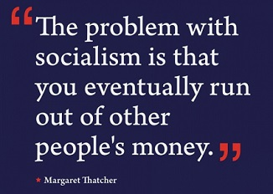 | President Obama and his Socialist policies caused many of the problems our country is facing today. We (the American voters) must elect people into office who will change things and make America great again.

I’m going to end this article with a little story about wild pigs.

Wild Pigs - A Reminder For All

A thought to remember, Marx said, "Remove one freedom per generation and soon you will have no freedom and no one would have noticed."

There was a chemistry professor in a large college that had some exchange students in the class. One day while the class was in the lab, the professor noticed one young man, an exchange student, who kept rubbing his back and stretching as if his back hurt. The professor asked the young man what was the matter.
The student told him he had a bullet lodged in his back. He had been shot while fighting communists in his native country who were trying to overthrow his country's government and install a new communist regime. In the midst of his story, he looked at the professor and asked a strange question.

He asked: "Do you know how to catch wild pigs?"

The professor thought it was a joke and asked for the punch line. The young man said that it was no joke. "You catch wild pigs by finding a suitable place in the woods and putting corn on the ground. The pigs find it and begin to come every day to eat the free food.”

"When they are used to coming every day, you put a fence down one side of the place where they are used to coming. When they get used to the fence, they begin to eat the corn again and you put up another side of the fence.”

"They get used to that and start to eat again. You continue until you have all four sides of the fence up with a gate in the last side.”

"The pigs, which are used to the free corn, start to come through the gate to eat that free corn again. You then slam the gate on them and catch the whole herd.
Suddenly the wild pigs have lost their freedom. They run around and around inside the fence, but they are caught. Soon they go back to eating the free corn. They are so used to it that they have forgotten how to forage in the woods for themselves, so they accept their captivity."
The young man then told the professor that is exactly what he sees happening in America. The government keeps pushing us toward Communism/Socialism and keeps spreading the free corn out in the form of programs such as supplemental income, tax credit for unearned income, tax exemptions, tobacco subsidies, dairy subsidies, payments not to plant crops (CRP), welfare entitlements, medicine, drugs, etc., while we continually lose our freedoms, just a little at a time.

One should always remember two truths: There is no such thing as a free lunch, and you can never hire someone to provide a service for you cheaper than you can do it yourself.

If you see that all of this wonderful government "help" is a problem confronting the future of democracy in America, you probably have a job and pay taxes.

If you think the free ride is essential to your way of life, then you probably don’t care what happens as long as you get your free corn.

BUT, God help us all when the gate slams shut!
Quote for today: "The problems we face today are there because the people who work for a living are now outnumbered."

bigdrifter44@gmail.com

