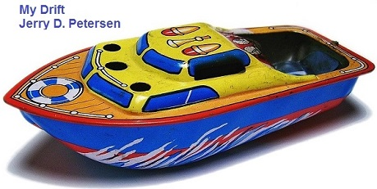

 | Toys  18 March 2015 | 196-2015-03

Did you ever wonder about what kids played with back in the “old” days before they started manufacturing all these toys you see today? Well, here is a little history lesson on children and their toys.

Before the 20th century (the 1900s), children had few toys to play with and those they did have were very precious. Furthermore children did not have much time to play. Only a few went to school and most children were expected to help their parents doing simple jobs around the house or out in the fields. Those were the lucky ones! Many of the children died before they could grow up. As many as 25% of children died before their fifth birthday. People died mostly from various diseases since this was before antibiotics and other modern medicines were invented. The average lifespan was about 40 years old. Both parents and teachers were very strict and beating naughty children was normal. However, most children did find time to play and enjoy themselves.

Actually, children in Ancient Egypt played with similar toys as the ones children play with today. They played with dolls, toy soldiers, wooden animals, balls, marbles, spinning tops and knuckle bones (which were thrown like dice). But, once Europe and most of the world went into the Dark Ages (5th to 15th centuries), life was hard for everybody – especially the children. Children in the Dark Ages, if they survived past early childhood, led lives full of turmoil and anguish. Most children did not have the privilege of living the lighthearted and blissful lifestyle that many children experience in current times. Because this time period was full of poor diet and sickness, the lifespan was cut short for many before they even reached adolescence. Also, many children did not experience hours of playtime because they were put to work in order to help their families.

For many children in the early 19th century things grew even worse! The industrial revolution created a huge demand for female and child labor. Children had always done some work but at least before the 19th century they worked in their own homes with their parents or on land nearby. Children's work was largely seasonal so they did have some time to play. When children worked in the factories, they often worked for more than 12 hours a day. This barbaric practice was ended by law in 1875. Since then, gradually children have been protected by the law more and more. Today in 2015, most of the kids I know are well behaved but I see a lot of other children out in public that are out of control and need a little more discipline.

Playing with toys is essential to a child’s development. Toys promote creativity and thinking, and encourage children to explore. From earliest infancy, play is the primary way children learn. Through play, children eagerly use all the “tools” they have at their disposal—their bodies and toys, their relationships with their family and peers, and the world around them. Play, more than any other activity, fuels healthy development of young children. It is through play that much of children’s early learning is achieved. Children like to play because it is fun. Play takes many forms, but the heart of play is pleasure. And with pleasure comes the powerful drive to repeat such activities. With repetition comes mastery. And mastery brings a sense of accomplishment and confidence.

I think “playing” is essential for adults too!!

For the rest of this article, I’m going to show you a lot of toys which I hope will bring back pleasant memories from your childhood days. Let’s start back in the real old days when there were only a few toys. It seems like there has always been dolls for little girls and balls for the boys. Boys played ball games with inflated pig's bladders and girls played with hand-made wooden dolls. Kids also managed to find other toys to play with.

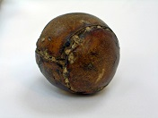 | 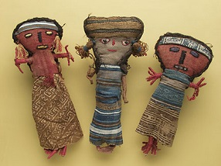 | 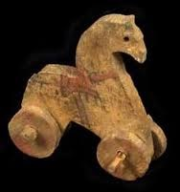 | 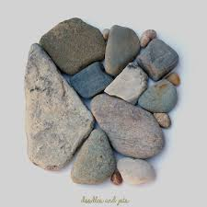
Pig Bladder Ball | Ancient Dolls | Roman Horse | Rocks
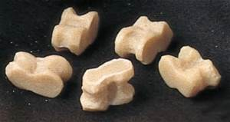 | 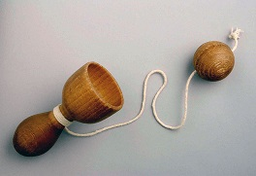 | 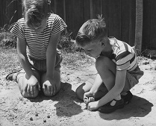 | 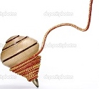
Knuckle Bones | Ball and Cup | Marbles | Spinning Top

I liked to play with rocks when I was a kid. Some people might find this a little strange but I enjoyed throwing rocks at things like a target on the old barn or at trees when out hiking or skipping flat rocks across the lake when out fishing. We used to go up in the mountains to look for Indian arrowheads and shiny or usually rocks. Yes, I could entertain myself for hours just throwing and playing with rocks. Here is another little known fact – I have been carrying a rock in my pocket for the past 28 years! Yep, ever since the Indian Witch Doctor cured my skin problem and give me a “Stress Stone”. Whenever I get feeling a little nervous, I pull out the rock and rub on it a little. Don’t laugh – it works for me!

Here are some toys from the late 1800s and early 1900s:

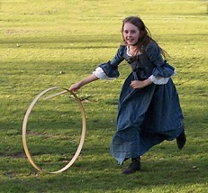 | 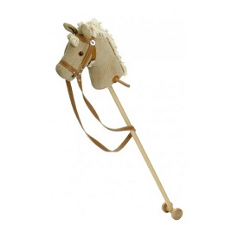 | 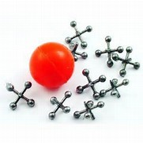 | 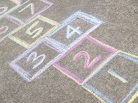
Hoop and Stick | Hobby Horse | Jacks | Hopscotch
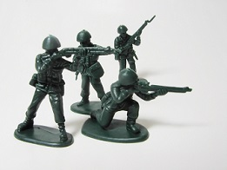 | 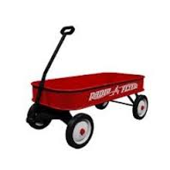 | 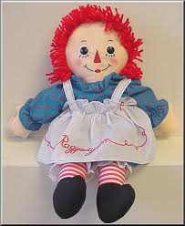 | 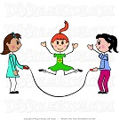
Toy Soldiers | Red Flyer Wagon | Raggedy Ann Doll | Jumping Rope

Some of the toys (pictured above) that I had when I was a kid were a Red Wagon and bag full of assorted marbles. My friends and I played marbles quite often. We would draw a 3 foot circle in the dirt and each of us would put 3 marbles in the middle. Then from the edge of the circle using our biggest and heaviest marble, we would try to knock the other kid’s marbles out of the circle. If we succeeded, we got to keep their marbles. Okay, I admit it, I have played Hopscotch, Jumping Rope, and Jacks. In fact, I think Jacks is quite fun. With that said, I can’t ever remember playing with dolls.

Pictured on the next page are toys that kids played in the 1920s and 1930s. One of the all- time favorite toys is the Teddy Bear that was named after President Theodore "Teddy" Roosevelt, Jr. - the teddy bear became an iconic children's toy, celebrated in story, song, and film. The Yo-Yo is another all-time favorite of mine. I learned to do some simple tricks like the “Sleeper” where you flick it sharply toward the ground. It should stay down -- spinning -- at the end of the string for a few seconds. Then you give a little jerk and it will return to your hand.

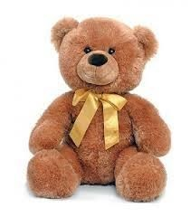 | 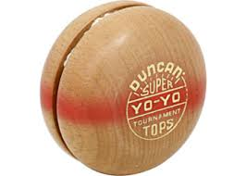 | 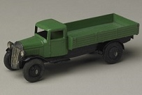 | 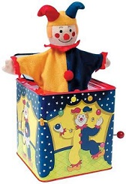
Teddy Bear | Duncan Yo-Yo | Green Truck | Jack in the Box
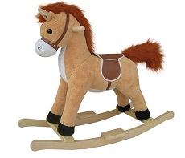 | 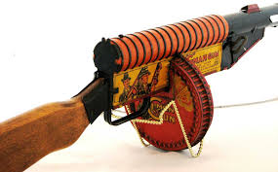 | 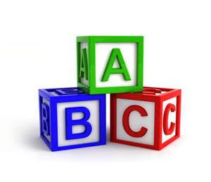 | 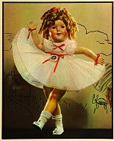
Rocking Horse | Tommy Gun | Alphabet Blocks | Shirley Temple

Here are some toys from the 1940s:
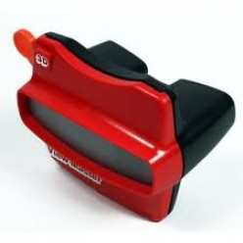 | 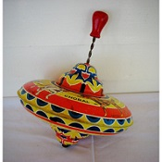 | 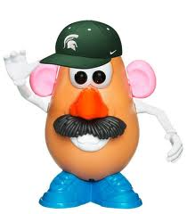 | 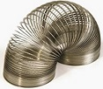
View Master | Spinning Top | Mr. Potato Head | Slinky
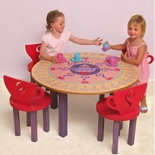 | 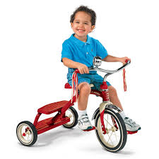 | 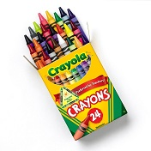 | 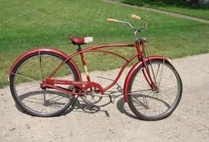
Tea Set | Tricycle | Crayons | Schwinn Bicycle

I remember my bicycle well since I rode it almost every day from about age 7 to 16 when I got my first car. The Boy Scout Merit Badge that I was most proud of was the cycling one. I think we had to go on 10 bike rides for a total of 200 miles – something like that. It was a good bike and I never had any problems with it. When I got my car, I put the bike in the barn and pretty much forgot about it. 20 years later, when my family from Hawaii went to visit my parents in Utah, my son discovered a bike in the barn. We cleaned it up and put new tires on and in a few hours my son had a bike to ride. Yes, it was my same childhood bike. They don’t make bikes like that now days!

Toys from the 1950s:
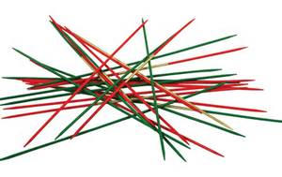 |  | 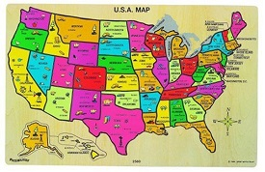 | 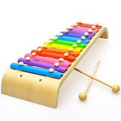
Pickup Sticks | Hula Hoop | States/Capitals Puzzle | Xylophone
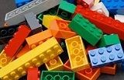 | 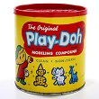 | 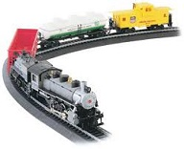 | 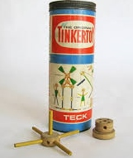
Legos | Play Doh | Toy Train | Tinker Toys
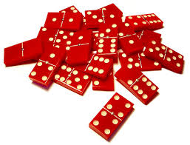 |  | 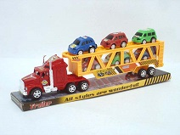 | 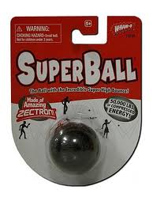
Dominoes | Blowing Bubbles | Toy Cars | Super Ball

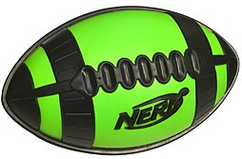 | 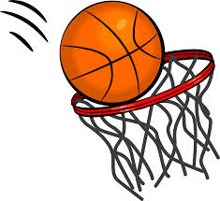 | 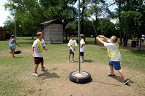 | 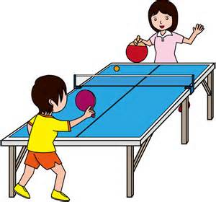
Nerf Football | Basketball | Tetherball | Ping Pong

My parent give me a U.S. States and Capitals puzzle when I was about 10 years old. I must have put it together 20 or more times and do you know what? I can remember every state capital to this day more than 60 years later. I enjoyed playing Pickup Sticks and building things with my Tinker Toy Set. I have never actually played the Dominoes game, but I had a set of dominoes that I used to crash them together to see what number would be the last standing. I have always been fascinated by trains and later worked on the Rio Grande Railroad during my college years.

I can first remember playing ping pong in my upstairs bedroom in our house in Pleasant Grove. I was just a young kid and I had the ping pong table setup so that I could play by myself. Later, I played a lot of ping pong while in college, the navy, and while working for the Federal Government. I’m quite good and have won many ping pong tournaments.

Basketball has always been my favorite sport. I’m including it here as a toy because I spent more time by myself shooting the basketball than doing any other activity when I was a young. In our yard (in Pleasant Grove, Utah) we had 2 basketball backboards and rims. One was nailed on to the grainery but I didn’t play there too much because in wasn’t very level and I kept running into the side of the building. The other basket was nailed onto a tree located over by the old outhouse and barn - this is where I learned to shoot the basketball. I practiced shooting the ball right and left handed, hook shoots with both hands, free throws underhanded, two handed, left handed, and right handed. I even practiced shooting with my eyes closed. I shot thousands of shots from all over the court. By the time I started playing organized basketball games in high school, I was a good player. I was named to first team All-State and was the highest scorer in the state tournament. I had several scholarship offers and played basketball at the University of Utah. I joined the Navy and played basketball there for 4 years. I continued to play in various leagues and pickup games until I retired from the Federal Government at age 70.

Some other toys for getting around:

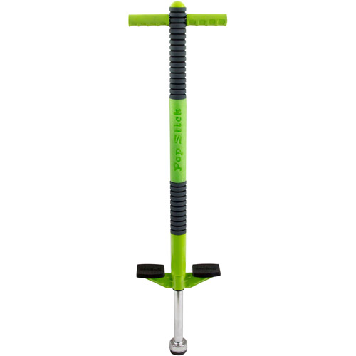 | 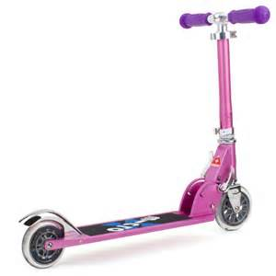 | 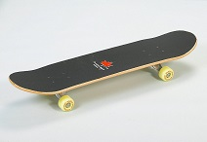 | 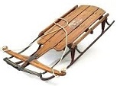
Pogo Stick | Scooter | Skateboard | Sled or Sleigh

While growing up in Utah during the 1940s and 1950s, we had snow on the ground for about 3 months out of the year. Since I could not shoot the basketball during the winter, I spent most of my time outside sleigh riding or inside playing cards or board games. We didn’t have a TV (until I was a teenager) but I listened to the radio almost every day. I didn’t listen to music but instead listened to mystery, comedy, and western shows like The Shadow, The Jack Benny Show, and The Lone Ranger.

Toys from the 1960s and 1970s:
This was the golden era for toys. Kids had countless more toys to choose from compared to previous decades and parents spent a lot more money on their kids. Combine that with bigger families in general and this lead to an influx of cash streaming into the toy industry. Companies like Mattel, Nintendo, and Fisher Price were producing many new toys. Stores like Toys “R” Us and two new stores called Walmart and Target (both opened in 1962) were selling a lot of toys and expanding across the United States. There are now more than 1000 Toys “R” Us stores world-wide. These 3 stores sell the most toys today.

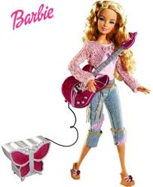 | 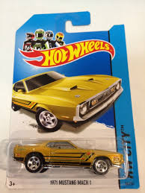 | 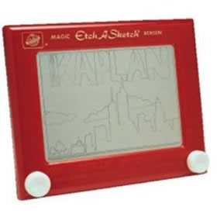 | 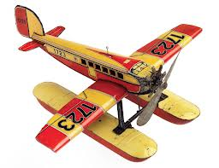
Barbie Dolls | Hot Wheels | Etch a Sketch | Toy Airplanes
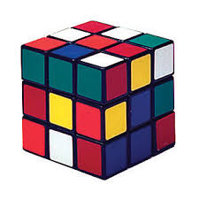 | 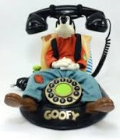 |  | 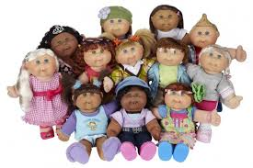
Rubik’s Cube | Talking Phones | Finger Paint | Cabbage Patch Dolls

A few educational toys:
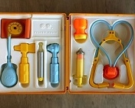 | 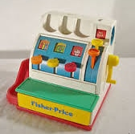 | 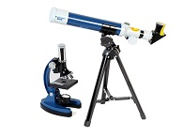 | 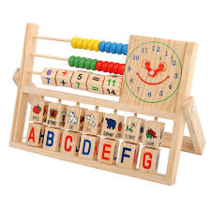
Doctor’s Kit | Cash Register | Micro & Telescope | Educational Toy

Kids now days think that Cars, Airplanes, Radio, Television, Computers, Smart Phones, and other electronic devices have been around forever. Well, when I was a kid, we had no indoor plumbing, no television, no computers, and no cell phones. It can’t be too long ago since I’m not dead yet. Here are some key dates of inventions that have affected the toys and games we play with today:

1752  1804  1840  1876  1885  1895  1903 | Electricity  Steam Engine (Train)  Bicycle and Camera  Telephone  Automobile  Radio  Airplane | 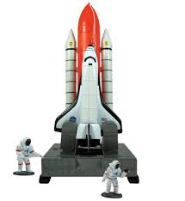 | 1940  1946  1980  1982  1990  2007  2010 | Television  Mainframe Computer  IBM PC and Cell Phone  Space Shuttle  The Internet  Smart Phone  iPad

Toys from the 1980s to Present:
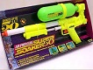 | 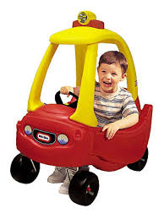 | 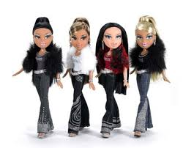 | 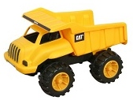
Super Soaker | Toy Car | Bratz Dolls | Heavy Equipment
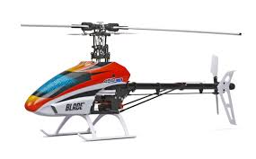 | 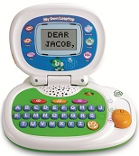 | 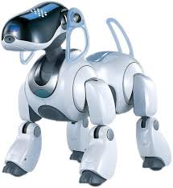 | 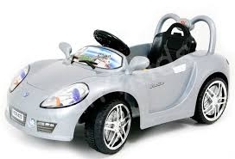
*RC Helicopter | Electronic Speller | Electronic Dog | Electronic Car
*Radio or Remote Control

Summary:
I hope this article brought back some good memories of the toys and games you played with when you was young. Some of us are still playing with some of them. Here is a short summary of things that are important when it comes to kids playing with toys:
- Personal Interaction. Playing with toys allow kids a chance to connect with other kids.
- Builds a Child's Sense of Confidence. When a child masters a new toy their eyes light up. It helps them learn creative problem solving skills.
- Teaches Motivation. Learning never seems like fun. But when you disguise learning in the form of a game or a new toy, it brings new motivation for learning.
- Stress Reduction. One of the benefits of toys is it offers a way to unwind and get rid of the stress of a hard day at school or a dose of life challenges - play offers a form of escape.
- Stimulates the Senses. Some kids need to be stimulated and the right toy can accomplish that. One of the benefits of play is the sensory stimulation. There are things to see, smell, feel, and hear. Active play is a fun reward for a child.
- Toys are more than just fun and games for kids. Most toys provide at least some opportunity for children to learn stuff.
- And lastly, don’t forget your pets – dogs and cats also love to play with toys!!

bigdrifter44@gmail.com

