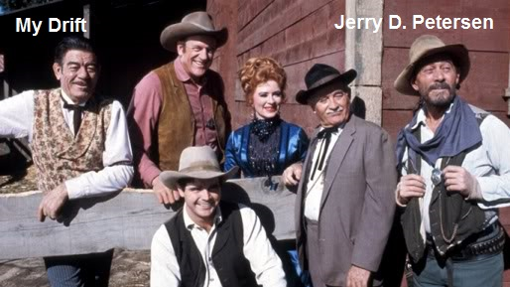

 | TV Shows  10 Sep 2015 | 209-2015-16

Well, a new TV season is about to start so I have decided to help you decide what to watch during the next 4 or 5 months. Finally, I have some good news – the number of reality shows is decreasing! I wouldn’t watch one of these so-called reality shows even if they wanted to pay me. Where do they find all of those weirdos anyway! There are actually some good new shows coming this fall that I will give you a brief summary of what to expect. I may even watch a few of these shows providing there are no good sports on that night. My two favorite (non-sport) shows return for another season – NCIS returns for its 13th season and Criminal Minds returns for its 11th season. Just in case you have never watched these shows, here is a short recap:

NCIS:
Naval Criminal Investigative Service (NCIS) Special Agent Leroy Jethro Gibbs leads a group of colorful personalities in investigating crimes -- ranging from murder and espionage to terrorism -- that have evidence connected to Navy and Marine Corps personnel. The team includes witty ex-homicide detective Anthony DiNozzo, quirky forensics specialist Abby Sciuto, and the brilliant -- if insecure -- Timothy McGee. Dr. Donald "Ducky" Mallard brings his vast experience in forensics into play to help solve cases.
 | 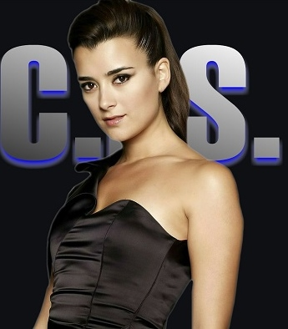
NCIS Current Cast |  | Cote de Pablo

Main cast members:
- Leroy Jethro Gibbs (Mark Harmon), Supervisory Special Agent (Seasons 1 thru present)
- Anthony "Tony" DiNozzo (Michael Weatherly), Senior Special Agent (Seasons 1 thru present)
- Abigail "Abby" Sciuto (Pauley Perrette), Forensics Specialist (Seasons 1 thru present)
- Dr. Donald "Ducky" Mallard (David McCallum), Chief Medical Examiner (Seasons 1 thru present)
- Timothy McGee (Sean Murray), Special Agent (Seasons 2 thru present)
- Leon Vance (Rocky Carroll), Director of NCIS (Seasons 6 thru present)
- Ziva David (Cote de Pablo), Junior Special Agent (Seasons 3 thru 11)
- Caitlin "Kate" Todd (Sasha Alexander), Special Agent (Seasons 1 and 2)
- Jimmy Palmer (Brian Dietzen), Assistant to Dr. Mallard (Seasons 10 thru present)
- Eleanor Bishop (Emily Wickersham), NSA Analyst (Seasons 11 thru present)
- Jenny Shepard (Lauren Holly), Director of NCIS (Seasons 3 thru 5)

Some statistics:
- Network: CBS
- First episode: Sep 23, 2003
- Number of episodes: 282
- Ratings: 3rd best TV show with a rating of 18.25 (Last season)
- In 2011, NCIS was voted America's favorite television show
- Spin-offs: NCIS: Los Angeles (2009 thru present) and NCIS: New Orleans (2014 thru present)
- NCIS, itself is a spin-off of another CBS series called JAG

CRIMINAL MINDS:
In this crime series, a crack team of FBI profilers fly from Quantico to the focal point of the criminal activity of various serial killers. There they investigate the evidence from the crime scenes, compose a profile and try to prevent the next fatal strike. Top brain was academic Jason Gideon who left the bureau after some difficult decisions. His more by-the-book operational right hand man Aaron "Hotch" Hotchner then took over the team. After Gideon leaves, David Rossi, previously retired, rejoins the bureau in an effort to make a difference in people's lives again and follow up on a case he worked years ago. The still juvenile Dr. Spencer Reid is an erudite on everything except real life, Penelope Garcia a brilliant computer whiz who gets access to any database etc. As they are mobile, cooperation with local police and FBI agents is important but often poses jurisdictional and other problems, as do some witnesses and suspects.

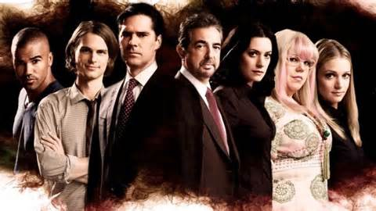
Criminal Minds – Primary Cast | Aisha Tyler – New Regular

Main cast members:
- Jason Gideon (Mandy Patinkin), Senior Supervisory Special Agent (Seasons 1 thru 3)
- Aaron Hotchner (Thomas Gibson), Unit Chief and Communications Liaison of the BAU team (Seasons 1 thru present)
- Derek Morgan (Shemar Moore), Supervisory Special Agent (Seasons 1 thru present)
- Dr. Spencer Reid, Ph.D., (Matthew Gray Gubler), Supervisory Special Agent (Seasons 1 thru present)
- Penelope Garcia (Kirsten Vangsness), BAU Technical Analyst and Communications Liaison (Seasons 2 thru present)
- Jennifer "JJ" Jareau (A. J. Cook), Supervisory Special Agent (Seasons 1 thru 5 and 7 thru present)
- Emily Prentiss (Paget Brewster), Supervisory Special Agent (Seasons 2 thru 7)
- Elle Greenaway (Lola Glaudini), Supervisory Special Agent (Season 1 and 2)
- Ashley Seaver (Rachel Nichols), FBI Cadet training at the FBI Academy in Quantico (Season 6)
- Dr. Alex Blake, Ph.D., (Jeanne Tripplehorn), FBI linguistics expert and professor at Georgetown University (Seasons 8 and 9)
- Kate Callahan (Jennifer Love Hewitt), FBI Undercover Agent (Season 10)
- Dr. Tara Lewis (Aisha Tyler), Psychologist with an eye on forensic psychology – Regular cast member starting in season 11

Some statistics:
- Network: CBS
- First episode: Sep 22, 2005
- Number of episodes: 233
- Ratings: 11th best TV show with a rating of 10.31 (Last season)
- Spin-offs: Criminal Minds: Suspect Behavior (2011) and Criminal Minds: Beyond Borders (2015 proposed new series)
- Shemar Moore and Matthew Gray Gubler are the only cast members to appear in every single episode of the show so far.

NEW TV SHOWS FOR THE 2015-2016 SEASON THAT I MIGHT WATCH
 |  | “BLINDSPOT” (NBC) - Stars Jaimie Alexander and Sullivan Stapleton. The series focuses on a mysterious tattooed woman who has lost her memory and does not know her own identity. The FBI discovers that each tattoo contains a clue to a crime they will have to solve.
“SUPERGIRL” (CBS) - It is based on the DC Comics character Supergirl (Kara Zor-El), created by Otto Binder and Al Plastino, and stars Melissa Benoist as the title character. Supergirl is a costumed superhero who is the biological cousin to Superman and one of the last surviving Kryptonians.
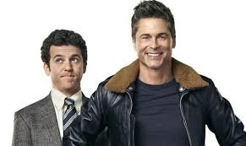 | “THE GRINDER” (Fox) stars Rob Lowe and Fred Savage (“The Wonder Years”). This is a new comedy about two brothers: one a spotlight-grabbing actor who plays TV’s most popular lawyer and the other, a real-life, small-town attorney who has yet to find his spotlight.

“QUANTICO” (ABC) stars Priyanka Chopra as Alex Parrish, one of a diverse group of recruits who have arrived at the FBI Quantico base for training. They are the best, the brightest and the most vetted, so it’s especially shocking that in the future, one of the recruits will turn out to be a sleeper terrorist responsible for the most devastating terrorist attack on U.S. soil since 9/11. |  | 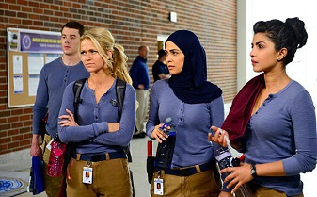
 | In a nutshell, “Limitless” (CBS) is about a drug called NZT, which enhances users’ brain power by giving them access to 100 percent of their brains. In the movie, this miracle pill enables a no-body played by Bradley Cooper to go from being a struggling writer to an actual candidate for the U.S. Senate.

“Rosewood” (Fox) is an upcoming American television series that is set to air on Fox, about a private pathologist named Dr. Beaumont Rosewood Jr., who works in Miami, Florida, where he is highly in demand with law enforcement.

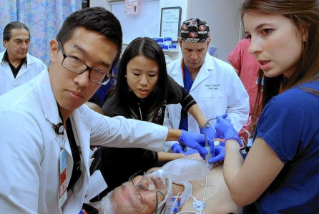 | “CODE BLACK” (CBS) follows the doctors who work tirelessly to save lives in the busiest and most notorious ER in the nation, L.A. County Hospital. If you were to take the Emmy-winning series ER, and pump it up with heart-pounding steroids, then you’d have Code Black. But what exactly does "code black" mean? "That's the moment in the emergency room when there are more patients than there are doctors and beds to take care of them," series star Marcia Gay Harden revealed.

“THE PLAYER” (NBC) follows Alex Kane, a former intelligence officer who after losing his wife, becomes the muscle to Mr. Johnson, a mysterious billionaire (Wesley Snipes) who runs the Las Vegas game. Part of the suspense every week is that Kane, Johnson and femme fatale Cassandra don’t exactly trust each other as fellow team members.

TV SHOWS THAT I MIGHT WATCH DURING THE 2015-2016 SEASON
A complete list of the TV shows I will probably watch during the upcoming season starts on the next page. One thing for sure – I plan to watch a lot of college and pro football games in the coming months. Basketball is not too far off and University of Hawaii women’s volleyball has started again. This is a great time of the year for sports.

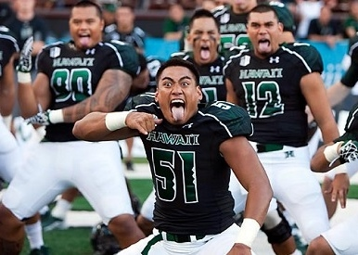 | 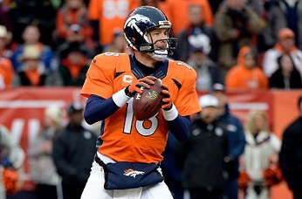
University of Hawaii Football | Payton Manning and the Denver Broncos
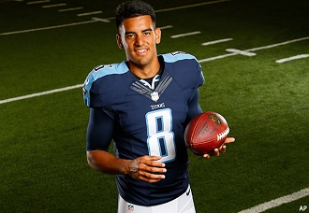 | 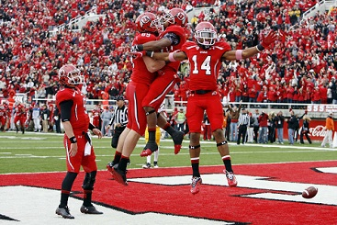
Marcus Mariota and the Tennessee Titans | University of Utah Football
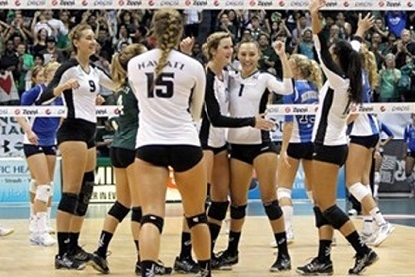 | 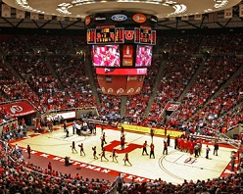
University of Hawaii Lady’s Volleyball | University of Utah Basketball

TV SHOWS THAT I MIGHT WATCH DURING THE 2015-2016 SEASON
DAY / TV SHOW | COMMENTS
MONDAY
“Gotham” (Fox)  “SUPERGIRL” (CBS)  “Scorpion” (CBS)  “BLINDSPOT” (NBC)  “NCIS: Los Angeles” (CBS)  “Monday Night Football (ESPN) | Lots of violence but entertaining  NEW – I may tune in to check it out  A bunch of super smart people solving crimes  NEW – Might be a good show  Good show – Second best NCIS  Yes, I will be watching this – hopefully in a bar
TUESDAY
“NCIS” (CBS)  “THE GRINDER” (Fox)  “QUANTICO” (ABC)  “Chicago Fire” (NBC)  “LIMITLESS” (CBS) | Currently my favorite TV show  NEW – I need to see what this show is about  NEW – Could be very interesting  Good show  NEW – I will definitely watch this show
WEDNESDAY
“ROSEWOOD” (Fox)  “The Mysteries of Laura” (NBC)  “Law & Order: SVU” (NBC)  “Criminal Minds” (CBS)  “Nashville” (ABC)  “Chicago P.D.” (NBC)  “CODE BLACK” (CBS) | NEW – Not sure what kind of show this is?  I like a good mystery now and then  This series has been on TV a long time  My second most popular current show  Have not watched this show yet but plan to soon  Good police action show  NEW – Might be a very good show
THURSDAY
“Grey’s Anatomy” (ABC)  “Bones” (Fox)  “Thursday Night Football” (CBS)  “Scandal” (ABC)  “The Blacklist” (NBC)  “THE PLAYER” (NBC)  “Elementary” (CBS) | Another show that has been on TV a long time  I find this show very interesting  Hope to find a good bar for these games  Not sure what this show is about  Good show to watch when football is not on  NEW – Need to checkout this one  Can be interesting – some good mysteries
FRIDAY
“Grimm” (NBC)  “Hawaii Five-0” (CBS)  “Blue Bloods” (CBS) | Not a bad show  Everybody in Hawaii watch this show – Right?  Tom Selleck shows are always good
SATURDAY
“College Football” (Many Channels)  “CSI: Cyber” (CBS) | I like to watch college football  All of the CSI series were good
SUNDAY
“NFL Football” (Many Channels)  “60 Minutes” (CBS)  “Madam Secretary” (CBS)  “Brooklyn Nine-Nine” (Fox) | Pro football is almost as good as college football  The best News Show  Good political action show  Good police show
WHAT MAJOR NETWORK HAS THE BEST TV SHOWS?

NETWORK | Number of Good Shows
CBS  NBC  FOX  ABC | 14  8  5  4
CBS wins by a mile.

SOME MORE TV FACTS AND STATISTICS
Percentage of households that possess at least one television: 99%
Number of TV sets in the average U.S. household: 2.24
Percentage of U.S. homes with three or more TV sets: 66%
Number of hours per day that TV is on in an average U.S. home: 6.75 hours
Number of hours of TV watched annually by Americans: 250 billion
Percentage of Americans who pay for cable TV: 56%
Percentage of Americans who say they watch too much TV: 49%

I was going to jump up on my soapbox and rant about how bad it is for kids now days to be spending all those hours watching television, playing games on the computer, and / or staring at their iPhones and iPads. They should be outside playing and getting some exercise. But, I will save that subject for a future article.

WHAT TV SHOWS HAVE BEEN ON TELEVISION THE LONGEST?

Longest Running TV Shows
Years | Show Name | Network | Episodes | Comments
68 years  (1947 – Pres) | Meet the Press | NBC | 5,050+ | Longest running show
67 years  (1948 – Pres) | CBS Evening News | CBS | 16,400+ | Longest-running network newscast
61 years  (1954 – Pres) | Face the Nation | CBS | 5,000+
57 years  (1952 – 2009) | Guiding Light | CBS | 15,762 | Longest running Soap Opera
52 years  (1962 – Pres) | Professional Bowlers Tour | ABC–CBS -ESPN | 2,000+ | Longest running sports show
49 years  (1966 – 2014) | Jerry Lewis MDA Telethon | Multiple | 49 | Annual broadcast
47 years  (1968 – Pres) | 60 Minutes | CBS
45 years  (1961 – 2006) | Wide World of Sports | ABC
46 years  (1969 – Pres) | Sesame Street | PBS | 4,400+ | Longest running children’s show
45 years  (1970 – Pres) | Monday Night Football | ABC - ESPN | 650+
43 years  (1972 – Pres) | The Price Is Right | CBS | 8,000+ | Longest running game show
40 years  (1975 – Pres) | Good Morning America | ABC | 9,920+
40 years  (1975 - Pres | Saturday Night Live | NBC | 800+ | Longest running variety show
35 years  (1979 – Pres) | SportsCenter | ESPN | 90,000+ | Most episodes ever in TV history
32 years  (1957 -1989) | American Bandstand | ABC | 4,134
32 years  (1983 – Pres) | Wheel of Fortune | Syndicated | 6,000+
31 years  (1984 – Pres) | Jeopardy! | Syndicated | 6,600+
29 years  (1986-Pres) | Late Night | NBC | 5,000+
27 years  (1955 – 1971) | The Lawrence Welk Show | ABC | 1,065
27 years  (1988 – Pres) | Live! with Kelly and Michael | Syndicated | 7,700+ | Show has had several names
27 years  (1988 – Pres) | 48 Hours | CBS
26 years  (1988 – Pres) | NBA on TNT | TNT
26 years  (1989 – Pres) | The Simpsons | Fox | 574 | Longest running animated series
26 years  (1989 – Pres) | America's Funniest Home Videos | ABC | 500+
25 years  (1985 – 2010) | Larry King Live | CNN
25 years  (1986 – 2011) | The Oprah Winfrey Show | Syndicated | 4,561
23 years  (1952 – 1975) | Death Valley Days | Syndicated | 558
23 years  (1948 – 1971) | The Ed Sullivan Show | CBS | 1,087
22 years  (1993 – Pres) | WWE Raw | USA | 1,110+
20 years  (1951 – 1970) | The Red Skelton Show | NBC
20 years  (1955 – 1975) | Gunsmoke | CBS | 635 | Longest-running prime-time drama (tie)
20 years  (1990 – 2010) | Law & Order | NBC | 456 | Longest-running prime-time drama (tie)

A LITTLE TELEVISION HISTORY
In the late 1940s, the three networks – NBC, CBS and ABC – were "networks" in name only. All of the programming originated, live, in New York. The only way the networks had to distribute the shows to the rest of the nation was to point a film camera at a television screen and convert video to film. These 16mm films, known as kinescopes, were then duplicated and shipped to the few affiliated stations for broadcast later. By necessity, most programming was local, and cooking shows, wrestling and cartoons took up most of the broadcast day.

The networks became true networks in 1952 when AT&T finished laying a system of coaxial cables from coast to coast. For the first time, television was able to broadcast the Republican and Democratic conventions live from Philadelphia to the rest of the nation.

Only 3% of US households owned a TV in 1950. You know the rest of the story – How things have changed.

On the next page I list the different categories of TV programming along with some of my all-time favorite shows in each category.

SOME OF MY ALL-TIME FAVORITE TV SHOWS

Type of TV Show | My Favorite Shows
Action/Adventure  Animated  Award Shows  Comedy Sitcom  Cooking  Crime Drama  Educational  Game Shows  History  Horror  Legal/Court Drama  Medical Drama  Movies  Mystery  News Programs  Political Drama  Reality  Religious  Science  Science Fiction  Soap Operas  Sports  Talent Shows  Talk Shows  Travel  Western  Variety/Musical | None  None  None  Seinfeld – All in the Family – Cheers – M*A*S*H  None  NICS – Criminal Minds – CSI – Hawaii 5-0 – 24 - Dragnet  None  Jeopardy – Wheel of Fortune  None  None  Perry Mason – Law & Order  ER – Marcus Welby, M.D.  (Variety of Movies – Lots of Western and Crime shows)  Columbo – Murder She Wrote  60 Minutes  None  None  Touched by an Angel  National Geographic Specials  The X-Files  None  (Most all sports - especially basketball and football)  None  Jay Leno  None  Gunsmoke – Rawhide – Bonanza  Carol Burnett – Jack Benny – Jackie Gleason Show

bigdrifter44@gmail.com

