My Drift |   Jerry D. Petersen | Rio de Janeiro  February 27, 2013  (154-2013-04)

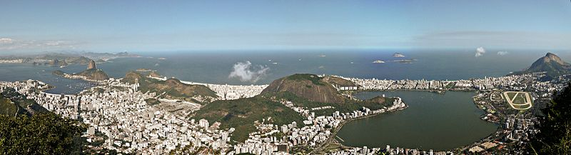

I have been thinking again about places I have never been to and would like to visit sometime. For some reason, the city of Rio de Janeiro popped into my mind. Maybe this was because of all the videos on the news and the Internet about the Rio Carnival which was held 9-12 Feb 2013. It looked like as big (or bigger) of a party then the Mardi Gras in New Orleans.

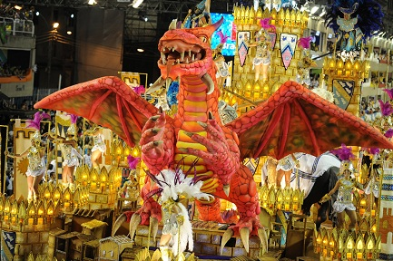 | 

Actually, I have never been to any countries on the entire South America Continent. Just in case I never get around to writing about South America again, I will provide a map (next page), a list of the countries, and a few interesting facts.
Area: 6,890,000 square miles
Population: Approximately 388,000,000
Largest country: Brazil - Encompasses around half of the continent’s land area and population
Primary religion: Roman Catholic
Primary languages: Spanish is the official language of most countries
Portuguese is spoken in Brazil
Dutch is the official language of Suriname
English is the official language of Guyana

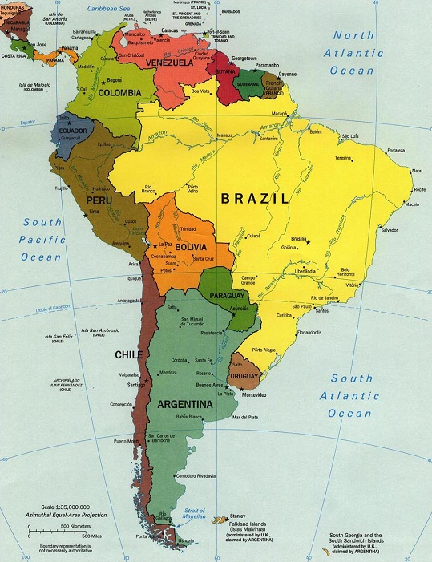

Countries with their Capitals
Argentina - Buenos Aires
Bolivia – La Paz
Brazil – Brasilia
Chile – Santiago
Colombia – Bogotá
Ecuador – Quito
Falkland Islands / Islas Malvinas - Stanley
French Guiana – Cayenne
Guyana – Georgetown
Paraguay – Asunción
Peru – Lima
Suriname – Paramaribo
Uruguay – Montevideo
Venezuela – Caracas
South America facts:
World’s highest waterfall - Angel Falls in Venezuela
Largest river - the Amazon River
Longest mountain range, the Andes (whose highest mountain is Aconcagua at 22,841 feet)
Driest place on earth - the Atacama Desert
Largest rainforest - the Amazon Rainforest
Highest capital city - La Paz, Bolivia
Highest navigable lake in the world - Lake Titicaca on the border of Peru and Bolivia
Unique species of animals - Includes the llama, anaconda, piranha, jaguar, vicuña, and tapir

Okay, let’s get back to Brazil and Rio de Janeiro. Here are a few interesting facts about Brazil:
Over 4 million species of plants and animals exist in Brazil
Brazil is famous for its soccer team - it has won the prestigious FIFA World Cup 5 times
Voting in the elections is compulsory - everyone between the ages of 18 and 65 has to vote
Brazil has over 8000 airports – second in the world behind the United States with over 15000
Spanning over 2800 miles from north to south, Brazil is the longest country in the world
Brazil is the world's fifth largest country, both by geographical area and by population
That is an area of 3,287,612 square miles and an population over 196 million people
It shares common boundaries with every South American country except Chile and Ecuador
Life expectancy is about 72 years with men living 68 years and women 76 years

Most people think Rio is the biggest city in Brazil but it’s not - Sao Paulo is the biggest in Brazil and South America with almost 15 million people – Rio has 6,320,000 people which is the second largest city in South America. Here are some attractions and views of the city:

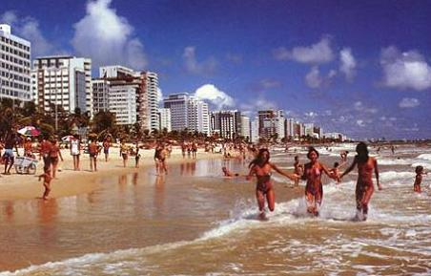 | Rio’s Famous Copacabana Beach  The beaches facing Guanabara Bay (Flamengo and Botafogo) are nearly always too polluted for swimming. But, thanks to a substantial current, the ocean beaches (Copacabana, Ipanema, and Barra) are much cleaner. Don’t take a bunch of stuff to the beach - why bring anything when everything you could possibly want is for sale on the beach? And don’t leave valuables laying around that can be stolen. Rent a beach chair, buy a beer, and enjoy the scenery - beach goers revel in exposing almost their entire bodies - Brazil has legalized nude beaches.
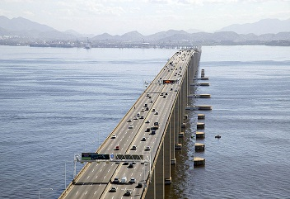 | Rio–Niterói Bridge  The Rio-Niteroi Bridge is a box girder bridge located at Guanabara Bay in Rio de Janeiro. It connects the cities of Rio de Janeiro and the municipality of Niterói. It is currently the longest prestressed concrete bridge in the southern hemisphere and is the sixth longest in the world. It was completed in 1974 and is 8.25 miles long.
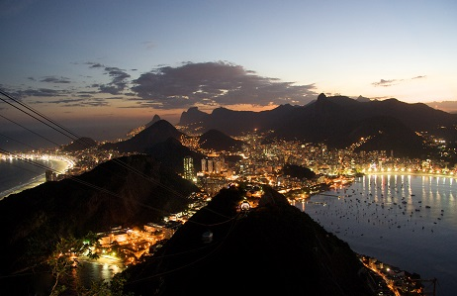 | The City of Rio at Night  Rio nightlife is famed to be the best in the world – the locals really know how to party in Rio. There are hundreds of bars, night clubs, and strip clubs. Most people drinks beer (Skol brand is most popular) and Cachaça (liquor made from fermented sugarcane juice). The place to be on Friday nights is the street party in Lapa. The streets are closed off and there are thousands of people dancing and having a great time. There are lots of street vendors selling food and drinks. There is music pumping from all the crowded bars nearby. The place is buzzing!

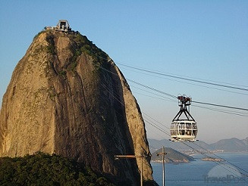 | Sugarloaf Mountain Cable Car  Rio's famed Sugarloaf cable car, one of the world's most visited tourist landmarks, had its 100th birthday in 2012 with plans to extend its service to other neighboring hilltops. Inaugurated on October 27, 1912, the cable car ferries visitors to the top of the Sugarloaf Mountain, the 395 meters (1,250 feet) tall iconic granite peak that towers over Rio de Janeiro. A visitor must first take a cable car to a lower hill called Morro da Urca before boarding a second car to the top of the Sugarloaf.
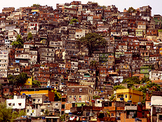 | Rio de Janeiro Slums  Favela is the term for a shanty town (slum) in Brazil. Actually, the slums of Rio de Janeiro have the best view of the marvelous city. They get the view of the hills, the orange back lit of Sugarloaf Mountain with its tourist filled cable cars, and of course the moonlit beaches of Copacabana and Leblon. The population of those living in those homes nestled old “third world” style in the hills of Rio number over a million.

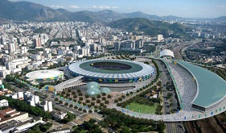 |  | Rio to Host 2016 Olympic Games  The 2016 Summer Olympics will be held in Rio de Janeiro from August 5 to 21, 2016. There will be 30 competition venues mainly in Barra da Tijuca, but also in Copacabana, Deodoro, and Maracanã. It will mark the first time a South American city hosts the event and also the first time a Portuguese speaking country hosts the event.

I saved the biggest (literally) Rio de Janeiro attraction for last – the Christ the Redeemer statue of Jesus.

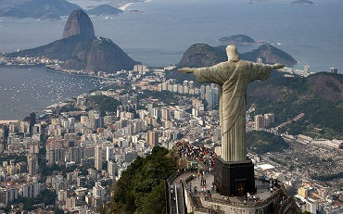 | 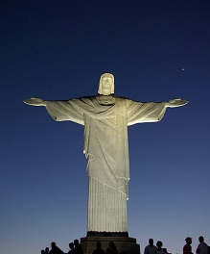

This statue of Jesus Christ in Rio de Janeiro, Brazil is the 5th largest statue of Jesus in the world. It is 120 feet tall and 62 feet wide. It weighs 635 tons and is located at the peak of the 2,300 feet high Corcovado Mountain in the Tijuca Forest National Park overlooking the city. It is the symbol of Brazilian Christianity and has become an icon for Rio de Janeiro and Brazil. It is made of reinforced concrete and soapstone, and was constructed between 1926 and 1931. The statue of Christ the Redeemer with open arms is a symbol of peace for the world. The reason why it was built was to show that Christ loves all.

If they built something like this in the United States, we would have the ACLU, the Muslims, the atheists, and the bleeding heart liberals suing to have it tore down. The United States is a Christian Nation but our religious freedoms are under attack and it is about time we put a stop to it.

The Christ the Redeemer statue was chosen as one of the seven new wonders of the world. Here is the complete list:

Taj Mahal | Agra, Uttar Pradesh, India | 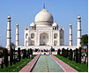
Chichen Itza | Yucatán, Mexico | 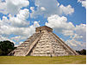
Christ the Redeemer | Rio de Janeiro, Brazil | 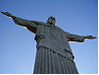
Colosseum | Rome, Italy | 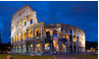
The Great Wall of China | China | 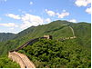
Machu Picchu | Cuzco Region, Peru | 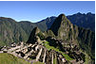
Petra | Ma'an Governorate, Jordan | 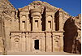
The Pyramids* | Giza, Egypt | 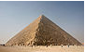

*Just in case you added up these wonders and got eight, the pyramids are honorable mention since they are the only remaining Wonder of the Ancient World. I have not visited any of these places but would like to see the pyramids, the Great Wall of China, and Christ the Redeemer.

History of Rio de Janeiro
The Tamoio people were living on the land surrounding the Baía de Guanabara when Gaspar de Lemos sailed from Portugal for Brazil in May 1501 and entered the huge bay in January 1502. Mistaking the bay for a river, Lemos named it Rio de Janeiro. The French, however, were the first Europeans to settle along the great bay in 1555. After a brief alliance with the Tamoio – who hated the Portuguese for their cruelty – the French were expelled in 1567. The Portuguese victors then drove the Tamoio from the region in another series of bloody battles.

By the 17th century, the Tamoio people had been wiped out. Those who weren’t taken into slavery died from disease. The Portuguese had set up a fortified town on the Morro Castelo in 1567 and, by the 17th century, Rio became Brazil’s third-most important settlement (after Salvador da Bahia and Recife-Olinda). African slaves streamed in and the sugar plantations thrived. Even more slaves arrived to work in the gold mines of Minas Gerais during the 18th century.

In 1807 Napoleon’s army marched on Lisbon. Two days before the invasion, 40 ships carrying the Portuguese prince regent (later known as Dom João VI) and his entire court of 15,000 set sail for Brazil. When the prince regent arrived in Rio, his Brazilian subjects celebrated wildly, dancing in the streets. He immediately took over the rule of Brazil.

At the end of the 19th century the city’s population exploded because of European immigration and internal migration (mostly of ex-slaves from the declining coffee and sugar regions). By 1890 Rio boasted more than a million inhabitants, a quarter of them foreign-born, and the city spread rapidly.

The early 1920s to the late 1950s were Rio’s golden age. With the inauguration of the grand hotels (the Glória in 1922 and the Copacabana Palace in 1924), Rio became a romantic, exotic destination for Hollywood celebrities and international high society who came to play and gamble at the casinos and dance or perform in the nightclubs.

Rio remained the political capital of Brazil until 1960, when the government moved to Brasília. During the 1960s, modern skyscrapers rose in the city, and some of Rio’s most beautiful historic buildings were lost. During the same period, the favelas (shantytowns) of Rio grew to critical mass with immigrants from poverty-stricken areas of the Northeast and the interior, swelling the number of Rio’s urban poor. The city began to lose its gloss as crime and violence increased.

But today, Rio’s coffers are full, and the city buzzes with an unstoppable creative energy, as long-awaited projects are finally being financed. The biggest is the Favela-Bairro project, which strives to integrate favelas into the rest of the city by providing basic sanitation and by planning leisure areas, health clinics, schools, preschools and community centers (Rio has pledged a total of US$1 billion over the life of the project). At the same time, some of Rio’s aging colonial gems are slowly being revitalized as new businesses arrive. Rio prepares to host the 2016 Olympic Games.

There are four primary districts in Rio de Janeiro:
Centro: Includes Lapa and Santa Teresa. The city's financial and business center also has many historic buildings from its early days, such as the Municipal Theatre, National Library, National Museum of Fine Arts, Tiradentes Palace, Metropolitan Cathedral and Pedro Ernesto Palace.
Zona Sul (South Zone): Includes Copacabana, Leblon and Ipanema, as well as the districts along Flamengo Beach. Contains some of the more upscale neighborhoods and many of the major tourist sites, such as the Rodrigo de Freitas Lagoon, and Sugar Loaf and Corcovado Mountains.
Zona Norte (North Zone): The Maracanã stadium, Quinta da Boa Vista Park with the National Museum the city's Zoo, the National Observatory and more.
Zona Oeste (West Zone): A rapidly growing suburban area including primarily the districts of Jacarepaguá and Barra da Tijuca, popular for its beaches. Most of the Olympics in 2016 will be hosted there.

If you plan to visit Rio, you need to be careful since Rio de Janeiro and all of Brazil still have a high crime rate. With roughly 23.8 homicides per 100,000 residents, muggings, robberies, kidnappings and gang violence, Brazil is one of the most criminalized countries of the world. In fact, Brazil used to be the most violent place on Earth. The good news is the crime rate has been going down rapidly in Rio as the city gets ready for the upcoming Olympics. They say it is best if you can “fit in” with the local population, but I’m afraid I will have a problem doing this. However, I have visited enough foreign countries to know how to get along and I think I will be just fine if I ever get a chance to visit Rio.

bigdrifter44@gmail.com

http://bigdrifter.com/

