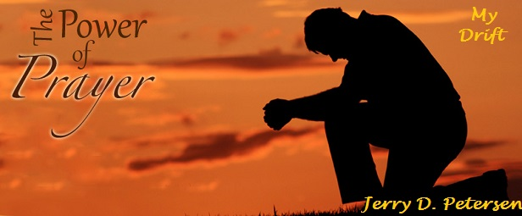

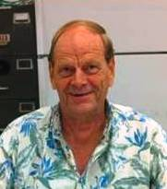 | The Power of Prayer  17 September 2014 | 185-2014-14

Do you believe in the power of prayer? Do you believe in God? If I was guessing (which I am), I would say that almost all of the people reading this article believe in both. America is still a deeply religious nation where 77% of all adults believe in both prayer and God. With that said, our country is moving in the wrong direction. Ten years ago, that percentage was closer to 85%. Generally speaking, a lot of young people in America don’t believe in much of anything whereas the older generation believes strongly in God and the power of prayer. You know how much I like statistics so let’s break that down even further. Democrats believe in prayer at a 72 percent clip, Republicans at 83 percent and independents at 78 percent. The only really significant difference was between self-identified liberals at 65 percent and conservatives at 85 percent, with moderates in the middle at 78 percent.

For the rest of this article, I’m going to talk about people in the United States who do believe in the power of prayer.

How often do people pray? 68% of Christians pray more than once every day – 16% every day – 12% a few times every week – 2% a few times a month – 2% monthly or less.

The number of people who pray multiple times every day kind of surprised me. I thought it would be much lower. But then I thought about the Muslims where 92% of them pray several times a day. I think I might fall in the, “a few times a week” category.

What do people pray the most about?
- Health and safety of self, family, and friends
- Personal finances or work
- Relationships
- Comforting the bereaved
- Pets
- God's forgiveness
- God's guidance
- Lost souls
- Victims of tragedies
- Improving the world
- The president/world leaders
- Stronger faith
- Giving thanks

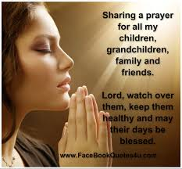

As we get older, it seems like there are more and more things to pray for. Our personal health and the health and safety of family and friends is by far the most prayed for thing. I believe this is the case for me and I include pets as part of the family. I admit that I do pray for my own body and mind to stay healthy.

Are our prayers answered? 43% of Christians said that their prayers were answered often.
27% said that their prayers were always answered. 25% said that their prayer were answered sometimes and 5% said that their prayers were rarely or never answered.

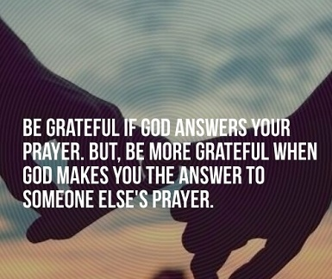

I think my prayers are answered most of the time. My family and friends seem to be fairly healthy. I’m still pretty much physically and mentally healthy. I do have a stiff and sometimes painful back. Of course, there might be some other people praying for me. Plus I believe in Guardian Angels and I must have a good one in order for me to still be around considering some of the places I have been and some of the things I have done in my life.

When your prayers don’t come true, what do you believe is the reason why? The number one reason given is, “It was not in God’s plan.” The number two reason was, “My faith was not strong enough.” The number three reason was, “God doesn't always respond to specific prayers.” “God hates me” was on the list but I don’t think this is ever the case. Is it?
Where do people pray the most often? At home was the run-away winner with about 80% - at church, at work, and while traveling rounded out the top four places. | 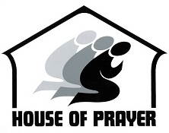
What words do people use? Only about 5% of Christians use sacred texts or written prayers – 60% use their own words and the other 35% use a mix of their own words and scared texts or written prayers. The two most popular written Christian prayers are:

The Lord's Prayer  Our Father, who art in heaven,  hallowed be thy name,  thy kingdom come,  thy will be done,  on earth as it is in heaven.  Give us this day our daily bread  and forgive us our debts and we forgive  our debtors,  and lead us not into temptation,  but deliver us from evil,  for thine is the kingdom and the power  and the glory, forever. Amen.  --- Matthew 6:9-13 | Twenty-Third Psalm  The Lord is my shepherd, I shall not want.  He makes me lie down in green pastures;  he leads me beside still waters;  he restores my soul.  He leads me in right paths for his name's sake.  Even though I walk through the valley  of the shadow of death,  I fear no evil;  for you are with me;  your rod and your staff--they comfort me.  You prepare a table before me  in the presence of my enemies;  you anoint my head with oil;  my cup overflows.  Surely goodness and mercy shall follow me  all the days of my life,  and I shall dwell in the house of the Lord  forever.  --- Psalms 23: 1-6

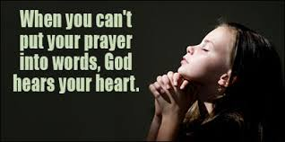

How do you pray? Most people say their prayers silently but there are a lot of people who chant or say their prayers out loud. Then there is the new generation that say their prayers over the Internet. About 25% of all Christians and about 60% of all Muslims kneel while praying.

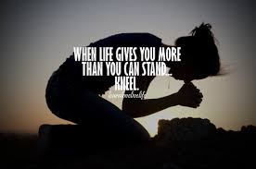

Can prayer heal people? Just think about this statement for a minute. It makes sense that people who pray and are religiously active tend to be healthier. This may be due to the power of prayer, but it could also be explained by a tendency toward clean living and not indulging in health risks like alcohol, drugs, cigarettes and casual sex. In addition, people active in their communities of faith may receive the help of social bonds within their religious groups. These statements are backed up by scientific studies that shows a direct connection between the mind and the body. Other scientists have found that a person's faith can help him or her live a longer and healthier life. Prayer is found to lower blood pressure and heart rate, both of which can contribute to a more virile immune system.

There have been many scientific studies that show that praying can prove beneficial for a person’s health. A recent study shows that as many as 85 percent of people suffering from disease pray in addition to receiving medical treatment. Prayer is the number one complementary medicine for Americans, more than vitamins, herbs or therapeutic exercise like yoga. If it makes someone feel better -- even if can't be proven scientifically -- what harm does prayer pose? None – it can only help!

The notion that we humans possess a capability to heal others simply by using our minds -- or by calling upon a higher power to intercede -- flies in the face of science. But in the pursuit of the truth, researchers have and will continue to investigate it scientifically. With so many people relying on prayer, scientists have a responsibility to determine whether it is helpful or harmful to people. In one study, there were 393 patients who checked into a coronary care unit in a San Francisco hospital. The patients were “statistically inseparable,” meaning their condition and symptoms were all similar. Each was randomly assigned to one of two groups: those who received intercessory prayer and those who didn't. Neither the doctor nor the patients knew who was in which group.

The first name, diagnosis and condition of each prayer patient were given to different groups of three or four active Christians from several denominations. These groups prayed for their patient daily throughout the patient’s stay in the hospital, without ever meeting the patient. They prayed for a timely, easy recovery and one free from complications.

When the study concluded, they found that there was indeed a significant difference in the quality of recovery among patients who received prayer. They fared better on average than their fellow patients who did not receive prayer. Almost 85 percent of the prayer group scored “good” on the rating system used by hospitals to rate a patient’s response to treatment. They were less likely to have a heart attack, need antibiotics or require intervention like ventilation or intubation. By contrast, only 73 percent of members of the other control group scored “good”.

There have been many studies with similar results. But, as non-believers are quick to point out, there have been other studies that show no differences between the patients being prayed for and the ones not being prayed for. There is no concrete evidence that praying can heal the sick just as there is no concrete evidence that God exists. You either have faith that prayer helps or you don’t.

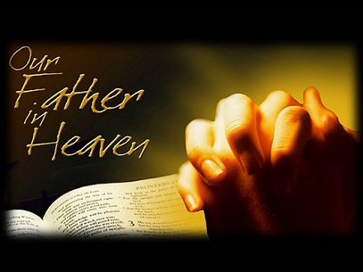

The power of prayer stories. There are millions of stories out on the Internet demonstrating the power of prayer. I’m going to share two of them with you.

The Power of Prayer
Author: Unknown

A young man had been to Wednesday night Bible Study. The Pastor had shared about listening to God and obeying the Lord's voice. The young man couldn't help but wonder, "Does God still speak to people?"

After service he went out with some friends for coffee and pie and they discussed the message. Several different ones talked about how God had led them in different ways.

It was about ten o'clock when the young man started driving home. Sitting in his car, he just began to pray, "God... If you still speak to people, speak to me. I will listen. I will do my best to obey."

As he drove down the main street of his town, he had the strangest thought to stop and buy a gallon of milk. He shook his head and said out loud, "God is that you?" He didn't get a reply and started on toward home.

But again, the thought, buy a gallon of milk. The young man thought about Samuel and how he didn't recognize the voice of God, and how little Samuel ran to Eli.

"Okay, God, in case that is you, I will buy the milk."

It didn't seem like too hard a test of obedience. He could always use the milk. He stopped and purchased the gallon of milk and started off toward home.

As he passed Seventh Street, he again felt the urge, "Turn down that street." This is crazy he thought and drove on past the intersection. Again, he felt that he should turn down Seventh Street. At the next intersection, he turned back and headed down Seventh. Half joking, he said out loud, "Okay, God, I will".

He drove several blocks, when suddenly, he felt like he should stop. He pulled over to the curb and looked around. He was in semi-commercial area of town. It wasn't the best but it wasn't the worst of neighborhoods either. The businesses were closed and most of the houses looked dark like the people were already in bed.

Again, he sensed something, "Go and give the milk to the people in the house across the street."

The young man looked at the house. It was dark and it looked like the people were either gone or they were already asleep. He started to open the door and then sat back in the car seat.

"Lord, this is insane. Those people are asleep and if I wake them up, they are going to be mad and I will look stupid."

Again, he felt like he should go and give the milk. Finally, he opened the door, "Okay God, if this is You, I will go to the door and I will give them the milk. If you want me to look like a crazy person, okay. I want to be obedient. I guess that will count for something but if they don't answer right away, I am out of here."

He walked across the street and rang the bell. He could hear some noise inside. A man's voice yelled out, "Who is it? What do you want?" Then the door opened before the young man could get away.

The man was standing there in his jeans and T-shirt. He looked like he just got out of bed. He had a strange look on his face and he didn't seem too happy to have some stranger standing on his doorstep. "What is it?"

The young man thrust out the gallon of milk, "Here, I brought this to you."

The man took the milk and rushed down a hallway speaking loudly in Spanish. Then from down the hall came a woman carrying the milk toward the kitchen. The man was following her holding a baby. The baby was crying.

The man had tears streaming down his face. The man began speaking and half crying, "We were just praying. We had some big bills this month and we ran out of money. We didn't have any milk for our baby. I was just praying and asking God to show me how to get some milk."

His wife in the kitchen yelled out, "I ask him to send an Angel with some. Are you an Angel?"

The young man reached into his wallet and pulled out all the money he had on him and put in the man's hand. He turned and walked back toward his car and the tears were streaming down his face. He knew that God still answers prayers.

------------------

The Power of Prayer
Author: Unknown

A poorly dressed lady (named Louise) with a look of defeat on her face, walked into a grocery store. She approached the owner of the store in a most humble manner and asked if he would let her charge a few groceries.

She softly explained that her husband was unable to work, they had seven children and they needed food. John Longhouse, the grocer, scoffed at her and requested that she leave his store. Visualizing the family needs, she said: "Please, sir! I will bring you the money just as soon as I can." John told her he could not give her credit, as she did not have a charge account at his store.

Standing beside the counter was a customer who overheard the conversation between the two. The customer walked forward and told the grocer that he would stand good for whatever she needed for her family.

The grocer said in a very reluctant voice, "Do you have a grocery list?"

Louise replied, "Yes sir." "O.K." he said, "put your grocery list on the scales and whatever your grocery list weighs, I will give you that amount in groceries."

Louise, hesitated a moment with a bowed head, then she reached into her purse and took out a piece of paper and scribbled something on it.

She then laid the piece of paper on the scale carefully with her head still bowed.

The eyes of the grocer and the customer showed amazement when the scales went down and stayed down.

The grocer, staring at the scales, turned slowly to the customer and said begrudgingly, "I can't believe it."

The customer smiled and the grocer started putting the groceries on the other side of the scales. The scale did not balance. So he continued to put more and more groceries on them until the scales would hold no more.

The grocer stood there in utter disgust. Finally, he grabbed the piece of paper from the scales and looked at it with greater amazement. It was not a grocery list. It was a prayer which said: "Dear Lord, you know my needs and I am leaving this in your hands".

The grocer gave her the groceries that he had gathered and stood in stunned silence. Louise
thanked him and left the store. The customer handed a fifty-dollar bill to the grocer and said, "It was worth every penny of it." Only God Knows how much a prayer weighs.

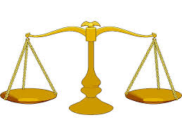
Last question – Why is it that more and more young people don’t believe in the power of prayer? Hold on a second while I get my soapbox…..

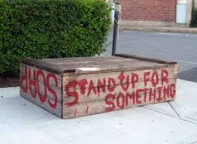 | The American Civil Liberties Union (ACLU), a few atheists and some liberals (with loud voices) have succeeded in removing prayer from our schools and government offices including military bases. All Christian crosses, pictures, and religious items have also been removed. They are trying to remove all references to God, Jesus, Christ, Lord, etc. from our currency and all government sponsored documents and events. They don’t even want stores and people to say, “Merry Christmas” during the holidays.

What is happening to our country? America was founded on Christian principles including the right to pray. The very First Amendment, amendment (1791) to the Constitution of the United States, part of the Bill of Rights, reads, “Congress shall make no law respecting an establishment of religion, or prohibiting the free exercise thereof; or abridging the freedom of speech, or of the press; or the right of the people peaceably to assemble, and to petition the Government for a redress of grievances.”

We are supposed to have Freedom of Religion in the United States! The large majority of Americans -- 77% of the population – belong to a Christian religion. Yes, this country is still predominantly Christian and we need to stand up for our rights. Let’s start with bringing back prayer in our schools. The public school system is tragically disintegrating as evidenced by the rise in school shootings, increasing drug use, alcoholism, teen pregnancy, and HIV transmission. School prayer can help combat these issues and is desperately needed to protect our children. Schools must do more than just train children’s minds academically. Here are some benefits of school prayer:
- Reinforce the moral values taught at home
- Instill a sense of right and wrong and a love for others
- Promote good citizenship

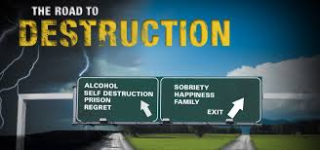 | School prayer may cause students to acknowledge a power greater than themselves on which they can rely for comfort and help in times of trouble. This will lead to decreased reliance on drugs, alcohol, sex, and dangerous amusements as well as fewer suicides. Many young people are heading down the road to destruction and need to get back on the right path. School Prayer can help them do this.

Separation of Church and State
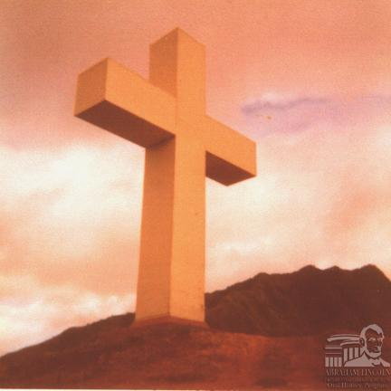  Schofield Cross | I believe in the separation of church and state to a certain degree. Church and State should be distinct so that the federal and state governments cannot elevate one denomination over another. This is good. But it doesn’t mean we tear down all crosses on government land, banished prayer from our schools, remove “under God” from the Pledge of Allegiance, etc. I’m still mad about when the military lost the court battle and had to take down the beautiful 65-foot brightly-lit cross at Camp Smith overlooking Pearl Harbor and the 35-ton steel cross at Schofield Barrack's Kolekole Pass. In addition to that, they had to remove all crosses from every military church.

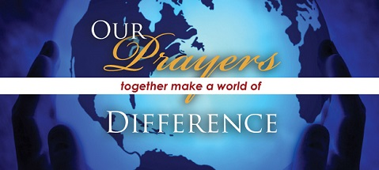

Prayer request
I was going to have everybody who reads this article say a little prayer for my aching back to get better but I have decided that there are more important events going on in the world that need all of our immediate prayers. Right now, there is a death threat to all non-Muslims world-wide and especially to Christians and Jews in the middle-east. Yes, extreme Islamic Terrorists (ISIS, al-Qaida and others) are killing all non-Muslims people they can find. They are also killing Muslims who don’t agree with them. Their goal is mass conversion to the Islamic Religion or death. ISIS has already beheaded two Americans. The United States and our allies can’t let these murderers continue slaughtering innocent men, women, and children. If we don’t do something, it won’t be long before they cross our borders and start killing Americans on our own soil.

So, let’s all pray for the Christians and all peace loving people of Northern Iraq and that entire region. These people are facing the terrible advancement of ISIS and possible death from these extreme Muslim murdering scumbags. Let’s also pray that our President and the leaders of other free world countries will make the right decisions in dealing with this crisis.

“God Bless America”

bigdrifter44@gmail.com

