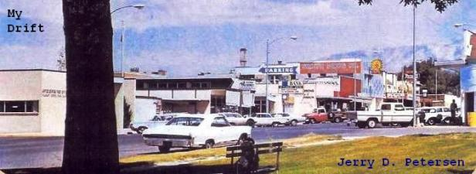

 | PGHS 50th Class Reunion  August 27, 2008

I recently attended my 50th class reunion. Yes, I know, “I’m old” but I was pleased to find out that so many of my Pleasant Grove High School classmates are still kicking. In a senior class of about 100 people, 53 of them showed up for this special event. Considering the fact that at least 18 people in our class are dead, that is a very good turn out. There were also about a dozen or so people they could not locate. The reunion was held on August 9th at the Utah Valley University Student Center located in Orem, Utah. This years committee members included Glen Hales, Alex Lott, Connie Johnson Bahr, Mac Boyer, Judy West Brown, Kay Giles, Peggy Kirk Jorgenson, and Ann Matthews Rowley. They did an excellent job of tracking down all these people and persuading them to attend the reunion. They also planned an excellent program that was entertaining and consumed the entire four hours they had the room reserved for. Everybody had a name tag and the first hour was used for mingling and finding out how life has treated our classmates over the past 50 years. I’m not much of a mingler but it was nice to see everybody again. There were even a few people who looked worse off then me (I think). Glen Hales was the committee chairman and acted as the MC for the event. After a good dinner (chicken or roast beef), they had a program that consisted of some singing and a humorous sketch about Don and Pat Jolley Hales. We then had a few words from the “very special” guests – our old football coach Ned Alger and our basketball coach Don Crump. They then passed the microphone around the room and let everybody tell the class what they have been doing since graduating from high school in 1958. It was a great reunion!

I went to the reunion with Lew Deveraux who was my best friend in high school and remains one of my best friends today. Lew is the only classmate that I have stayed in contact with over the past 50 years. We talk by email and I see him at least once a year when I come to Utah. He even came to Hawaii a couple of times. It is fun to get together with Lew to play a few games of pool, drink a few cold beverages, and talk about what is happening in Utah and Hawaii. My other best friend from high school is Benny Hullinger but I have only seen him a couple of times since school and he didn’t show up at the reunion.

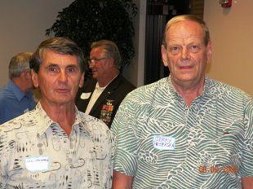 | 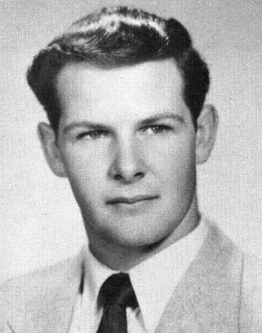

At the reunion I sat at a table with Lew, Larry Gillman, Coach Alger, Coach Crump, Myrna Turner and her friend. There were no spouses at our table. It was really good to see and talk to my old football and basketball coaches again. I have often wondered how they were doing. These were the two primary sports I played in high school. Coach Alger and Coach Crump were two of the best ever to coach high school sports in Utah.

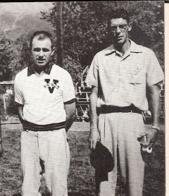 | 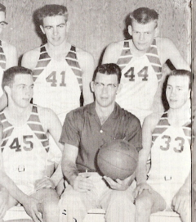
Coach Alger and Coach Crump | Kay, Alan, Coach, Jerry and Glen

Coach Ned Alger only coached at Pleasant Grove High School from 1954 to 1958. He won two state championships and went 31 games in a row without a defeat. (There were a couple of ties in this record) Regardless, this is probably the greatest coaching record in Utah history. I remember Coach Alger not as a great X’s and O’s coach but as a great psychologist. He talked to the team about life and how important it was to succeed. He had all of us convinced that it was impossible for us to lose. Yes, Coach Alger was the John Wooden of high school football. It also didn’t hurt that he had a lot of good football players like Paul Allen, Gene Ash and Don Hales. He went on to coach football and serve as the Associate Athletic Director at the University of Utah. With all this success, the game I remember best is our last game and only defeat in our high school years. We lost to Dixie and to make things worse, I injured my shoulder in that game. After thinking about it for a long time, I have decided we didn’t lose that game due to a poor performance or bad coaching – Dixie was just a better team that day.

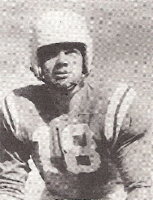 | 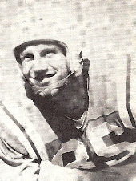 | 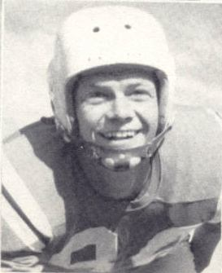 | 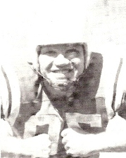
Don Hales -  QB and Kicker | Paul “Horse” Allen  The Running Back | Jerry “Camel” Petersen – End | Gene Ash -  The Blocker

Coach Don Crump moved to Pleasant Grove after graduating from BYU in 1952. He served as head basketball coach, assistant football coach and track coach for 16 years at Pleasant Grove High School. He also won two state championships during this period – one while our class was in the 10th grade. It should have been three state championships but I had a bad game and we lost to Union 42-40 in the first game of the 1958 state tournament. We went on to win the consolation championship and I scored a tournament high 72 points. But, there is no doubt in my mind that we had the best team in the state going into the tournament with a 14-1 record. After leaving the high school, Don Crump worked as principal of Pleasant Grove Junior High School for 12 years. He also worked as a police officer and on many special projects designed to help the youth of Pleasant Grove. Coach Crump was honored by being named the 2007 Strawberry Days Grand Marshall. I would like to thank Coach Crump for teaching me the game and for letting me shoot so much.

No sporting event would be complete without the cheerleaders and the fans. We had some great cheerleaders, a large Pep Club and a large following of fans cheering us on to many victories.

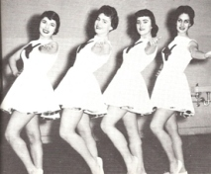 | 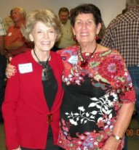
Pat Jolley - LaVerne Hall – Glenda Adams – Ann Matthews | Pat and Ann at the Reunion. LaVerne’s whereabouts is unknown and sadly Glenda passed away a few years ago.

Glenda is not the only one to die since 1958. Here are the classmates (we know about) who are no longer with us:

Karen Swenson  Almira Bird  Carol Smith  Vaneta Madsen  Glenda Adams  Bruce Rogers | Dennis Chorniak  Paul Gillman  Connie Bronson  Darrell Hooley  Thelma Janice Mann  Jim Nelson | Norma Jean Springer  Myrla Williams  Kent Hallsey  Bill Jones  Kay Walker  Bert Wooten
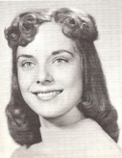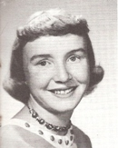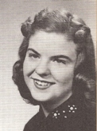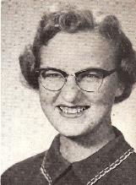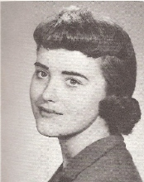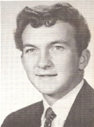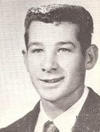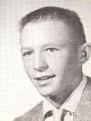

The above people had a good excuse for missing the reunion (maybe they were there in spirit). The following people could not be located and are either lost somewhere in the World or else they are dead:

JoAnne Arnold  Bud Atwood  Bill Bernard  Cleora Campbell  Edna Cates  Roberta Jones | Linda Cherrington  Nyle Christopherson  LaVerne Hall  Marilyn Jarvis  Maureen Merrill | Joyce Ann Nielsen  Larry Nielsen  Leroy Simmons  Lois Stringfield  Kent Roberts

For the rest of our classmates who elected not to come to the reunion, they really missed out on an enjoyable evening. If I can make it from Hawaii, they should be able to get there some how from wherever they are located. Here is the list of the unsociable party poopers:

Sue Chester  Fae Bezzant  Don Fordham  Paul Fugal  Lorraine Herring  Kenny Johnson  David Price  Larry Hampton  Dorothy Harris  Joan Haycock  Benny Hullinger  Harold Jones | Lowell Smith  Robert Walker  Barbara Jean West  Mary Lee Judd  Lucile Kearley  Carolyn Young  Mike Aaron  Vonda Jensen  Robert Mallinson  Dora Powell  Ronald Swenson  Jeanne Holdaway | Phillis Adams  Douglas Benson  Roberta Bone  Verlene Christiansen  Susanne Church  Jim Cobbley  Ted Fisher  Karolyn Swenson  Carol Warburton  Kathryn Washburn  Wanda Wilkinson

I’m sorry but there are several people on these last two lists that I don’t remember. I have my senior yearbook and there are 86 of us with senior pictures in it. I guess these strangers were in our class at one time or another and I just don’t remember them. I told you that I’m getting old and beer has killed most of my brain cells.

Okay, let’s take a closer look at the people who did show up for the reunion.

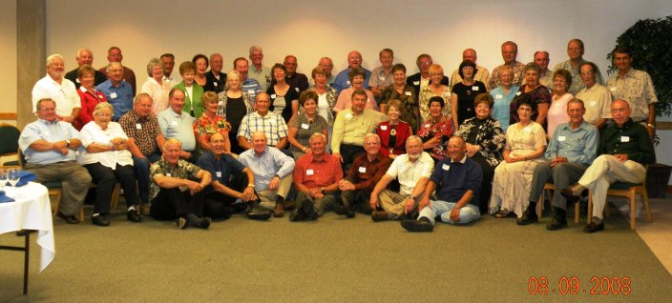

Note: Boyd McAffee and Russ Gines attended reunion but did not get into the picture for some reason.

Sitting on the floor, left to right: Leroy Christensen, Glen Hales, Richard Warnick, Gary Hunter, Elden Armistead, Larry Saling, and Alex Lott

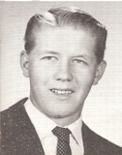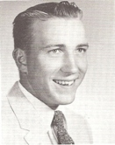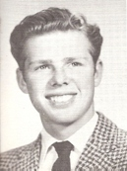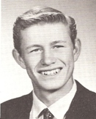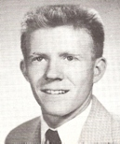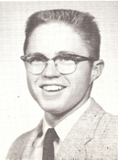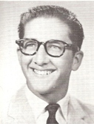
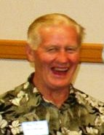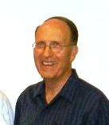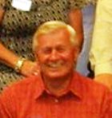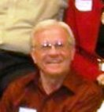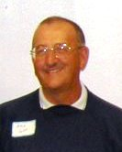

Seated on chairs, left to right (left side): Fred Farley, Carolyn Gates, Delyle Flack, Kay Giles, Karma Jensen, Frank Hansen, and Pat Carling

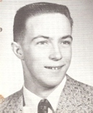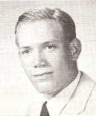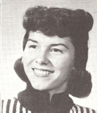
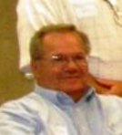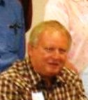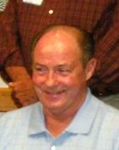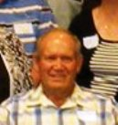

Seated on chairs, left to right (right side): Don Hales, Pat Jolley, Ann Matthews, Karen Belliston, Peggy Kirk, Coach Don Crump, and Coach Ned Alger

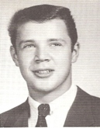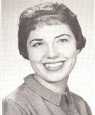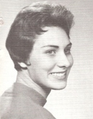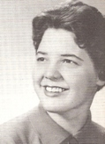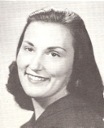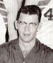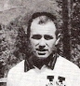
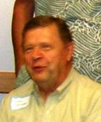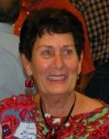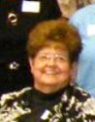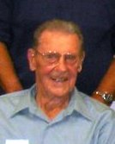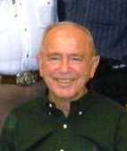

Standing behind chairs, left to right (right side): Toby Bath, Joan Goode, Kay Richens, Marielen Huish, Judy West, and Lynda Sorenson

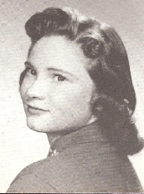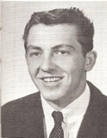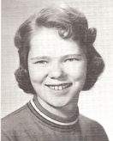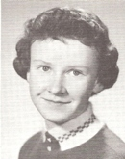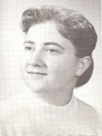
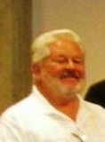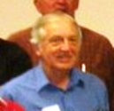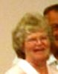

Standing behind chairs, left to right (center): Connie Johnson, Joy Cullimore, Nola Ash, Linda Morrill, and Sheila Draper

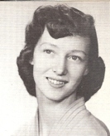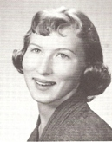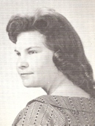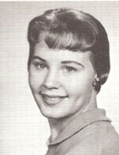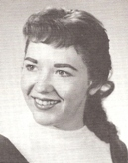
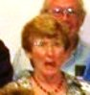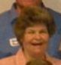

Standing behind chairs, left to right (right side): Bonnie Robertson, Donna Carlson, Myrna Jarman, Myrna Turner, Lloyd Atkinson, and Lew Deveraux

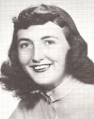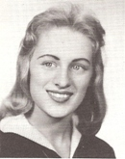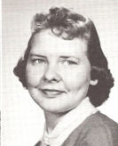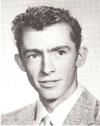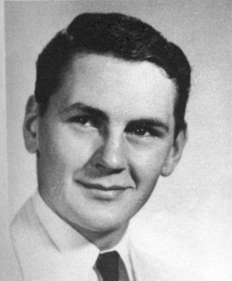
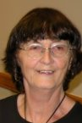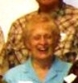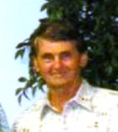
Standing in back row, left to right (left side): Paul Allen, Alan Fugal, Bernell Halliday, Pat Camp, Mac Boyer, Larry Gillman, Don Rawlinson, and Linden Morrill
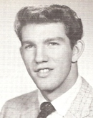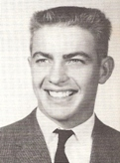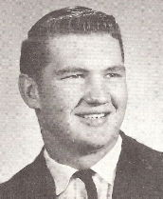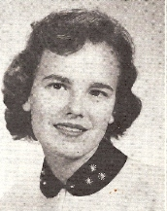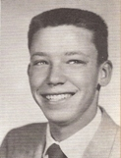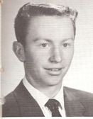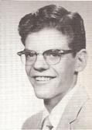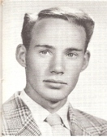
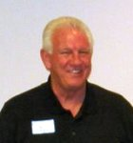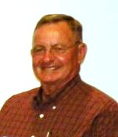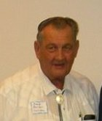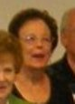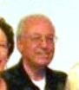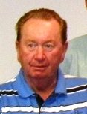
Standing in back row, left to right (right side): Terry Holman, Gene Ash, Elden Davis, Lynn Gilles, Jim Danklef, Alton Hone, Brent Fryer, and Jerry Petersen
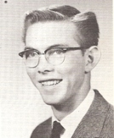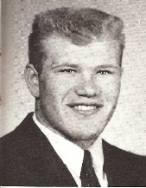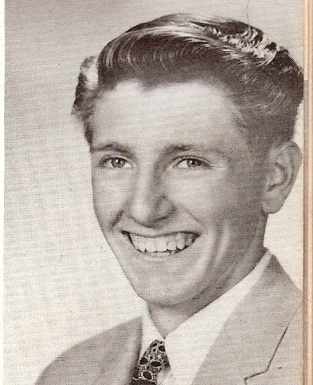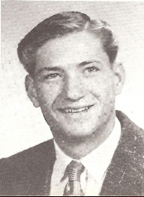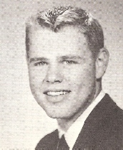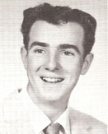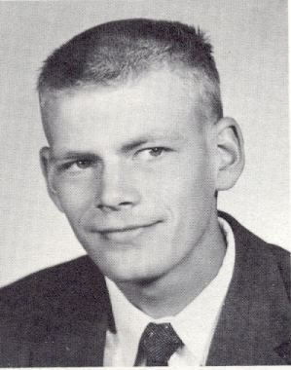
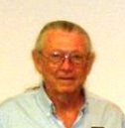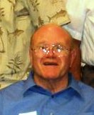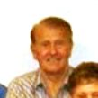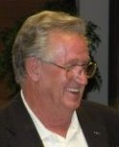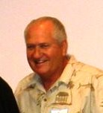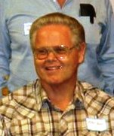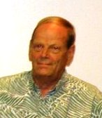
Okay, I have looked at all the pictures and I’m going to pick the five women and five men who have aged the most gracefully or look the most like they did in 1958. No, I didn’t make the list. I have thinning hair, many wrinkles, age spots and have put on about 20 pounds. But I don’t have any bad diseases and can still beat most people in a game of one-on-one basketball.
Women  1. Pat Carling  2. Linda Morrill  3. Myrna Turner  4. Joan Goode  5. Sheila Draper |  | Men  1. Alton Hone  2. Gary Hunter  3. Don Rawlinson  4. Eldon Davis  5. Lew Deveraux
I have been to three High School reunions and the primary thing everybody remembers most about our High School days is “G” Day. Our class was the last to attend the old High School and we did our best to make class of 58 the most famous (notorious) class ever to attend Pleasant Grove High School.
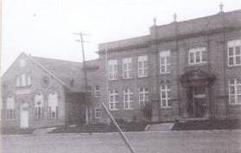 | 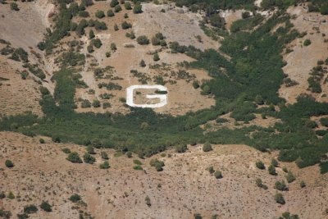

The following is what I remember about “G” Day in 1958. All of the facts may not be a hundred percent accurate but you will get the general idea about what happened.

"G" Day is the day in which the Pleasant Grove High School seniors are supposed to hike up the “G” mountain to fix up and paint the big rock “G” which is visible to the entire valley. “G” Day occurs about a week before graduation and the entire senior class gets out of school that day. Well, when our class got done doing “G” Day, there was no “G” on the mountain, major damage was done to the High School and the town’s softball fields, a couple of seniors got arrested, two had to go to the doctor, and our graduation was in doubt. I guess our class over did it a little bit!
We started drinking beer and whiskey in the morning while we prepared the paint and stuff we needed to carry up to the “G”. Somebody had the bright idea to use our horses to carry things up the mountain. There were about a dozen of us who had horses. So we saddled up and headed for the High School. I guess the booze kicked in about the time we got to the school because we proceeded to ride our horses right into the school and down the main hallway. Since school was in session for everybody else, there was quite a commotion as we charged by all the classrooms and out the other side of the building.
We rode across the town’s softball fields as we headed toward the mountain. By the time we reached the “G, we were all too drunk to do any work so we sit there and drank more beer and whiskey. A fight (more like a brawl) broke out and by the time we got everything under control, the “G” was demolished. Most of us spent the night on the mountain – passed out. By the time the Police arrived the next morning, we were well on our way to re-building and painting the “G”.
The principle and city fathers (the Mayor and City Council) were not too happy about our rampage but they decided not to press charges and the principle decided to let us graduate. All we had to do was repair the damage we caused and promise to behave.
My columns (My Drift) aren’t usually this long but for this special event I added a few extra words and pictures. My email and website addresses are at the bottom of this page. If you are a classmate or a former coach, please feel free to send me your comments on this write up.
I hope you all have good health and a lot of happiness in the future. With any luck at all, we will see everybody again at the next reunion in five years.

Email - bigdrifter44@gmail.com
Website - http:// bigdrifter.com/

