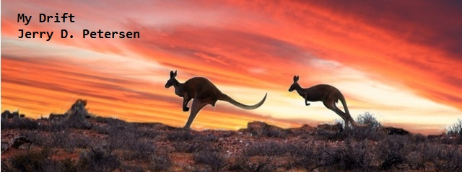

 | The Outback  10 February 2014 | 173-2014-02

I was watching Maria Sharapova playing tennis in the Australian Open the other night and got thinking (again) about Australia and The Outback. Things like:
- Is Australia bigger than the United States?
- How big is The Outback and where is it located?
- Why is the weather so hot in late January?
- Should I put Australia on my travel “Bucket List”?

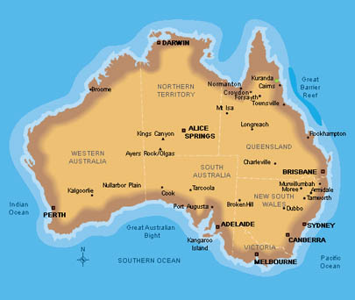
Reference the Map of Australia on the previous page as I present some interesting facts and statistics about the Australian continent, the country, and the outback.

The Australian Continent
- The Australian Continent is comprised of mainland Australia, Tasmania, New Guinea, Seram Island, Timor, and a few other neighboring islands.
- New Zealand is not part of the Continent of Australia.
- It is the smallest of the seven traditional continents:

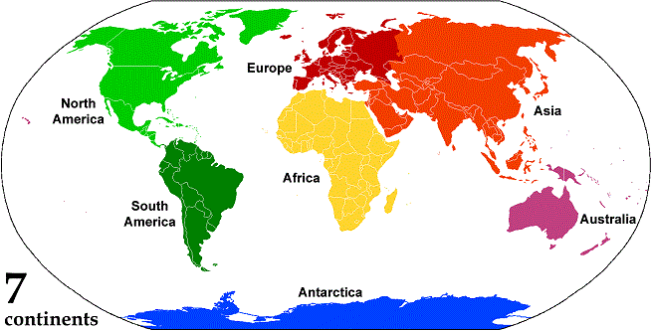

- It is the driest inhabited continent on earth. Its interior has one of the lowest rainfalls in the world and about three-quarters of the land is arid or semi-arid.
- Just in case you were wondering, Hawaii is located in a wider region known as Oceania.

The Country of Australia
- Australia is the sixth largest country after Russia, Canada, China, United States, and Brazil.
- It is a little smaller than the 48 contiguous United States – 2.97 vs 3.12 million square miles. The U.S. is 3.794 million square miles with Alaska and Hawaii.
- Australia is made up of five states and two territories plus the sixth island state of Tasmania to the south of the mainland. In addition, there are six island territories, known as external territories plus the Australian Antarctic Territory.
The states include:
- New South Wales is Australia’s oldest and most populated state. Sydney is the capital.
- Victoria is the smallest in size but the second most populated. Melbourne is the capital.
- Queensland is Australia’s second-largest state in size. The capital is Brisbane.
- South Australia is a state in the south central part of the country which covers some of the most arid parts of the continent. The state capital is Adelaide.
- Western Australia is Australia’s largest state by area. The capital is Perth.
- Tasmania is separated from mainland Australia by the Bass Strait and is the smallest state in Australia. The capital is Hobart.
Mainland territories:
- Australian Capital Territory - Canberra is the national capital and the center of the government.
- The Northern Territory lies at the top end of Australia. Darwin, on the northern coast, is the capital, and Alice Springs is the principal inland town.
- The population of Australia is appropriately 23 million vs 313 million for the United States.
- Australia's population is very much concentrated in and around a few cities on the eastern, southern and south-western coast.
- 97% of the Australian people live near the ocean. The five largest cities are:

City | Territory/State | Population
Sydney  Melbourne  Brisbane  Perth  Adelaide | New South Wales  Victoria  Queensland  Western Australia  South Australia | 4,668,000  4,247,000  2,190,000  1,898,000  1,278,000

The Outback
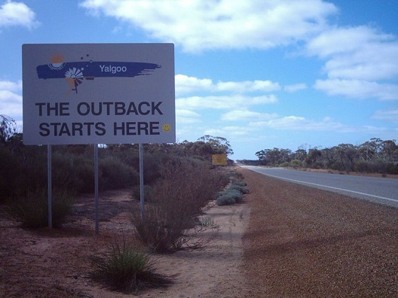

Area and Climate
- The outback covers most of Australia. It neither has a specific size, nor a specific location. Outback is a term that is used for all sparsely populated regions.
- The outback covers about 90% of the total area and has only about 3% of the population. All of inland Australia and most of north and north-west Australia is generally known as outback Australia. The outback is more than 2.5 million square miles in area and covers several climate zones.
- About 70 percent of the outback is dry and composed of two arid zones, one with cold winters in the center and one with mild winters in the north.
- July and August are the coldest months, with freezing temperatures almost every night.
- However, during the rest of the year, days are generally mild or hot throughout the country.
- Northern Australia is mostly outback and has a dry season and a wet season. The dry months are April, May, September and October; the rest of the year is very wet and humid.
- Keep in mind that the seasons in Australia are opposite to the northern hemisphere: its summer is from December to February, and winter is from June to August.

Cities and Towns
- There are no big cities in the outback. The biggest town is the gold mining town of Kalgoorlie with a population of about 30,000. The city is located in the region of Western Australia 370 miles east-northeast of Perth at the end of the Great Eastern Highway. Kalgoorlie has one of the world’s largest (The Super Pit) open-cut gold mines that is approximately 2.2 miles long, 1 mile wide and 1,680 feet deep.

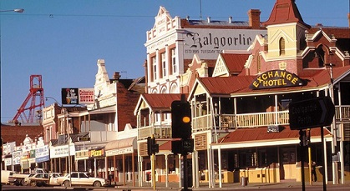 | 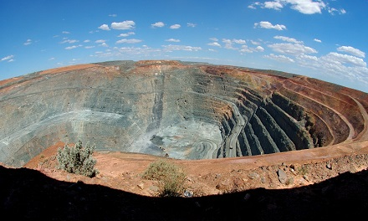

- The most famous outback town is Alice Springs (known as “The Alice”) which is located in the geographic center of Australia in the Northern Territory. The Alice is at least 930 miles from the nearest city which is Darwin. Yes, it is located in the middle of NOWHERE.

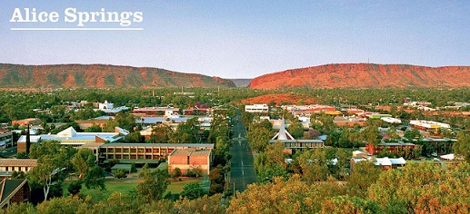 | 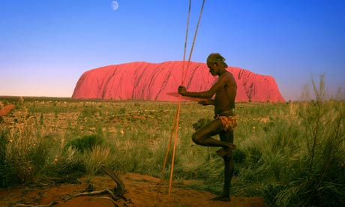

- The original inhabitants, the Aboriginal Arrernte people have lived in the Central Australian desert in and around Alice Springs for thousands of years. Alice Springs lies in the physical and spiritual heart of Australia’s scenic Red Centre. Alice Springs has a population of about 24,000 people.

- The Australian outback pub made famous by the 1980s film Crocodile Dundee is in the Walkabout Creek Hotel, in the small town of McKinlay, in the State of Queensland. | 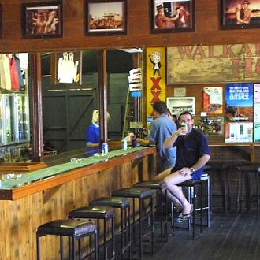
Deserts, Mountains, Lakes and Rivers

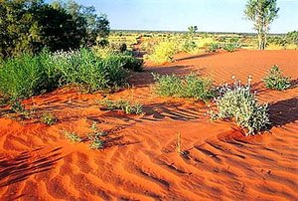  Great Victoria Desert: 164,000 square miles  Great Sandy Desert: 110,000 square miles  Tanami Desert: 71,235 square miles  Simpson Desert: 68,145 square miles  Gibson Desert: 60,230 square miles | - Australian Deserts  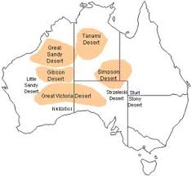

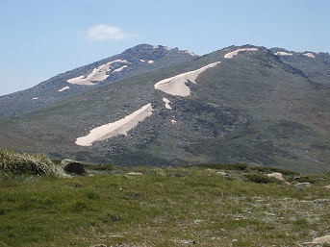 | - Largest Mountains  Mount Kosciuszko (New South Wales - 7,310 feet)  Mount Bogong (Victoria - 6,516 feet)  Bimberi Peak (Capital Territory - 6,273 feet)  Mount Bartle Frere (Queensland - 5,322 feet)  Mount Zeil (Northern Territory - 5,023 feet)  Mount Woodroffe (South Australia - 4,708 feet)  Mount Meharry (Western Australia - 4,111 feet)
- Largest Freshwater and Saltwater Lakes

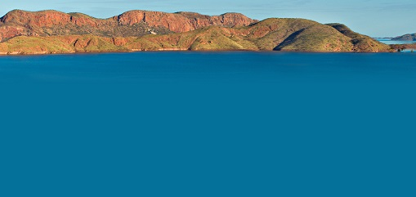 | 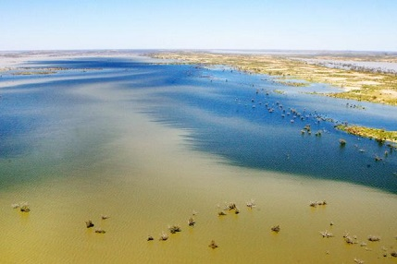
Lake Argyle is Australia’s largest freshwater lake covering an area of about 380 square miles at the full level. It is located near the East Kimberley (Western Australia) town of Kununurra. The primary inflow and outflow is the Ord River. The Ord River Dam was officially opened in 1972 and is 1,100 feet long, and 322 feet high. | Lake Eyre, is the great salt lake of central South Australia, with a total area of 3,700 square miles. On the rare occasions that it fills, it is the largest lake in Australia and the 18th largest in the world. It is also the lowest point in Australia at about 49 feet below sea level.

- Longest Rivers
Australia's longest rivers are:
1. Murray River – 1,476 miles
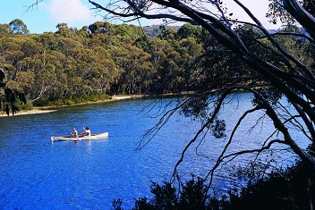  2. Murrumbidgee River – 923 miles  3. Darling River – 915 miles  4. Lachlan River – 900 miles  5. Warrego River – 857 mies | 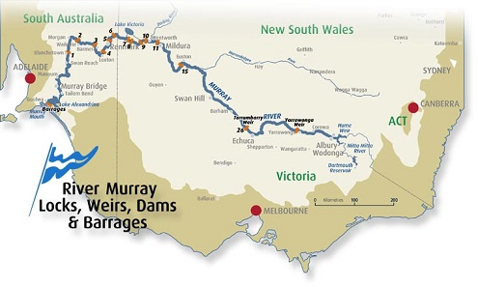

Transportation (Roads, Railroads, and Air Travel)

- Roads
Australia's Highway 1 is a network of highways that circumnavigate the Australian continent, joining all mainland state capitals. At a total length of approximately 9,000 miles, it is the longest national highway in the world, longer than the Trans-Siberian Highway (6,800 miles) and the Trans-Canada Highway (4,990 miles). Every day more than a million people travel on a part of it.

Stuart Highway is one of Australia's few major highways actually in the outback. It is a segment of Australia's Highway 1 extending from Darwin, Northern Territory, via Tennant Creek and Alice Springs, to Port Augusta, South Australia—a distance of 1,760 miles. The principal north-south route through the central interior of mainland Australia, the highway is often referred to simply as "The Track".

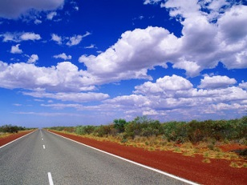 | 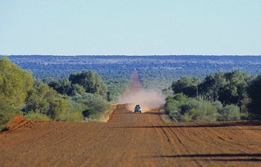
Stuart Highway. There is 226,000 miles of paved highways and roads in Australia – most of it is in the big cities near the ocean. | However, most of the roads in the outback are dirt roads and look more like the picture above. There are 348,000 miles of unpaved roads in Australia.

- Railroads  Railroads in Australia are a crucial aspect of the Australian transport network. There are about 26,000 miles of railroad track in Australia and they seem to follow the major highways to the state capitals and Alice Springs in the outback. The big cities of Sydney, Melbourne, and Brisbane all have electric powered rail for their mass transit systems. | 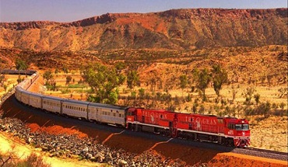

- Airports  There are more than 300 airports with paved runways. The two biggest and busiest international airports are located in Sydney and Melbourne. There are also hundreds of small towns in the outback with unpaved air strips. | 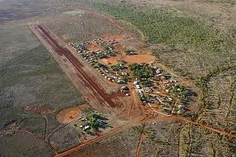
Australia’s Animals

- The many unique animals are one of the many reasons people visit Australia. It has more than 378 mammal species, 828 bird species, 4,000 fish species, 300 species of lizards, 140 snake species, two crocodile species and around 50 types of marine mammal. More than 80 per cent of the plants, mammals, reptiles and frogs are unique to Australia and are found no-where else in the world. Some of the best-known animals are the kangaroo, koala, echidna, dingo, platypus, and wombat.

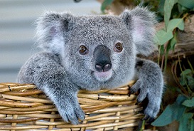 | 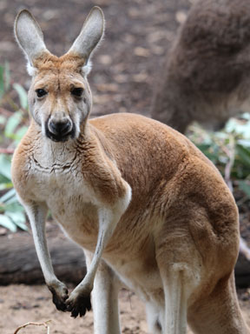 | 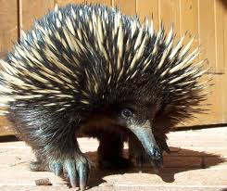
Koala | Kangaroo | Echidna
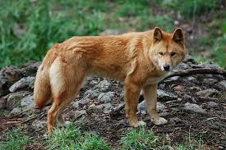 | 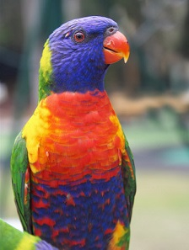 | 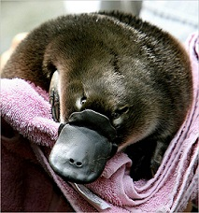
Dingo | Rainbow Lorikeet | Platypus
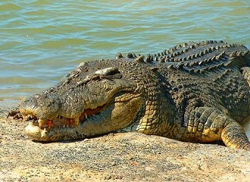 | 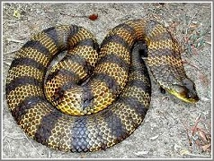 | 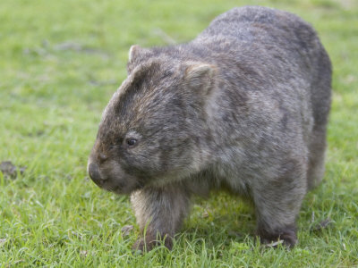
Saltwater Crocodile | Tiger Snake | Wombat

Is the Australian Outback safe?

Well, it depends. If you travel into the outback as part of a tour or with someone who lives there and knows their way around, then yes it is pretty safe. But, if you rent a car and head out into the outback by yourself or even with friends, no it is not safe. Many people die in the outback every year. Here is one newspaper story:

Don't Die in the Outback
Last year, two men in an old Land Rover were stranded in the desert outback of Western Australia when their vehicle broke down. They had only 2 quarts of water with them, no extra fuel beyond what was in their tank, no two-way radio, just a mobile (cell) phone that does not work in the outback, and a dog for company.

They had last been seen at an Aboriginal settlement on the rarely used Talawana Track east of the inland town of Newman. They had been dead at least a week when a passing station hand chanced on their vehicle and the men's (and dog's) bodies near the intersection of the Canning Stock Route.

These men were Australian, and they weren't the first Australians to die in the outback as a result of misadventure.

The stunning interior of Australia is deadly to those who don't know it or those who don't respect it. But, with a little common sense and knowledge, you can survive the outback. So, if you are planning on driving through any part of the Australian outback, here are a few tips:
- Take lots of water with you – at least 4 quarts per person/per day of your trip.
- Don't leave the main roads unless you know exactly where you are going.
- If something does happen, stay with your car.
- Let people know where you are going, and when you are expected to arrive.

If you follow all these tips, you shouldn't have a problem travelling through the outback.

Wrap up
Yes, I would like to visit Australia and yes I would like to venture out into the Great Australian Outback. I’m adding it to my Bucket List. Do you remember the sign that says, “The Outback Starts Here”? Well, I’m going to drive out to that sign and take 3 steps into the outback, then turn-around and return to Sydney where I will find a nice little Pub where I will drink a few cold Australian beers. When I return to Hawaii, I will tell all my friends stories about how I survived the Australian Outback.

I learned a lot of things about Australia and the outback while writing this article but one of the one things I will always remember about the outback is – there is certainly a lot of red dirt, sand, and rocks. Everything is red!! It reminds me of the dirt in Mililani, Hawaii.

bigdrifter44@gmail.com

