My Drift | Jerry D. Petersen | Sights and Sounds of the Night  Sep 25, 2013  (167-2013-17)

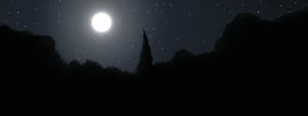

Since our new dog Patti come (from Romania) to live with us, I have been spending a lot more time outside after dark. Patti is not fully trained to not pee on floor so she doesn’t have the run of the house like our other dog Monty. So, I usually stay outside with Patti (and Monty) until it is time to go to bed – about 8:30 or 9:00 o’clock. Patti is doing better and she sleeps in my bedroom – Monty has the rest of the house to find a place to sleep. Yes, I go to bed early since the dogs will be getting me up at 4:30AM. It gets dark now days in Mililani about 7:00PM so I have a couple of hours every night to enjoy the sights and sounds of the night. I actually enjoy the peace and quiet and it gives me a chance to relax and think about the meaning of life and other things. Although many of the things I describe below don’t happen every night, I’m going to talk about a few sights and sounds that occurred in mid to late August 2013.

Our Dogs
Our male Rottweiler Monty really likes our female Rottweiler Patti so they are playing together constantly. Rottweilers don’t exactly play like other dogs. They bite each other (softly), jump on top of each other, and chase each other all over the yard. If you didn’t know better, you would think they were fighting but it’s just their way of having fun. I only have to referee occasionally when they get too carried away and bite hard. Once in a while Patti tries to bite Monty’s private parts which is not nice and makes him a little irritated. They have a couple of dozen toys out in the patio to play with but they find things in the yard like a stick to play tug-a-war with. Whenever anybody walks by our house, both Monty and Patti run to the gate to bark at them. This happens 3 or 4 times a night when a neighbor will be walking their dog or somebody is just out walking. I think I knew this, but I now know for sure that Monty can bark louder than any dog on the block – 20 out of the 35 houses on the loop have at least one dog. Patti girl is probably the second loudest. One good thing is we don’t have many door-to-door salesman coming near our house.

World traveler – Not too many dogs have a “Pet” Passport. Patti has one that contains her name, breed, birth date, weight, color, etc. plus her complete medical record plus the most important piece of information – her microchip number. When she goes through Customs, they scan this embedded microchip and compare it to the one in the passport. The trip to Mililani, Hawaii covered more than 9800 miles. Patti left the breeder’s house just outside of Bucharest, Romania by SUV for a two day road trip of 740 miles through the countries of Hungary and Austria on their way to Munich, Germany. There, she was loaded on an “animals only” transport plane. Yes, Patti was traveling with other dogs and cats plus an assortment of zoo animals on their way from Europe to the United States. The plane ride from Munich to Newark, New Jersey was 4070 miles. Patti went through Customs at Newark International Airport. The next “leg” of the long trip was 2450 miles to Los Angeles where they unloaded the animals going to west coast cities. The flight to Honolulu was 2560 miles and Patti was almost home – just another 10 miles to Mililani. She was in good spirits and very happy to get out of that travel crate where she was greeted by Monty and her new family.

The Birds
As soon as it starts getting dark, all of the birds in the neighborhood head for their nests in the trees where they sleep. I can hear several Doves fly into the shrubs near our house to roost for the night. We have a family of Red Cardinals that sleep in our Orange tree in the back yard. The stupid Mynah birds try to find a place in people’s carports to roost. They are pests since all they do is squawk loudly and mess on the cars. Once it is dark, all the birds stop singing.

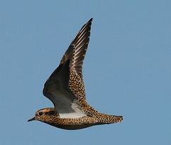 | But, then one night I hear this loud “chu-eet” – “chu-eet” sound in the sky and I know that the Pacific Golden Plover that calls our neighborhood home is back from his summer in Alaska. He makes a lot of noise so that everybody knows he is back in town. This particular bird spends a big part of his day standing on the top of our house. When my wife or I are out in the yard we will talk to the bird (my wife calls him “pretty boy” and he will stand there bobbing his head and looking very handsome). We are quite sure that our Golden
Plover is a male because in the bird world, the males are usually much prettier than the females. When the Plovers are not standing on somebody’s roof, they fly down to a North Shore beach or to some grassy field to look for food. After flying non-stop for over 3,000 miles from Western Alaska to Hawaii, these birds are skinny and very hungry.

One of the primary reasons we like the Plover on our roof is when he is up there, no other birds are allowed. The Plover is bigger and tougher and will chase away all those loud squawking Mynah birds that like to hang around our place. The Hawaiian word for the Pacific Golden Plover is Kolea. Most Hawaii people call them the Kolea Bird but I just call them Plovers. It is estimated that approximately 15,000 of these birds migrate to the Hawaiian Islands every year in late August and they can be found all over the island of Oahu. After vacationing in Hawaii during the Alaska cold and snowy months, the Plover flies back to Alaska in May for its breeding season (June and July). There are 4 or 5 Plovers that hang out in the park by our house and call our neighborhood home.

Interesting fact – Did you know that Plovers can fly up to 100 miles per hour (depending on the wind) and at altitudes up to 15,000 feet?

The Geckos
We seem to have a lot of Geckos in our yard this year. Our new dog Patti spends much of her time chasing them. I’m not sure she would know what to do with it if she ever catches one. Most of these Geckos are greenish gray and I understand that these are day-time Geckos. But we have at least two night-time white or albino Geckos that I watch every night. They hangout near or behind the porch light by the front door. These lizards are quick! They run around on the wall at lightning fast speeds. They survive by waiting patiently for a flying bug (like a termite) to come near the light. Once the bug lands on the light or the wall, these lizards have a meal. They catch a high percentage of the bugs or insects that come near them. Even Patti has given up catching these albino Gecko lizards.

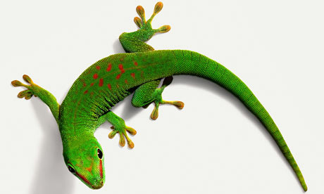 | 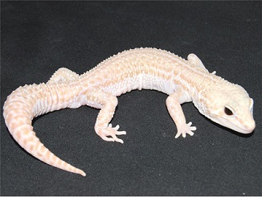

Quiz Time – How can Gecko lizards walk on walls and across a ceiling upside-down? They can do this thanks to invisible hairs on the soles of their feet. The foot of a gecko is covered with about a billion tiny hairs called spatulae. Each spatulae is some 200 nanometers in length and width. Much smaller than a human hair which is roughly 100,000 nanometers wide. These spatulae use what is called “van der Waals” force to allow the gecko’s feet to adhere to almost anything. Named after Hohannes Diderik van der Waals, this is the combined force of atoms and molecules that polarize and adheres to all nearby particles.

Traffic Noise
Our house is located on Alaalaa Loop that has 35 houses on it. On our side of the loop there are only four houses further away from the main road so we have little or no traffic in front of our house. Mostly only residents and visitors and a few lost motorists use our road so we only average about three cars going by every two hours. For some reason, I can’t hear any of the traffic on the main road above our loop which is only about a block away. But, I can hear the traffic on Kamehameha (Kam) Highway which is about a half mile away. There are only two roads in and out of Mililani – The H2 Freeway (which is on the other side of town) and Kam Highway. Both of these roads are very busy 24 hours a day. When I’m in the house, I can’t hear any traffic noise except when a fire engine, ambulance, or police car go down Kam Highway with the siren blasting. In the Mililani Town map below you can find Kam Highway, Alaalaa Loop, and the Golf Course a little to the left of the red star (in the middle) of the map. The red highway in the upper right hand corner is the H2 Freeway.

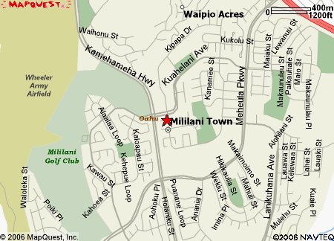 | 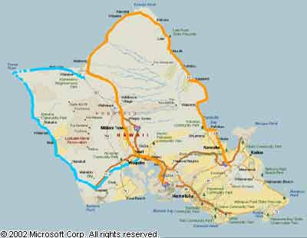
Mililani Town | Kamehameha and Farrington Highways

Kamehameha Highway Facts - Oahu's Kam Highway (marked in orange above) and Farrington Highway (marked in blue) are two surface routes that loop around the island. The Kamehameha Highway is named for the first monarch reigning over all the Hawaiian Islands, King Kamehameha I ("the Great"). It begins near Kailua on Oahu's windward (east) coast, heading north as state route 83. A few miles to the north, it passes through downtown Kaneohe and continues all the way around the north shore of Oahu to Haleiwa. There, Kam Highway changes to an unnumbered county road passing through downtown Haleiwa and then becomes State route 99 at Weed Circle. From there, the highway proceeds south through the pineapple fields and the central Oahu cities of Wahiawa and Mililani. It continues south until it reaches the Interstate H1/H2 interchange on the Leeward side of Oahu. It then goes southeast through Pearl City and Aiea (by Aloha Stadium and Pearl Harbor) until it reaches the H1 Freeway again. It then runs concurrent with Nimitz Highway for about three miles under the Airport Viaduct. At the other end of the viaduct, Kam Highway peels away from Nimitz Highway as State route 7401, but only for about 500 feet until it turns into Dillingham Boulevard for the rest of the way into downtown Honolulu. All of these segments together span a little more than 70 miles making Kamehameha Highway the longest road on Oahu.

Mililani High School “John Kauinana” Stadium
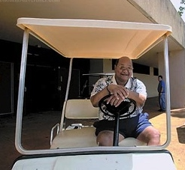 | The football stadium was named after “Big John” Kauinana who was Mililani High School’s first athletic director and head football coach starting in 1973 when the school first opened its doors. He stayed until his retirement in 2002. Kauinana's impact as a coach and mentor lasted throughout his years, even after retirement. "He was a difference-maker, regardless of whether he knew it. He was very, very humble," "He put so much into the school. He left a legacy." He was instrumental in building the Trojans' athletic program. Working with community resources, he was able
to develop the athletics infrastructure, such as the gymnasium and baseball and softball fields. Kauinana was a standout football player at Kaimuki High, where he graduated in 1964. He was a Honolulu Advertiser Interscholastic League of Honolulu all-star offensive line tackle in 1963 and a second-team selection as a junior in 1962. He continued his education at Boise State University in Idaho before returning to Hawaii. Big John died on 5 June 2011 at age 64.

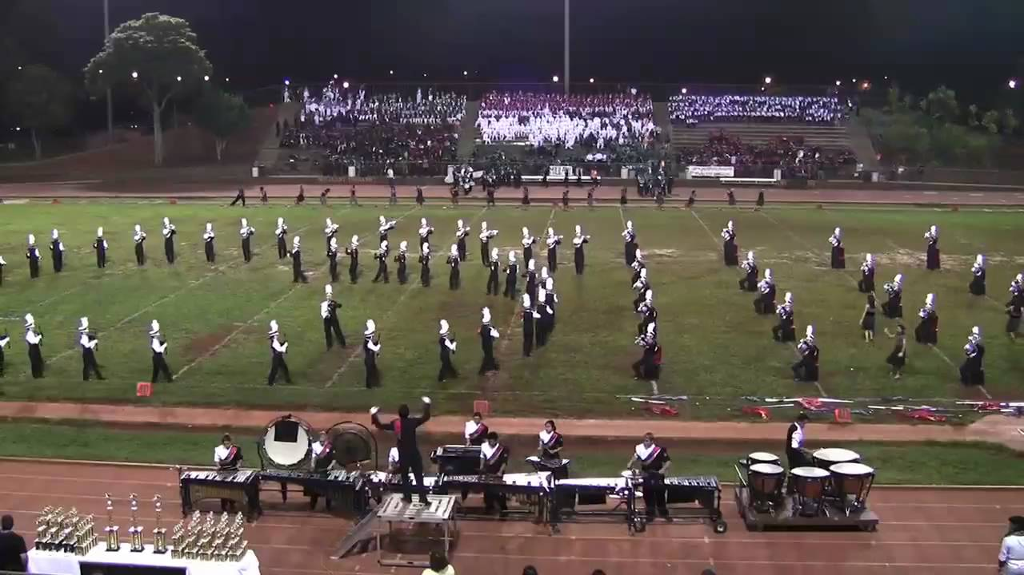
Mililani High School Band

Late August is a great time of the year. High school football is just getting started with college and pro football not too far behind. Mililani High School “John Kauinana” Stadium is just on the other side of Kam Highway about a half mile from our house. When there is a game, I know when Mililani scores a touchdown from the crowd cheering and from the game announcer shouting “TOUCHDOWN, MILILANI” into the loud speaker systems. Mililani played one home pre-season game in late August against the #1 team in the state – Punahou High School. This game was on TV so I watched it on the patio TV with the dogs. I did learn something - I could hear the loud cheers and the announcer shouting “TOUCHDOWN, MILILANI” before they actually scored the touchdown on TV. I learned that “live TV” on Oceanic Cable is 2 or 3 seconds delayed. I guess it take that long for the electrons to travel from the stadium cameras through the cable to my TV set.

The football games are good but the sounds I hear the most coming from the stadium are the Mililani High School Band playing. They practice a lot! Mililani has one of the biggest and best bands in the state. When I go to the games, I noticed that the band takes up a whole section of the stands and they always provide great half time entertainment. Every year Mililani’s band gets invited to perform at one of the mainland’s major parades like the Macy's Thanksgiving Day Parade or the New Year’s Day Rose Bowl Parade. Like it does for the football team, all that practice pays off for the band.

Mililani Hongwanji Okinawan Bon Dance
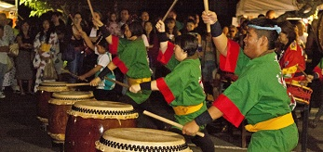 | Once a year in mid-August, the Mililani Hongwanji Buddhist Temple hosts a two night Okinawan Bon Dance Festival. If you have never tasted Okinawan food or listened to Okinawan music, you may want to attend one of these Bon Dances some time. They serve all kinds of Okinawa food and the Okinawan “Dango” Donut is an Obon Festival favorite. I even like them!  Here is this year’s (2013) schedule:  August 16 and 17, Friday and Saturday  6:00 p.m. Food Booths Open  6:30 p.m. Craft Fair Opens  6:45 p.m. Lantern Parade Begins  6:55 p.m. Opening Ceremony  7:00 p.m.  The Bon Dance  10:30 p.m.
The Mililani Hongwanji Buddhist Temple is about 200 yards (as the bird flies) from our house. At the end of our street loop there is a 30 yard path leading to one of the many parks in Mililani. On the other side of the park is the Hongwanji Temple which also serves as a school for Buddhist children. During the Bon Dance they really make a lot of noise pounding on the drums, singing, chanting, and dancing. You have probably never heard anything like this in your life – it is a different kind of oriental music. Regardless, it sure sounds like everyone there is having a great time.

A Quick Lesson on Buddhism:
I have done some research on the Buddha Religion and found out that they have a lot of good ideas. Buddhism has 380 million members which is about 6% of the world population. Most members are found in Thailand, Cambodia, China, and Japan. Buddhism is a religion, a practical philosophy, and a psychology focusing on the teachings of the Gautama Buddha who lived from the mid-6th to the early 5th century BC. A Buddha is generally considered to be a person who discovers the true nature of reality through years of spiritual cultivation, investigation of religious practices, and meditation. Any person who has become “awakened” from the “sleep of ignorance” by realizing the true nature of reality is called a Buddha.

The Moon and the Stars
When I was a kid growing up in Pleasant Grove, Utah, once in a while I would sleep outside (in my sleeping bag) on the front lawn. I remember looking up at the sky watching the falling stars and trying to find the little and big dipper, etc. I also watched the moon and wondered if “man” would ever set foot on it. This was 60 years ago, long before anyone went into space or actually walked on the moon. Well, during this 60 year period, I can’t remember even once sitting outside in the dark by myself looking up at the sky. But recently, I have started looking at the sky again. My most comfortable outside chair is the one by the pool and that is where I spend an hour or two every night now days. There is one bright star that shows in the sky 15 or 20 minutes before any other stars are visible. Even after it is very dark and all stars are visible, it remains by far the brightest. It is located in the northwest sky and I thought it must be the North Star. But after doing a little research on Google, I found out that I was wrong and this star is called Sirius.

Yes, the brightest star in the sky is called Sirius and is also known as the "Dog Star", reflecting its prominence in its constellation, Canis Major (Greater Dog). The first rising of Sirius marked the flooding of the Nile in Ancient Egypt and the "dog days" of summer for the ancient Greeks, while to the Polynesians it marked the coming of winter and was an important star for navigation around the Pacific Ocean.

What can you remember about American space exploration to the moon? While sitting in my chair by the pool, I looked up at the moon and tried to remember those days and asked myself the following questions:
- What president was mostly responsible for putting Americans in space?
- What is the name of the first space program?
- What is the name of the space program that first reached the moon?
- What year was that?
- Who was the first person to walk on the moon? Who was the second?
- How many times did American spacecrafts land on the moon?
- How many men have walked on the moon?
- When did the Lunar Rover go to the moon? Who got to drive it on the moon?
- What year was the last time anybody walked on the moon? Who was that?
- What was the mission that failed to reach the moon and the Commander said, “Houston – we have a problem!” They made a movie about this adventure.

I failed the test – 50% right - I got 1, 3, 4, 5 and 10 right. I remember the first trip to the moon quite well but not much after that. If you got seven or more answers right, your memory is holding up better than mine and you passed the moon test. If you flunked the test like me, the following few paragraphs will refresh your memory.

The Apollo program was first conceived during the Presidency of Dwight D. Eisenhower as a three-man spacecraft to follow the one-man Project Mercury which put the first Americans in space. President John F. Kennedy stated on May 25, 1961 that our national goal was to "land a man on the Moon and return him safely to the Earth" by the end of the 1960s. Project Mercury was followed by the two-man Project Gemini (1962–66). The first manned flight of Apollo was in 1968 and this program later succeeded in landing the first humans on Earth's Moon from 1969 through 1972.

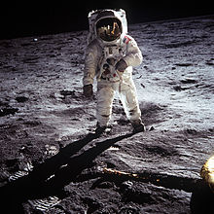  Apollo 11 – Buzz Aldrin  (2nd man to walk on the moon) | Kennedy's goal was accomplished on the Apollo 11 mission when astronauts Neil Armstrong and Buzz Aldrin landed their Lunar Module on the Moon on July 20, 1969, and walked on its surface while Michael Collins remained in lunar orbit in the command spacecraft, and all three landed safely on Earth on July 24. Five of the six subsequent Apollo missions also landed astronauts on the Moon, the last in December 1972. In these six spaceflights, 12 American men walked on the Moon. Apollo 13 had an oxygen tank explosion in transit to the Moon and had to abort but it returned to earth safely. The 1995 Apollo 13 movie stared Tom Hanks.

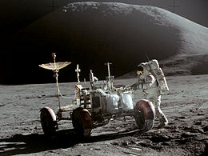  The Lunar Rover with Astronaut James Irwin | List of Astronauts to Walk on the Moon  Order Name Mission Date(s)  01. Neil Armstrong Apollo 11 July 21, 1969  02. Buzz Aldrin Apollo 11 July 21, 1969  03. Pete Conrad Apollo 12 November 19–20, 1969  04. Alan Bean Apollo 12 November 19–20, 1969  05. Alan Shepard Apollo 14 February 5–6, 1971  06. Edgar Mitchell Apollo 14 February 5–6, 1971  07. David Scott Apollo 15 July 31 – August 2, 1971  08. James Irwin Apollo 15 July 31 – August 2, 1971  09. John W. Young Apollo 16 April 21–23, 1972  10. Charles Duke Apollo 16 April 21–23, 1972  11. Eugene Cernan Apollo 17 December 11–14, 1972  12. Harrison Schmitt Apollo 17 December 14, 1972

The first Lunar Rover went to the moon with Apollo 15. Two more Lunar Rovers went up to the moon with Apollo 16 and 17. The last six astronauts to walk on the moon also got to drive around in one of the Lunar Rover known better as the “Moon Buggy”. These battery-powered four-wheeled drive vehicles are still up there on the moon - just in case you were wondering.

I have one more question. What is wrong with our country’s leaders? We should have been to Mars by now! It has been 41 years since the United States last landed on the moon. In my humble opinion, there has only been two great presidents (in my lifetime) who were visionaries and had the foresight and the guts to accomplish great things. They were John F. Kennedy and Ronald Reagan. These two men were also respected and well liked around the world. The current Obama administration can’t agree on anything and has pretty much killed whatever was left of a once great American Space Program.

Airplanes and Helicopters
Every night there are 2 or 3 small single engine airplanes that fly around in the sky above Mililani Town. I hear the plane engine noise first and then I look up in the sky to find the plane. It is not too difficult since they all have flashing lights on their wing tips. What really intrigues me is the number of helicopters that fly by every night.

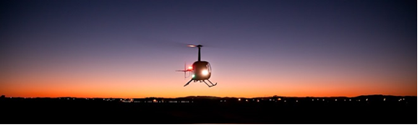

From my chair by the pool, I can hear and see at least a dozen helicopters fly by in the same location on the north side of town. They come by in a line about two minutes apart from the east (Honolulu direction) heading west probably to Wheeler Army Air Field. My theory is - all of these aircrafts are military helicopters bringing the Generals back to their quarters on Schofield Barracks.

I have learned a few things about Generals in my 49 years of working for the government. I learned that once you make it to the rank of General, you have it made for life. You get the biggest and nicest house on post (for free) that comes with a staff to take care of all maintenance, you get a government sedan with a driver (usually an Army Captain), and you get your own personal government helicopter with a pilot to fly you around to your various important events. I have learned that Generals make the most money and spend the least. In these times of severe budget cuts where Federal Government civilians are taking a 20% pay cut, do you think these General would give up their helicopters? Are you crazy? Do you expect a General to sit in traffic for an hour getting to Schofield from Fort Shafter when they can fly there by helicopter in 10 minutes? The sedan driver has to leave Fort Shafter early to drive (and sit in traffic) to Wheeler so that when the General arrives, he or she can drive the General to the club or their quarters. I have learned that Generals just like the President, our Senators, and our Congressman, never ever give up anything.

Unidentified Flying Objects (UFOs)

On Tuesday, 27 Aug 2013, at about 8PM, me and the dogs were outside in the front by the pool when all of a sudden I saw these two things flying in the east sky over Mililani. They were both the same color – green and red lights on the ends with a yellowish white color in the middle. They could move in any direction at a very high rate of speed - like go across the sky in 2 or 3 seconds. They moved fast or slow and could stop suddenly and then go again. They made no noise that I could hear. The shape of both UFOs was the same and appeared to be oblong but could have been circular. They were in the sky for at least 20 minutes. I had never seen anything like this in my life, so I run in the house to get my camera (a Sony Sure Shot) and told my wife to come out and see the UFOs. My wife called a couple of the neighbor ladies to come outside and take a look. I attempted to take some pictures and even put my camera in movie mode for a while. But it was really dark that night and my camera is not designed for these kind of pictures so they didn’t turn out very good. You could see the UFOs much better with the naked eye. About the time I put the camera away and was about to bring the dogs in for the night, I hear Monty barking like crazy. I look up and there is one of the UFOs hovering right over our house. The aliens from space must have wanted to get a better look at that creature down there on the ground barking at them. I thought for a second or two that maybe we were going to be "beamed" up to the spaceship. But then it zipped off into space and both UFOs disappeared.

One of the pictures I took is on the left.

I put the movie video I took on You Tube – You can take a look at the following URL:

http://www.youtube.com/watch?v=JLipib3pBC4

Okay, I know that most people don’t believe in Flying Saucers and Aliens from outer space. Since I sent out my email describing this UFO event to all my friends, I have heard back with the following possible explanations:

Japanese Sky Lanterns | It must have been Remote Controlled Airplanes.  It must have been Laser Beams.  It must have been Japanese Sky Lanterns.  It must have been two Drones sent by Obama to spy on me. (I like this one)

But, I’m sticking with my Flying Saucer and Aliens from Outer Space Theory.

I have done some research on Google to find out if anybody else has seen these “Green” and “Red” UFOs. As it turns out, another lady reported seeing a green and red “Christmas Tree Star” shaped UFO in the Mililani sky on Saturday, 29 Jun 2013. She said, “It was moving from one end of the town to the other. Stopping over certain areas then moving back across the sky then stop again for about 5 seconds. It kept repeating the cycle till I got afraid as it got closer and I went in the house!” Actually, there are many reports of seeing a Green and Red UFO world-wide. There is a better picture the UFO on the next page:

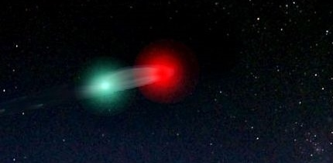

So, anyway, as you can tell by now, my life has pretty much gone to the dogs. I don’t have anything better to do at night then standing around outside looking for Flying Saucers. Next time that thing hovers over my house, I’m going to wave my arms like crazy to see if they can beam me up. Maybe those Aliens from outer space are medically advanced enough to reverse the aging process and make me young. If I was 30 again, I think I could find better things to do at night.

bigdrifter44@gmail.com

http://bigdrifter.com/

