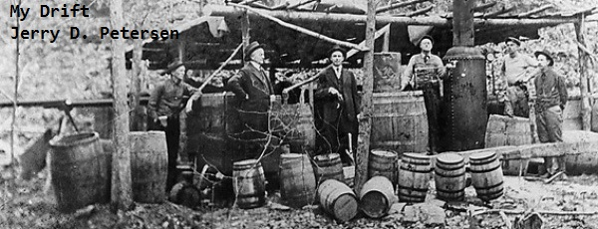

 | Moonshine  1 January 2014 | 172-2014-01

The other day, one of my co-workers at DS Information Systems was talking about watching the hit TV show “The Moonshiners” on the Discovery Channel. He stated that “Popcorn” Sutton was one of his biggest heroes and sent me a video staring this famous moonshiner. You might want to google “Popcorn Sutton” after reading this article to learn more about this interesting character and to watch this old moonshiner in action. Well, I have never heard of him so I watched the video and decided to learn more about good ole Popcorn and the moonshining business.

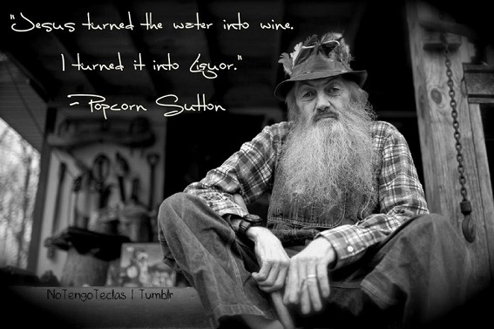

Marvin "Popcorn" Sutton was an American Appalachian moonshiner originally from Maggie Valley, North Carolina. He wrote a self-published autobiographical guide to moonshine production, and self-produced a home video depicting his moonshining activities, and he was later the subject of a documentary that won a Regional Emmy Award. He committed suicide by carbon monoxide poisoning in 2009 rather than report to Federal prison after being convicted of offenses related to his moonshine production.

He was a short, skinny fella, who always wore his hat—that was kind of his claim to fame, his hat that he always wore. And his bib overalls—he always wore bib overalls. Even when he came to federal court, he was wearing his hat and bib overalls. He was a friendly fellow, and of course every time you would talk to him, he would say, ‘I’ve run my last run of moonshine, I'm not gonna do it anymore, I'm just getting too old to be doing this stuff.' According to several of his friends, Sutton was given the nickname of "Popcorn" after damaging a bar's faulty popcorn vending machine with a pool cue.

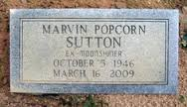 | 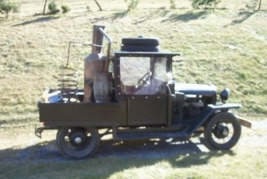

Popcorn’s Tombstone | Popcorn’s vehicle with a still on the back

The following obituary article was written by Stephen Miller and appeared in several newspapers including The Wall Street Journal:

“Legendary Tennessee Moonshiner applied His Trade to the End”

A scrawny, long-bearded mountain man with a foul mouth and a passing acquaintance with copper tubing and kettles, Marvin “Popcorn” Sutton seemed the embodiment of moonshiners of yore.

Brought up in rural Cocke County, Tenn., identified as one of four “moonshine capitals of the world” in the corn-whiskey history “Mountain Spirits,” Mr. Sutton learned the family trade from his father. The practice goes back to the Scots-Irish, who brought it to the New World, and it wasn’t illegal until after the Civil War, says Dan Pierce, chairman of the history department at the University of North Carolina at Asheville. “This is something that legitimately is an expression of the culture of this region,” Mr. Pierce says.

Like his forebears, Mr. Sutton had brushes with the law, and was first convicted of selling untaxed liquor in the early 1970s. He mostly kept out of trouble after that, though friends say his nickname came from an unfortunate encounter with a balky barroom popcorn machine. But he was well known as a distiller around his native Parrottsville.

He was a familiar figure at the Misty Mountain Ranch Bed & Breakfast in nearby Maggie Valley, N.C., wearing faded overalls and with a back stooped, he said, from decades of humping bags of sugar into the hills. He picked the banjo and serenaded guests on the inn’s porch. He helped decorate the $155-a-night Moonshiner suite at the inn with some still hardware.

Mr. Sutton put a modern spin on his vocation, appearing in documentaries and even penning an autobiography, “Me and My Likker.” Souvenir shops in Maggie Valley sold his video, “The Last Run of Likker I’ll Ever Make,” and even clocks with his image on them.

Other moonshiners have gone legit and cashed in; a former NASCAR driver and moonshiner now offers Junior Johnson’s Midnight Moon in Southern liquor stores. But Mr. Sutton insisted on earning a living the old-fashioned way, and in 2007, agents from the Bureau of Alcohol, Tobacco, Firearms and Explosives busted him with 850 gallons of moonshine, stored in an old school bus on his property.

He was convicted in 2008 and was due to report to prison Friday, his widow, Pam Sutton, told the Associated Press. Instead, facing the verdict and ill health, he was found dead by Ms. Sutton at the age of 62 on Monday, and authorities suspect carbon-monoxide poisoning, according to the AP. The Cocke County district attorney’s office said it is investigating the death.

Although Tennessee was once a hotbed of moonshine and federal “revenuers” pursued bootleggers through the hills, an attorney for the Eastern District of Tennessee in Greeneville says he couldn’t remember the last federal prosecution of a moonshiner.

“Modern-day moonshining is the manufacture of methamphetamine,” First Assistant U.S. Attorney Gregg L. Sullivan says. “Tennessee is in the top five states nationally.”

Ms. Sutton discovered her husband in his green Ford Fairlane. “He called it his three-jug car,” she told the AP, “because he gave three jugs of liquor for it.”

What is Moonshine?
Moonshine is any kind of alcohol usually whisky or rum that is made in secret to avoid high taxes or where there is an outright ban on alcoholic drinks. The term "moonshine" comes from Britain, where it originally was a verb, "moonshining," that referred to any job or activity that was done late at night. Because the operators of illegal whisky stills had to conduct their business out of the sight of legal authorities, these backwoods brew masters became known as moonshiners, and the term became exclusively theirs.

Moonshiners are the people who actually make the alcohol. Bootleggers are the smugglers who transport it and sell it. In colonial times, these distributors would conceal their product inside their tall riding boots, which is how they got their name. More recently, bootleggers in the 1930s, '40s and '50s took to racing cars packed with moonshine through the night to avoid local police. Their mechanical skills developed as they learned to drastically increase the horsepower of their vehicles to outrun the authorities. This created a culture of car lovers in the southern United States that eventually grew into the popular NASCAR racing series. In fact, the winner of the first ever NASCAR race had used the same car to make a bootleg run just a week earlier.

Brief History of Moonshine
The governmental taxing of whiskey and illegal distilling is not a new thing. The Whisky Rebellion of 1791 was a result of the Congress under President George Washington laying a tax on alcohol. Most of the distillers of the time were farmers who lived in remote areas where it was difficult to get their grain to market. Their excess grain was distilled. The “Whiskey Boys” of Pennsylvania, Virginia, North Carolina and South Carolina protested the tax, sometimes violently. Tennessee and Kentucky, not yet in existence, offered safe haven for distillers or they too would have been a part of the protests.

The violence turned to armed rebellion in 1794. One tax collector had his head shaved, his horse stolen and was then tarred and feathered. Washington responded with a sizable militia ordered into the countryside to arrest and detain the rabble-rousers. The suppression of the rebellion proved unpopular and became a detriment to the Federalist Party. The whisky tax was repealed in 1803.

The Civil War found a new whisky tax instituted to fund the Federal Government. The extremely high taxes were as much as eight times the cost of the liquor itself. Small distillers began hiding in the backwoods in order to avoid the taxes. The Revenue Bureau of the Treasury Department transformed their “collectors” into a policing authority. The Moonshiners and Revenuers were born.

Prohibition
For some reason I always thought Moonshiners came into being during prohibition when you could not buy any booze. But, this craft has always been around and is still going strong today.

In 1919, the 18th Amendment to the U.S. Constitution, which prohibited the sale and manufacture of alcohol, was ratified. It went into effect on January 16, 1920. After several years, prohibition became a failure in North America and elsewhere, as bootlegging became widespread and organized crime took control of the distribution of alcohol. Distilleries and breweries in Canada, Mexico and the Caribbean flourished as their products were either consumed by visiting Americans or illegally exported to the United States. Chicago became notorious as a haven for prohibition dodgers during the time known as the Roaring Twenties. Prohibition generally came to an end in the late 1920s or early 1930s in most of North America and Europe, although a few locations continued prohibition for many more years.

I’m glad I wasn’t around during prohibition and the Great Depression that started in 1929 and ended about the time World War II started in 1939. This was a very sad and unhappy period in U.S. history.

Alcohol
Let’s learn a little bit about alcohol itself.

Man has been using alcohol to get high since before the beginning of history. The first histories were written about 4 thousand years ago on clay tablets, and the intentional use of alcohol predates that by another 2 thousand years. The problem was that at this time, they really didn’t know how to make alcohol. They would leave fruits and berries in a covered container for a few months and sometimes when they opened it they would have a mash with a little bit of alcohol in it and sometimes it would be a rotten goo. It was pretty much hit or miss at this point, but none the less early man still tried to produce it.

After a couple of thousand years of experimentation we discovered better and better ways to make alcohol. Eventually this culminated in the production of wines. The first wines were actually not made from grapes, but from vegetables. Sugar beets and carrots were used as they both contain a lot of sugar, and sugar is needed to make alcohol. Eventually someone tried grapes and a whole new lifestyle was born. Grape juice is mostly sugar, water, and nitrogen and nothing ferments as well.

So what exactly is fermentation?
Fermentation is the process for microorganisms called yeast consuming sugar and giving off carbon dioxide and alcohol. Yeasts exist wild in the air in every part of the planet, including Antarctica. Yeasts are everywhere. There are tens of thousands of different varieties, each imparting their own flavor to a fermentation. Some flavors are good and highly cherished, while some are pretty terrible. Others produce high alcohol contents of up to 20%, some die off around 4%. Some produce pure ethanol, others produce things that are more harmful. There is a lot to worry about with yeast, which is why it’s so nice that we produce it commercially now. Commercially produced yeast is much safer to use for fermentation than wild yeast because you are assured to get the variety that you want.

You can use regular bread yeast to make alcohol. Really! You can do it yourself in the comfort of your own home. Just add some sugar to a gallon of grape juice, add some bread yeast and leave the cap half screwed on to allow some gasses to escape and in about two weeks you will have wine. It won’t be very good, but it will technically be wine. If you want to spend a few dollars on some wine yeast at the store or on the internet, you can get a much better drinkable product.

Nothing about this is illegal by the way. In fact, if you go to a brewing supply store, they will encourage you to do this yourself. It is perfectly legal to make wine in your home since the end of prohibition, and it has been legal to make beer since 1976. It’s actually pretty fun and it’s cheap. You can get all the materials and supplies you need to do this for about $20. Of course the wine and beer you make will probably turn out tasting pretty bad. I can remember when my dad decided to make his own beer. Well, I was just a kid but I decided to try some of it when my parents were not home – it was not good.

So, why is moonshine illegal if you can legally make wine and beer in your home?
The answer comes from the 20% yeast barrier. Yeast gives off alcohol as a byproduct of their life cycle. They eat sugar and give off alcohol and then reproduce. But just like if you were living in a vat of your own byproducts, it eventually gets toxic. Most yeast tap out around 14% alcohol. That’s why most wines contain 14% alcohol. However there are a few super yeasts out there that can ferment to 20% alcohol. The yeast used to produce beer ends up with a much smaller percentage of alcohol usually between 3.2% and 6%. Still, this is a long way off from the 40% (80 proof) that most hard alcohols are produced to, and still further away from things like 75% (150 proof) Puerto Rican rum and 95% (190 proof) Everclear alcohol. So, any alcoholic beverage over 20% alcohol that require distillation are considered illegal to make yourself. I guess the government realized that it would be impossible to enforce a tax on wine and beer made in the privacy of millions of homes in the U.S.

Distillation
The way whiskey and other liquors are made is to distill them. Distillation is the process of evaporating a liquid to concentrate certain properties of that liquid. Here is where the real hard core science kicks in. Water and ethanol (the good alcohol) are 100% miscible. That means that they can be dissolved in any quantity of the other one. Because of that, it’s impossible to separate them conventionally. However, water and alcohol have different boiling points. Water boils at 212 degrees Fahrenheit and ethanol boils at 178 degrees Fahrenheit. That mere 34 degrees makes the whole distillation process possible. As you heat a liquid that contains water and alcohol past the 178 degree mark, the alcohol will start to evaporate leaving most of the water behind. Therefore, if you hover your temperature between 178 and 212 degrees, the majority of the water will be left behind. The alcohol takes a little with it when it evaporates but this is expected. However, once you get it evaporated, you still need to condense it back to a liquid. This process captures the steam and runs it through a condensing coil where it comes out liquid on the other side. (A condensing coil is merely a tube of conducting metal that allows the vapor to cool off and re-condense into a liquid) This process is called distillation and it has been around for 3,000 years in one form or another.

Our Moonshiner Still
Okay, let’s purchase a few items needed to build our own Moonshine Still. Making moonshine requires the following 3 pieces of equipment:

A still - A mash tub - A condenser

We will order these items over the Internet. If you wanted to use regular hardware store items, you can use a brand new metal garbage can, a pressure cooker and the kitchen sink. But, a good copper still will make for a cleaner, tastier batch of moonshine than what you would get from a garbage can.

Here is what our still is going to look like:
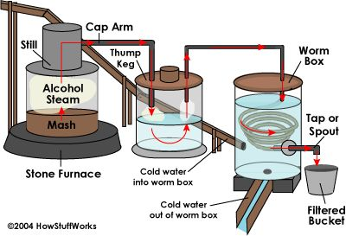 | 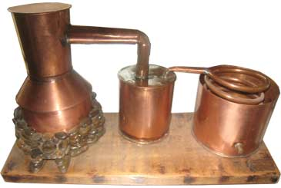

Moonshine Still Components | Still–Mash Tub–Thump Keg-Condenser

Once we got our still put together and ready to go, we only need five basic ingredients to make Moonshine Whiskey:

Water – Cornmeal – Sugar – Yeast – Malt

A good recipe for Moonshine Whiskey requires:
A 5lb bag of cornmeal
A 5lb bag of white granulated sugar
10 gallons of good fresh water
1 cake of yeast
1 pint of malt extract
A small bottle of Iodine and a piece of litmus paper (for testing)
Instructions for Making Moonshine:
1. We need to fill a 20 gallon drum container with 10 gallons of water and heat it to 120° Fahrenheit.

2. Add the cornmeal and sugar slowly to the water, a little at a time. Stir well.

3. Put the 20 gallon drum over a slow burning (stone furnace) fire for about 30 minutes. Keep the temperature of the mash under 145° Fahrenheit or it will scorch. When the mash becomes the consistency of runny porridge, remove from heat and place the drum into cool water (a lake or pond is ideal – the kitchen sink will work in a pinch).

4. When your mash becomes cool to the touch, conduct the iodine test. Take half a cup of mash and put a drop of iodine on top of it. If it turns dark purple, there’s still unconverted starch that needs to be turned into sugar. If so, place the drum back over the heat for another 30 minutes. If the iodine is very light purple, the starches have been sufficiently converted.

5. Add the pint of malt. Crumble the yeast cake, dissolve it in a cup of lukewarm water, and add to the mash. If mash is too thick, add a little warm – not hot – water, a cup at a time.

6. Your mash is now ready to sit for a few days. The temperature where you store the drum should be about 65° Fahrenheit and the drum should be uncovered if possible. But if this location has vermin such as rats or cockroaches, you might want to cover the drum with a cheesecloth.

7. The mash will rise and foam. When it stops rising, the mash should be ready. Perform test using litmus paper to determine the acidity of the mash. If the paper turns blue with no more than a slight pinkish hue, it’s good. If the paper turns bright pink, you have vinegar and you must start over.

8. Put the sour mash into the mash tub (part of the still) and slowly bring the temperature up to 178° Fahrenheit.

9. The alcohol will start to evaporate. As pressure builds in the still, the alcohol steam is forced through the cap arm, a pipe that leads out of the top of the still into a thump keg, which is simply a heated barrel. Some solid material from the mash usually comes along with the steam, so the thump keg, so named for the thumping sound the bits of mash make when they drop into the barrel, re-evaporates the alcohol, filtering out the mash.

10. The steam then travels into the worm box that contains a coiled length of copper pipe that winds down inside the barrel. The worm box or barrel has cold water, usually diverted from a nearby creek, flowing into the top and then back out the bottom. This keeps the worm box with constantly circulating cold water, which condenses the alcohol steam into liquid.

11. A tap or spout leads from the bottom of the worm box into a bucket, usually through one last charcoal filter to clean out any impurities and make the beverage fit for drinking.

12. The resulting clear liquid moonshine is ready for drinking. Enjoy!

Is a Moonshine Still Dangerous?  It can be potentially very dangerous. Alcohol vapor is highly explosive and flammable. That is why experienced moonshiners build their stills out in the woods near a cold stream. Do not try to operate a moonshine still indoors! Even the most experienced moonshiners encounter dangerous | 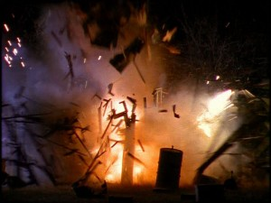
situations that they haven't planned for. If you do happen to make a mistake while distilling, your moonshining session might result in a fire that is hard to control or put out. This has even happened to our favorite moonshiner “Popcorn” Sutton a few times.

What does the “XXX” on the Moonshine container mean?  The “XXX” signifies how many times the moonshine batch had been run through the still. Three X’s indicated that it had been run through three times and that the shine is almost pure alcohol. | 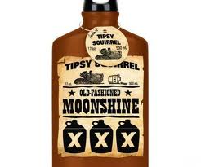

So, is drinking moonshine liquor dangerous? Can it really make you go blind?
Not if it’s made properly. However, there have been a few cases of people going blind from bad batches of moonshine. Those were cases when the person making it didn’t know what they were doing or got greedy and used the wrong ingredients. There are many types of alcohol. One is ethanol and that’s what we are trying to make when we want to drink something. Another type is methanol (wood alcohol). Methanol is an optic nerve poison and can legitimately make someone go blind. All yeast fermentation will produce some small amount of methanol, and in small quantities it is harmless. However, if you get a large quantity, it could indeed make you go blind.

Here is some interesting information
We have already learned that you can make wine and beer (less than 20% alcohol) without a still. But now that we have our still and know how to make Moonshine Liquor, we can use it to make a variety of alcoholic beverages. So, let’s go back to our wine. If we take some grape juice, add some sugar and yeast, and run it through our moonshine still removing half the volume of water from the mix. That will double our alcohol content and we now have brandy at 40%. If we were to do the same thing using plain sugar, we would have vodka, molasses would give us rum and corn or rye products would give us the almighty whiskey. Yes, we can make all kinds of different liquors on our “homemade” moonshiner’s still. This is the exact same process every commercial distillery and every moonshiner in the world uses. The only real differences are the amount, quality, and marketing of the booze they make.

So, how does moonshine and its history effect your life today?
First, if you have ever had a soft drink, you may want to thank moonshine. The soft in soft drink refers to the fact that it contains little or no alcohol. In the 1640’s, the English and Spanish governments started demanding higher and higher taxes for any drink that contained more than 3% alcohol. So the makers started distilling the alcohol out of beers made from ginger and sarsaparilla root and selling the left over product with very little alcohol in it as a tax free beverage. These were the first soft drinks.

The American tradition of racing cars, and everything that came after that started with moonshiners. The moonshiners were the first ones to modify their cars for speed and maneuverability so that they could outrun the authorities that were trying to stop their activities. This lead to the creation of NASCAR and Stock Car Racing. To this day, NASCAR is still based in the same southern states that have the most moonshiners.

The first car engine that was designed to burn alcohol was designed by a moonshiner. In an attempt to smuggle booze more freely, he filled his gas tank up with high proof moonshine and altered his engine to run off of alcohol. When he would get to his destination, he would drain the tank of alcohol and replace it with gasoline and drive back.

It was the first antifreeze. In the days before antifreeze, people had to pull the radiator drain plug every night. Then they would add boiling water in the morning to help get the car started. Some people in the tarted filling their radiators full of moonshine because the alcohol kept it from freezing in the winter and shattering the radiator. In 1927, Prestone produced the first non-alcohol automotive radiator antifreeze.

The TV Show “The Moonshiners” on the Discovery Channel
Think the days of bootleggers, backwoods stills and "white lightning" are over? Not a chance! It's a multi-million dollar industry. But perhaps more importantly to the moonshiners, it's a tradition dating back hundreds of years, passed down to them from their forefathers. It's part of their history and culture. While this practice is surprisingly alive and well, it's not always legal.
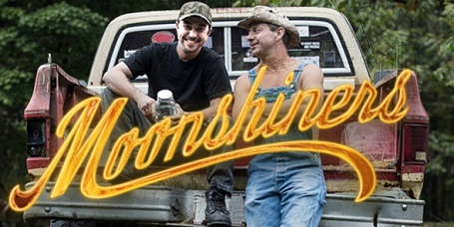

Discovery's series Moonshiners tells the stories of the men and women who keep tradition alive, and make a fortune in the process, distilling illegal whiskey in the back woods of their respective territories. Moonshining is a multi-million dollar industry, based on a practice that precedes the founding fathers, and it's not slowing down any time soon.

Shiners hail from all across Appalachia, and as far south as Mississippi, working with the elements to create the stuff of legends, all through processes passed down by oral tradition. While moonshine can bring a pretty price, it's all crafted outside the bounds of federal and state laws, and the authorities have taken notice. Moonshiners must constantly adapt to the changing methods of law enforcement, applying new, covert methods of distillation and distribution to increase profits and stay one step ahead of the law.

Moonshiner Movies
Here are three movies you might remember if you are near my age:

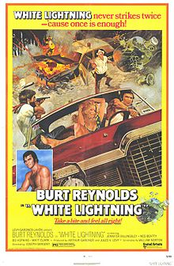 | 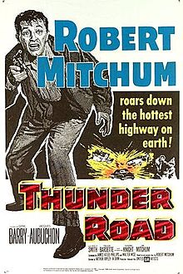 | 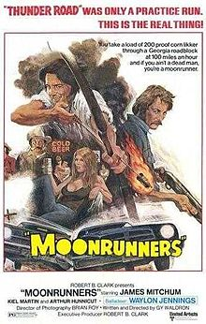

I will stick with beer made by professional brew masters and sold in stores and bars. I hope you found Moonshining as fascinating as I did and don’t forget to watch the Popcorn Sutton video - http://www.youtube.com/watch?v=Yp56sT66D1U

bigdrifter44@gmail.com

