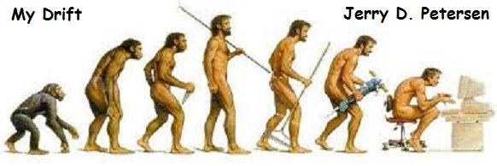

 | Inventions That Changed the World (Part 1 of 4)  15 October 2014 | 186-2014-15

In this article I’m going to present my list of inventions that changed the world in chronological order from early prehistoric times to the present. I hope we can learn something about the progression of mankind throughout history. Did you know that the oldest human skeletons were found in East Africa? One of the best preserved human remnants is a female skeleton dug up near the city of Hadar in Ethiopia. Anthropologists assembled about 40% of the young girl that was given the nick name "Lucy". Lucy lived about 3 million years ago and that is why Africa is called “the cradle of the human race.”

Human history can be divided into several different ages and periods of time but the basic three ages are stone, bronze, and iron.

Stone Age  3 Million BC to 3000BC | Bronze Age  3000BC to 1000BC | Iron Age  1000BC to Present

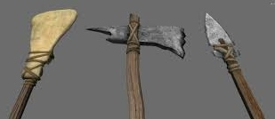 | The Stone Age is a broad prehistoric period during which stone was widely used to make tools with a sharp edge, a point, or a percussion surface. The period lasted roughly 95% of all known human history and ended in about 3000BC when humans finally figured out how to make and use medals.

There were at least three other very important inventions during the latter part of the Stone Age. I will show you these starting on the next page but first let’s get some terminology straight. You know what BC and AD mean, right? Everybody knows that BC stands for “Before Christ” and AD stands for “After Death”. Wrong!! BC is correct but if AD meant “After Death”, the world would be missing the 33 years that Jesus Christ lived. That would not be good. Actually, AD means “Anno Domini” which is Medieval Latin, translated as in the year of the Lord or the day Jesus was born. This way of identifying the number of years is used with the Julian and Gregorian calendars. BC and AD are Christian terms so how do atheists, bleeding heart liberals, and other non-Christians refer to the years of the calendar? Well, recently these fine folks decided to use BCE and CE instead. BCE stands for “Before the Common Era” and CE stands for “Common Era.” BCE is used in place of BC, and CE is used in place of AD. The word “Common” in both instances refers to the dates employed by the most commonly used calendar system, the Gregorian calendar.

Do Muslims use the Gregorian calendar? Yes – actually Muslims believe that Jesus was a prophet. Since most people and businesses in the world use the Gregorian calendar, Muslims conform. However, in the Islamic Middle East, Muslims have a Hijri calendar which is dated by the moons cycles instead of the suns cycles. This means that the months change every 29/30 days instead of every 30/31 days which makes the years about 13 days shorter than the Gregorian calendar year. Most Muslim calendars are printed with both systems on it so they can use either or both calendars.

Here are three of the greatest inventions in the Stone Age:

Invention | Date | Description and Comments
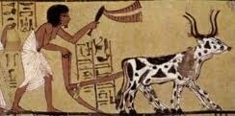  The Plow | 6000BC | The Plow was invented once humans figured out how to grow food. In the beginning, men and women had to pull the plow. It was greatly improved once they started using animal power.
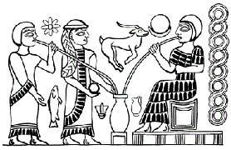  Beer | 4000BC | Beer was the first alcoholic beverage known to humans. The ancient Chinese were the first to brew a beer-like substance known as Kui. A little later in ancient Mesopotamia, clay tablets indicate that brewing was a fairly well respected occupation and that the majority of brewers were women. Early pictures show a lot of women drinking the beer they brewed. This was really a great invention!
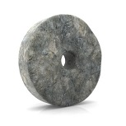  The Wheel | 3100BC | Evidence indicates that wheels were created to serve as potter's wheels around 3100 BC in Mesopotamia some 1100 years before someone figured out how to use them for chariots and carts in 2000 BC. The earliest wheelbarrows were used around 200 AD by soldiers in the armies of Chuko Liang, a Chinese general.

How did early humans survive the last major Ice Age that began about 1.8 million years ago and lasted until about 11,700 years ago? Glaciers covered huge parts of the planet Earth and it was very cold. Well, they did have caves back then and yes..... they knew how to start a fire and it was kind of like living in Greenland or the Antarctica today. Actually, there has never been an Ice Age that covered the entire Earth with ice so there has always been other humans ready to retake the northern areas even if all the people in the north died off. People living during the Ice Ages had to be very resourceful.

Another way that history has been sub-divided since ancient times (the Stone Age) looks something like this:

Classical Antiquity Period  3000BC to 476AD | Middle Ages  476 to 1500  Dark Ages (476 to 1000) | Modern Era  1500 to Present

The Classical Antiquity Period is a broad term for a long period of cultural history centered on the Mediterranean Sea, comprising the interlocking civilizations of Ancient Greece and Ancient Rome. The Western Roman Empire may have fallen more than 1,500 years ago, but its rich legacy of innovation and invention can still be seen today. The Romans were prodigious builders and expert civil engineers, and their thriving civilization produced advances in technology, culture and architecture that remained unequaled for centuries. Here is partial list of the great inventions during this period:

Invention | Date | Description and Comments
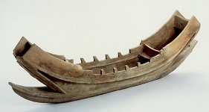  Boats | 3000BC | Both of the earliest civilizations, the Egyptian and the Mesopotamian, made extensive use of boats for transport on the Nile, Euphrates and Tigris.
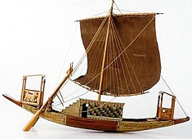  Ships | 1100BC | The Phoenicians designed the first fleet of ships used for carrying goods and passengers. They later designed and used ships for war.
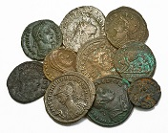  Coins | 700BC | The history of coins begin with their invention in Aegina Island, or in Ephesus, Lydia. Since that time, coins have been the embodiment of money. The first coins were made of electrum, a naturally occurring pale yellow mixture of gold and silver that was further alloyed with copper. alloyed with silver and copper. most universal embodiment of money. These first coins were made of electrum, a naturally occurring pale yellow mixture of gold and silver that was further alloyed with silver and copper.

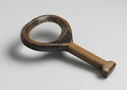  Magnifying Glass | 424BC | Seneca the tutor of the Roman Emperor Nero first invented the Magnifying glass in 424 BC. The modern magnifying glass was invented in 1250 by Roger Bacon. alloyed with silver and copper. most universal embodiment of money. These first coins were made of electrum, a naturally occurring pale yellow mixture of gold and silver that was further alloyed with silver and copper.
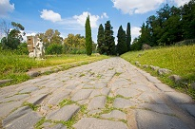  Roads and Highways | 420BC | The Romans built the most sophisticated system of roads the ancient world had ever seen. These Roman roads—many of which are still in use today—were constructed with a combination of dirt, gravel and bricks made from granite or hardened volcanic lava. The Romans built over 50,000 miles of road by 200 AD. These roads allowed the Roman Army to travel as far as 25 miles per day. alloyed with silver and copper. most universal embodiment of money. These first coins were made of electrum, a naturally occurring pale yellow mixture of gold and silver that was further alloyed with silver and copper.
Roman Cement and Concrete | 400BC | Many ancient Roman structures like the Pantheon, the Colosseum and the Roman Forum are still standing today thanks to the development of Roman cement and concrete. The Romans first began building with concrete over 2,400 years ago and used it throughout the Mediterranean basin in everything from aqueducts and buildings to bridges and monuments.
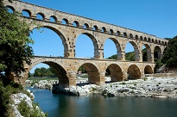  Running Water Sewer Systems | 312BC | The Romans enjoyed many amenities for their day, including public toilets, underground sewage systems, fountains and ornate public baths. Roman aqueducts were engineering marvels that used gravity to transport water along stone and concrete pipelines and into city centers. While the Romans did not invent the aqueduct—primitive canals for irrigation and water transport existed earlier in Egypt and Babylon—they used their mastery of civil engineering to perfect the process.
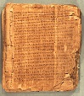  Paper | 210BC | Paper was invented in ancient China during the Han Dynasty and spread slowly to the west via the Silk Road. Roman newspapers first appeared around 131 B.C. and typically included details of Roman military victories, lists of games and gladiatorial bouts, birth and death notices and even human interest stories. alloyed with silver and copper. most universal embodiment of money. These first coins were made of electrum, a naturally occurring pale yellow mixture of gold and silver that was further alloyed with silver and copper.
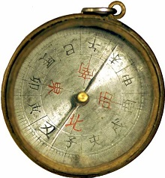  Compass | 100BC | The compass was invented in China, during the Han Dynasty. The first compasses were made of lodestone, a naturally magnetized ore of iron. Seafarers used this type of compass until the early 14th century, when the magnetic compass made its first appearance in the Mediterranean. alloyed with silver and copper. most universal embodiment of money. These first coins were made of electrum, a naturally occurring pale yellow mixture of gold and silver that was further alloyed with silver and copper.

Let’s learn a little more about the Colosseum and the Pantheon of Rome.

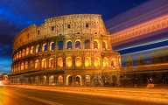 | 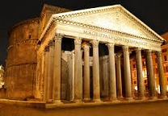
The Colosseum (Finished in 72AD) | The Pantheon of Rome (Finished in 128AD)

1. The Colosseum is the largest amphitheater in the world.  2. It has as over 80 entrances and can seat about 50,000 spectators.  3. It took 9 years to build using over 60,000 Jewish slaves.  4. Over 500,000 people lost their lives and over a million wild animals were killed.  5. The last gladiatorial fights took place in 435 AD.  6. It was the earthquakes of 847 AD and 1231 AD that caused the damage you see today. | 1. The Pantheon is the best-preserved Ancient Roman monumental building.  2. It took over 3 years and 732 construction workers for the Pantheon to be completed.  3. The Pantheon was originally built as a pagan temple dedicated to all the gods.  4. The building’s dome is still the largest unreinforced concrete dome in the world.  5. The oculus measures 30 feet in diameter and provides the only source of light.  6. The Pantheon has been in continuous use throughout its history.

The Romans had exceptional engineers and the people living in that area during this period in our history (approximately 500BC to 476AD) had it pretty good. Unless, of course, you were a Christian and Cleopatra decided to have you thrown into the ring at the Colosseum to fight the lions. The Roman Empire was one of the greatest and most influential civilizations in world history. It began in the city of Rome in 753 BC and lasted for well over 1000 years. During that time Rome grew to rule much of Europe, Western Asia, and Northern Africa.

One of or maybe the biggest event ever in the history of the world occurred during this period in time. The birth of Jesus Christ. Christianity developed out of Judaism in the year 33AD. It is founded on the life, teachings, death, and resurrection of Jesus Christ, and those who follow him and his teachings are called "Christians." Just in case you have forgotten, it was the Romans who crucified (killed) Jesus.

I find the Roman Empire period of time fascinating and plan to write more about it at a later date.

The Dark Ages (year 476 to 1000)

But, as with everything else, all good things must come to an end. The decline and fall of the Roman Empire is the major event marking the end of the Classical Antiquity Period and the beginning of the European Middle Ages that lasted for about 1000 years. The first 500 years of the middle ages is referred to as the Dark Ages. Throughout the 5th century, the Roman Empire's territories in Western Europe and northwestern Africa, including Italy, fell to various invading Armies.

Unfortunately, after the fall of the Roman Empire, Europe pretty much abandoned its pursuit of cleanliness as civilization and human development took several steps backwards. Many Roman inventions such as the art of making Concrete were lost or destroyed. As a result, there were no major inventions during the Dark Ages.

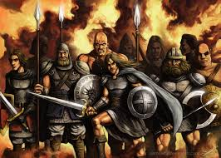 | 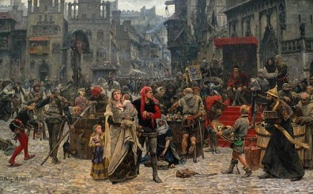

Inventions during the second half of the Middle Ages (year 1000 to 1500)

Invention | Date | Description and Comments
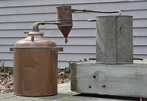  Distilled Liquor | Around  1200 | Almost every early civilization such as the Chinese, the Romans, the Greeks, etc. had some form of alcohol to drink. But up to about 1200, it was some kind of non-distilled beer or wine. It is unknown who first invented distilled alcohol. Some say it was the Chinese or the Greeks - but most historians believe that it was the Arabians.
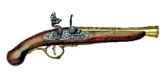  Guns | 1260 | The Chinese invented both gunpowder and the first guns including the cannon. These inventions later made their way to the Middle East, Europe, and Africa. Samuel Colt patented the first percussion-repeating revolver in 1836. In the 1850s, rifles quickly replaced muskets on the battlefield.
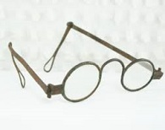  Eyeglasses | 1270 | The first use of lenses for optical purposes (magnifying lenses inserted in frames) were used for reading in both in Europe and China the late 13th century. It is not known whether the West learned from the East or vice versa. alloyed with silver and copper. most universal embodiment of money. These first coins were made of electrum, a naturally occurring pale yellow mixture of gold and silver that was further alloyed with silver and copper.
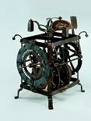  Mechanical Clock | 1305 | The first mechanical clocks with a balance wheel timekeeper were invented in Europe at around the start of the 14th century. These early devices were quite large and struck only the hours and did not have hands or a dial. The oldest surviving clock in England is at the Salisbury Cathedral, which dates back to 1386.
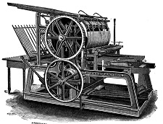  Printing Press | 1450 | German Johann Gutenberg invented the first printing press that used the art of printing with movable types. He also printed the first book to ever be printed which was a Latin language Bible, printed in Mainz, Germany. However, the first printing press was invented in China by Bi Sheng in 1040 that used woodblock printing on cloth and later paper.

Just when the world was getting civilized and moving forward again - something bad happened. THE BLACK PLAGUE or BLACK DEATH!! The Black Death arrived in Europe by sea in October 1347 when 12 Genoese trading ships docked at the Sicilian port of Messina after a long journey through the Black Sea. The people who gathered on the docks to greet the ships were met with a horrifying surprise: Most of the sailors aboard the ships were dead, and those who were still alive were gravely ill. They were overcome
with fever, unable to keep food down and delirious from pain. Strangest of all, they were covered in mysterious black boils that oozed blood and pus - this gave their illness its name – “The Black Death.” The Sicilian authorities hastily ordered the fleet of “death ships” out of the harbor, but it was too late: Over the next five years, the mysterious Black Death would kill more than 100 million people in Europe – almost one-third of the continent’s population. It was spread throughout Europe by fleas living on black rats that were regular passengers on merchant ships and other means of transportation.

Christopher Columbus
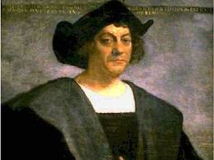 | Up to this time, the only people living in America were the Native Americans. Christopher Columbus is the explorer who is credited for discovering America in 1492. Columbus knew that there were great riches to be had in China and East Asia. However, traveling overland by the Silk Road was dangerous and a sea route around Africa seemed much too long. Columbus thought he could sail straight to China by crossing the Atlantic Ocean. It would turn out that Columbus was wrong. The Earth was much larger than he
thought and there was another land, the Americas, between Europe and Asia. He set sail on August 12, 1492 with three ships named the Nina, the Pinta, and the Santa Maria. The voyage was long and difficult. At one point, his men threatened to mutiny and wanted to turn back. Columbus promised them he would turn back in two days if they didn't find land. On October 12, 1492 land was spotted. It was a small island in the Bahamas that Columbus would name San Salvador. He met natives there that he called Indians because he was convinced that he had landed somewhere in India.

The Early Modern Era (1500 to 1800)

1501 to 1600 (the 16th century)
The 1500s might be part of the modern era but things were anything but modern and life was hard. The life expectancy in the 1500s was about 35 years. The discovery that disease was caused by microorganisms that could be killed by frequent washing was an idea that was still a long way in the future. No one washed much and most people’s skin was often dark and dirty. Moreover, only the rich could afford to eat well. Most people still thought the earth was flat! This all changed in 1543 when Copernicus published his theory that the Earth was not the center of the universe, rather, the Earth and the other planets orbited around the Sun. Called the Copernican Revolution, his theory forever changed astronomy, and ultimately changed all of science. Here are a couple of important inventions:

Invention | Date | Description and Comments
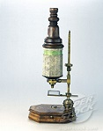  Microscope | 1590 | Dutchmen, Zacharias Janssen invented the microscope. Up to now, the smallest thing humans could see was about as wide as a human hair. When the microscope was invented around 1590, suddenly we saw a new world of living things in our water, in our food and right under our nose.
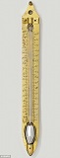  Thermometer | 1593 | Galileo Galilei invented the first thermometer.  In 1714, the first mercury thermometer was made by Gabriel Fahrenheit. Using mercury combined with improved glass working techniques led to a much more accurate thermometer.  In 1742, a Swedish scientist named Anders Celsius devised a thermometer scale dividing the freezing and boiling points of water into 100 degrees – he called it the Celsius Scale.

1601 to 1700 (the 17th century)
During the 17th century (1601-1700) major changes in philosophy and science took place. Before the 17th century began, science and scientists were not truly recognized. In fact, at first people like the 17th century genius Isaac Newton were called natural philosophers, since there was no concept of the word scientist for most of the 17th century. You remember Isaac Newton, don’t you? The guy that figured out the laws of gravity by watching an apple fall from the tree.

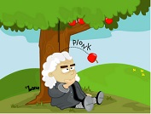 | Sir Isaac Newton is best known for his work on gravity. He also worked on and discovered many other scientific wonders during his lifetime (1642-1727). His work in physics was so advanced that he was the first scientist to be knighted, which is a great honor in England and the reason "Sir" precedes his name. Newton also developed the three laws of motion which form the basic principles of modern physics. His discovery of
calculus led the way to more powerful methods of solving mathematical problems. His work in optics included the study of white light and the discovery of the color spectrum. It was his experiments with light that first made him famous.

Invention | Date | Description and Comments
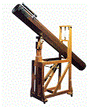  Telescope | 1608 | The telescope was invented by a Dutch eyeglass maker named Hans Lippershey in 1608. The device had three-times magnification with a concave eyepiece aligned with a convex objective lens.
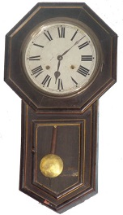  Pendulum Clock | 1656 | Chris Huygens (Dutch mathematician and scientist) invents the first pendulum clock. The pendulum clock was regulated by a mechanism with a "natural" period of oscillation and had an error of less than 10 seconds a day.
1701 to 1800 (the 18th century)
The 18th century was the beginning of the Industrial Revolution where modern manufacturing using steam engines replaced animal labor. The 18th century also saw the widespread replacement of manual labor by new inventions and machinery. It was also part of the "The Age of Enlightenment", a historical period characterized by a change away from traditional religious sources of authority, and a move towards science and rational thought. Some of the more important inventions include:

Invention | Date |  | Description and Comments
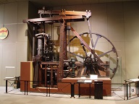  Steam Engine | 1700s |  | There were 3 inventors during the 1700s that invented and/or improved the Steam Engine:  Thomas Savery (an English inventor) patented the first crude steam engine. It was used for pumping water out of coal mines.  Thomas Newcomen (an English blacksmith) invented the atmospheric steam engine which improved the original steam engine.  James Watt (a Scottish inventor and mechanical engineer) was renowned for his improvements to the steam engine.
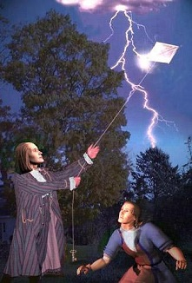  Electricity | 1752 |  | There were many inventors involved in the history of electricity but Ben Franklin's lightning rod was the first practical application. By tying a key onto a kite string during a storm, he proved that static electricity and lightning were the same.  Michael Faraday is best known for his discoveries of electromagnetic induction and of the laws of electrolysis. His biggest breakthrough in electricity was his invention of the electric motor.  Joseph Henry invented the electrical relay that is used to send electrical currents long distances.  Samuel Morse invented the electric telegraph - a machine that could send messages long distances across a wire.
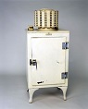  Refrigerator | 1755 | Artificial refrigeration began in the mid-1750s, and was further developed in the early 1800s. In 1834, the first working vapor-compression refrigeration system was built. The first commercial ice-making machine was invented in 1854. In 1913, refrigerators for home use were invented.
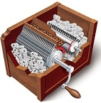  Cotton Gin | 1794 | Eli Whitney built a machine that could effectively and efficiently remove the seeds from cotton plants. The invention, called the cotton gin (“gin” was derived from “engine”), worked something like a strainer: Cotton was run through a wooden drum embedded with a series of hooks that caught the fibers and dragged them through a mesh. The mesh was too fine to let the seeds through but the hooks pulled the cotton fibers through with ease.
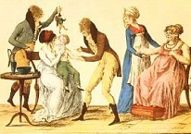  Vaccinations | 1796 | A British doctor named Edward Jenner used the cowpox virus to protect against smallpox in 1796, but it wasn’t until Louis Pasteur developed a rabies vaccine in 1885 that the medicine community and the government began to accept the idea that making someone a little bit sick could prevent further sickness.

Quick recap: During the first 3 million or so years that humans have been here on earth, they were perfectly happy using sticks and rocks to protect themselves and to kill animals for food. They learned how to control fire and were able to cook food and stay warm. They may have had other inventions during this period but we have no proof of this. Actual written history started in about 6600BC with symbols and pictures carved out on rocks and shells. The first hand written language (scripts and words) was the Sumerian language that started in about 3100BC in southern Mesopotamia.

The Romans, the Egyptians, the Greeks, and the Chinese made many great inventions and built many impressive structures during the period 500BC to 476AD. The fall of the Roman Empire plunged most of the world into a long 500 year period of intellectual darkness and economic regression. There were many invading armies and most people were afraid and just trying to stay alive.

Since the year 1000, civilization started moving forward again and there were many great inventions during the second half of the middle ages and the Early Modern Era. I think the greatest invention was electricity which lead the way for countless other inventions and improvements for us humans.

Since this article is running a little long, I’m going to stop here. Part 2, which covers the years 1801 through 1900 (the 19th century) and Part 3, which covers the years 1901 through 2014 (the 20th century and to where we are now in the 21st century), should be ready in a couple of weeks.

bigdrifter44@gmail.com

