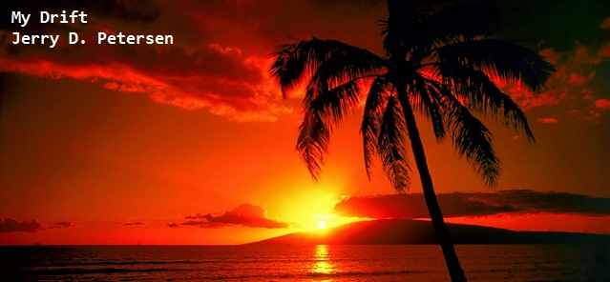

 | Trouble in Paradise  7 March 2014 | 174-2014-03

The island of Oahu in the state of Hawaii is a great place to live. The weather is great almost all year, the air is clean most of the time, the scenery is beautiful, most of the people are friendly and there is a casual laid-back life style. I have lived in Hawaii since 1970 and I don’t have any desire to move any place else. But, there are many problems and issues facing the people living in Hawaii. I have written articles about several of these problems in the past – e.g. the homeless problem, Oahu traffic solutions, graffiti, and littering. But, I think it is time to make a list and provide some updated information, statistics, comments and a few possible solutions.

The number one problem in Hawaii is the high cost of living. Almost everything costs a lot more in Hawaii than anywhere else in the United States. Most of our problems and issues are directly or indirectly related to the high cost of living. Below is a breakdown of my list of Oahu problems:

The High Cost of Living in Hawaii

Directly |  | Indirectly |  | Other
House and Condo Prices  Rent Cost  Food Prices  Utilities Prices  Gasoline Prices  Taxes  Water and Sewer Systems  Low Paying Jobs  Public Schools  University of Hawaii Athletics | Homelessness  Crime and Prisons  Drugs  Graffiti  Littering - Trash  Mass Transit – Rail  Roads  Traffic  Development  Landfills |  | Earthquakes  Volcano Eruptions  VOG  Tsunamis  Flooding  Hurricanes/Tropical Storms  Droughts  Shark Attacks

#1A - Housing Prices
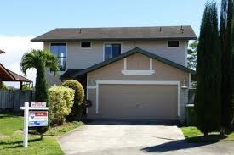  This house in Mililani sold for $680,000 | Problem: Hawaii has the highest housing prices in the nation. The median price of a single-family 3-bedroom home on Oahu in 2013 was about $680,000. The average monthly rent for a 3-bedroom house was about $3000.  The median price of a 2-bedroom condo on Oahu in 2013 was about $360,000. The average monthly rent for a 2-bedroom condo was about $2000.  Insurance: Home owners must pay for two insurance policies – the normal fire and theft plus an additional hurricane policy which costs about $2000 per year.  Comments: The landowners and housing developers are getting rich. The house on the left would sell for about $200,000 in Utah and most other states. But, since there is not much available land on Oahu and the demand for housing is high, prices will only go up.

#1B - Food Prices
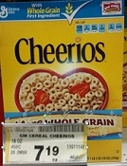 | 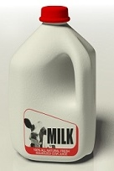 | Problem: Hawaii has the highest food prices in the nation. Would you pay $7.19 for a box of Cereal? We have to! A gallon of milk costs about the same. The cost to ship food across the ocean makes the grocery bill in Hawaii 66% higher than that of a family on the mainland. On top of that, Hawaii is one of the few states that taxes food (4.5% general excise tax).  Solution: The Hawaii State Government should get rid of the tax on food but they only increase or add new taxes. Most people in Hawaii reduce their food bill by shopping at big box stores like COSTCO.

#1C - Utilities
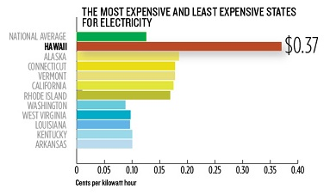 | Problem: The cost of electricity (37 cents per kilowatt-hour) is about 3 times the national average. The average Hawaii home owner pays between $300 and $500 a month. If they have air-conditioning, it is much higher. The combined water and sewer charge is also sky high. We pay a base rate ($68.39) and so much per 1000 gallons. Oahu’s water and sewer systems are obsolete and need to be upgraded.  Solution: The utility companies need to give us citizens a break but they plan to raise the rates – not lower them.

#1D - Gas Prices
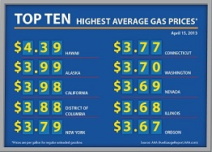 | Problem: Hawaii has the highest gas prices in the United States by far.  Solution: There is no solution! The gas companies can charge us whatever they want. All oil comes to Hawaii by tanker ship and is processed into gas and other products at either the Chevron or Par Petroleum refineries. It is rumored that Chevron will close its Hawaii refinery by 2015. Then things will get even worse for us poor Oahu drivers.

#1E - High Taxes
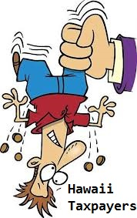 | Problem: The only state with a higher personal income tax is California. Here are the top 3:  - California 13.3%  - Hawaii 11.0%  - New Jersey 8.97%  Hawaii’s property tax rate (.26% of property value) is not that bad but with the very high property value assessments, home owners end up paying a lot more than most states.  Hawaii does not have a sales tax, but instead has a gross receipts tax which is called the General Excise Tax. This 4.5% tax applies to almost everything purchased in Hawaii.  Comments: Hawaii city and state lawmakers are looking for more and new ways to tax us poor citizens. The city just announced that they want to charge all Oahu households $10 a month for curbside garbage pickup.  What are they doing with all of our tax money?

#1F - Low Paying Jobs
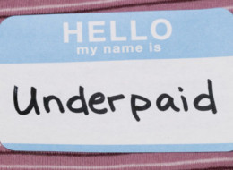 | Now wait just a minute. You would think that with all these high prices and high taxes, the wages in Hawaii must be very high. Right? WRONG!!  Problem: Hawaii ranks 17th with an average income of about $45,000 and 8th with a median household income of $62,000. Connecticut has the highest average income ($60,000) and Mississippi has the lowest ($33,000). The minimum hourly wage in Hawaii is $7.25 which equates to $15,080 a year.  Comments: You can’t live on that anywhere in the U.S. It needs to be raised to at least $10 an hour. Hawaii has a lot of tourist related jobs which are mostly low paying jobs. Many workers in Hawaii have to work two jobs in order to get by.
#2A – Public Schools
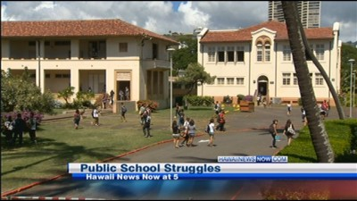
Problems:
- Most of the 255 public school in the state are old and are in disrepair. A majority of these schools were built more than 50 years ago.
- Most classrooms don’t have enough electrical outlets to power computers and other devices. Newer schools, like Kapolei High School or Ewa Makai Elementary, have as many as 24 outlets in each classroom.
- Overcrowded schools and classrooms. Several high schools including Mililani, Campbell, Waipahu, and Farrington have over 2400 students. The national average is less than 1000.
- Many classrooms are hot and uncomfortable with temperatures in the 90s during the summer. Only 12 public schools in the state are fully air conditioned.
- Hawaii ranks 50th among the states in the amount spent on school facilities in the last 15 years. Our state government only spends about $300 per student on capital outlay improvements where nationally the average is about one thousand dollars.
- Low starting salaries (average is $38,480) for teachers. Hawaii public school teachers are quitting and leaving their jobs at much higher rates than the national average.
Solutions:
- In this election year, Hawaii Gov. Neil Abercrombie is taking credit for the state having an $844 million surplus. If he is not going to give it back to us over taxed citizens, I recommend he spends it on our public schools and give the teachers a raise.
- Hawaii needs a lottery!! Only Utah and Hawaii don’t allow any form of gambling. If 48 other states can manage a lottery that provides much needed money for public schools, I’m pretty sure Hawaii can figure out a way to run one.

#2B – University of Hawaii Athletics
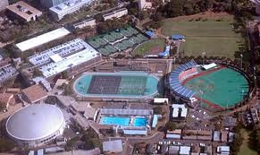  UH Sports Complex | Problem: UH athletics lost $2 million dollars last year. 450 student athletes compete in 21 men’s (7), women’s (12), and coed (2) varsity teams. Normally, the football, men’s basketball, and women’s volleyball programs are expected to make enough money to support all of the teams. However, last year the football team only won 1 game and didn’t have much fan support.  Solution: The football team needs to win more games and our state government needs to subsidize UH sports. The University of Hawaii is a state school and should be able to use the state owned Aloha Stadium for free,
#3A – Roads and Traffic
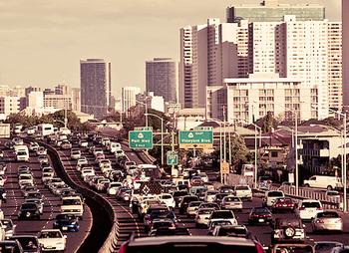  The H-1 Freeway in Honolulu | Problems: The traffic in Honolulu and on our major highways and roads is reaching total gridlock. The worst traffic (morning and afternoon rush hour) is between Kapolei and Honolulu. Most roads on Oahu have many potholes, cracks, and other problems.  Solution: Mayor Kirk Caldwell is doing a good job on his campaign promise to fix the roads. Fixing the traffic mess will be much more difficult.  Suggestions:  - Complete the mass transit (rail) system  - Dig a tunnel and make a highway under Pearl Harbor from Ewa Beach to Hickam Air Base (see little red line on map below).  - Build a new road from Pearl City to Waipio (see red line by Pearl City) connecting to the H2 Freeway interchange near COSCTO.

#3B - Mass Transit – Rail
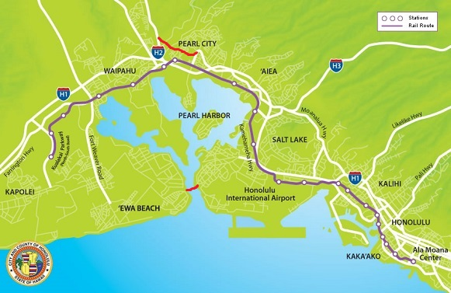
The Oahu Mass Transit (Rail) Route – Kapolei to Ala Moana Center
Comments: I’m for the Oahu Mass Transit (Rail) system. It will be good for creating more jobs and it will get a lot of cars off of the roads. The only issue I have with it is the route shown above. An effective mass transit system on the island of Oahu needs to go to the airport, downtown Honolulu, Waikiki, and the University of Hawaii. I think 2 out of 4 is not good enough! This 20-mile rail line is costing taxpayers $5.2 billion dollars.

#4 - Homelessness
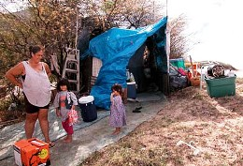 | 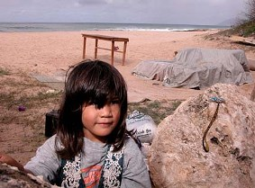 |  | 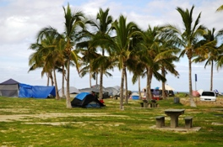
Homeless Families
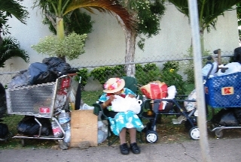 |  | 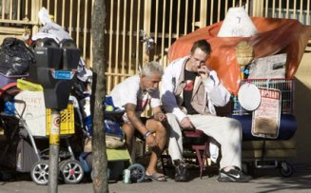 |  | 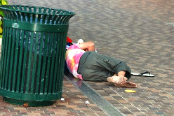
The Chronically Homeless
Problem: Homelessness is out of control on Oahu. There are homeless people everywhere – there are tents and people sleeping on sidewalks, parks, and beaches. Plus many homeless families are living in their cars. Here are some statistics:
Hawaii (population 1.4 million) has about 8,000 homeless people on any given night. About 5,000 of these people are right here on Oahu. The number of homeless people has doubled since 2004. Let’s take a closer look at who these homeless people on Oahu really are:
The Chronically Homeless  About 2500 are chronic homeless  700 are recently here from the mainland  900 have some type of mental illness  800 are military veterans  2200 have alcohol/drug use problems  1000 have chronic health issues  Most live on the street in downtown Honolulu | Other Homeless People  About 2500 are other homeless people  1600 are families (1000 children)  500 are other homeless men  150 are other homeless women  250 are other homeless youth (12-17)  600 have low paying jobs  Most live on the leeward coast beaches
Solutions/Recommendations: There is no solution! Every state and every major city in the U.S. has a homelessness problem. However, here are a few ideas on how to deal with the homeless:
- 1. Help the homeless families first. Help them find low cost housing. Help them find job(s) if possible. Homeless children need a stable family life and this means a home - not living in a car or a tent on the beach. Next, help the men, women and youth who are sober that want a better life.
- 2. Pass a law to make Waikiki, the most popular beach parks, and the downtown Honolulu Business District homeless free zones. The worst of the homeless are now hanging out in these areas and are causing the state to lose much needed tourists and national/international business.
- 3. Set aside some land at a couple of isolated places on the island for homeless tent cities. This idea has worked in several states and there is no reason it can’t work here if properly controlled.
- 4. If another state sends a homeless person to Hawaii, our state officials must send this person back immediately. There should be a national law against a state sending their homeless to another state.
- 5. There is always going to be the chronically homeless. There is not much hope for getting them completely off of the streets. I suggest that we hide these people as much as possible. They should be living in a back alley somewhere or a remote tent city – not on Kalakaua Ave. in Waikiki.
- 6. You can’t be nice to the chronic homeless or else the state of Hawaii will be overrun (worse than it already is) with homeless people coming here from all over the world.
#5A – Crime and Prisons
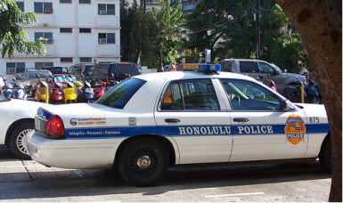  Honolulu Police Department  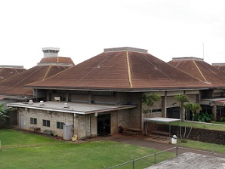  Oahu Community Correctional Center  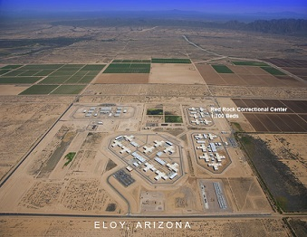  Red Rock Prison in Arizona | Hawaii Crime Statistics for 2013:  3,330 Violent Crimes  Murders – Rapes – Robberies – Assaults  29 285 1,040 1,976  42,817 Property Crimes  Burglary – Theft – Auto Theft  7,979 31,233 3,605  The number of violent crimes in Hawaii is well below the national average. For example, the city of Detroit (population 700,000) had 333 murders in 2013. However, property crimes in Hawaii are a little above the national average.  Comments: The police are doing an excellent job of catching the bad guys and getting convictions but the courts are letting them go free. Almost every day I read where the police are looking for somebody with 20 or 30 convictions who has violated the terms of their release. These crooks are still out on the streets robbing people. Whatever happened to the “3 strikes and you’re out!” law – These thugs belong in jail!  Oahu has over 4000 inmates at 4 Prisons:  Oahu Community Correctional Center - Honolulu  Halawa Correctional Facility - Aiea  Waiawa Correctional Facility - Waipahu  Women's Community Correctional Center – Kailua  Hawaii has 1900 inmates at 2 prisons on the mainland:  Red Rock/Saguaro Correctional Centers - Eloy, Arizona  Problem: Hawaii prisons are overcrowded and the courts keep letting the criminals out on the street. It costs $125 a day to house one prisoner in Hawaii and $75 in Arizona.  Solution: Stop being nice to these criminals! Put the bad guys in jail or prison. Send more prisoners to Arizona.

#5B - Drugs
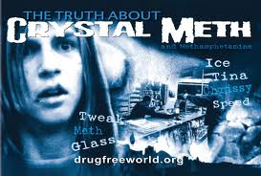 | Problem: It seems like every time I read the newspaper, there is a tragic story related to crystal meth (ice) use. Most crimes such as family abuse, robbery, and murder here in Hawaii are committed by someone high on ice. Yes, the crystal meth drug problem has reached epidemic proportions in Hawaii. Ice is the drug of choice here and is considered by far the most significant drug threat. Per capita, Hawaii has the most ice users in the nation. There were over 100 deaths last year related to ice – overdoses, suicides, accidents, homicides, and users just dropping dead from heart failure. It only takes using ice once to be hooked for life or until you die (which is usually soon).  Recommendations:  - Legalize marijuanna  - Put the crystal meth distributors in jail
#5C – Graffiti
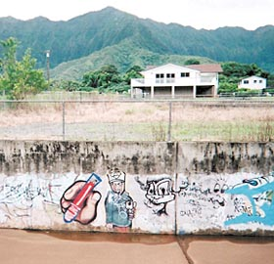 | 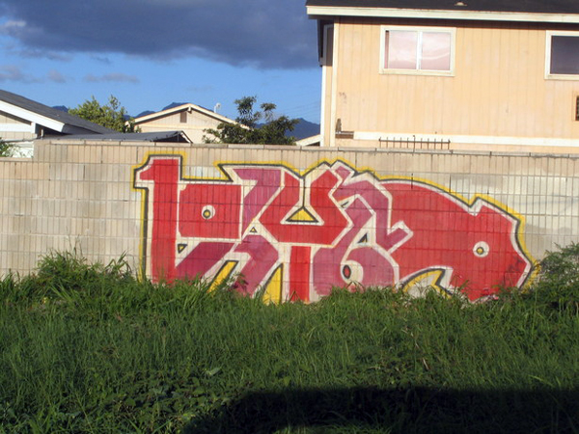 | 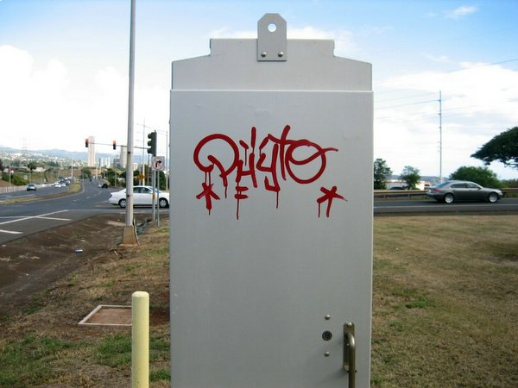
Problem: Nothing gets my blood pressure up more than driving around this beautiful island of Oahu and seeing graffiti painted all over the walls, buildings, traffic signs, and most everything else in sight. I keep thinking, “How can these sneaky classless punks do this to their own island home?”
Recommendations: Police are doing what they can to catch these criminals but with limited resources and the many possible targets, most graffiti artists get away with their disgraceful acts. The police need more surveillance cameras, conduct more stakeouts, and get a lot more help from the public.
Solution: The best solution to the graffiti problem is to clean it up fast. Taggers and graffiti artists want everybody to see it because that is how they express themselves and how they get their thrills.
Penalties: Don’t waste taxpayer money and jail space on these vandals. For first offenders, fine the parents and make the punks clean up their mess. For second offenders, public floggings would be good and for third offenders, chopping off one finger would be a great deterrent. The ACLU and our liberal leaders might not go for these last two penalties but if they were in effect, graffiti would disappear from the islands and my blood pressure would be a lot lower.

#5D – Littering – Trash – Abandoned Vehicles
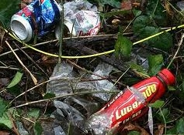 | 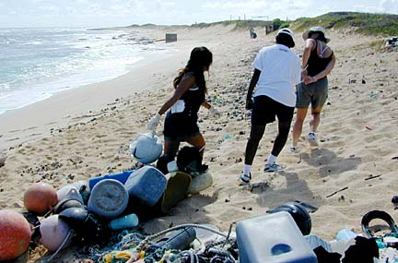 | 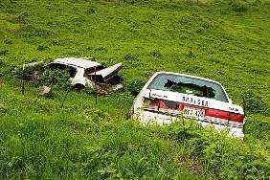
Problem: I used to stop at the Mililani Shopping Center every morning to buy a newspaper and there was always a bunch of trash in the parking lot. There is a Jack-in-the-Box there that is open all night and most of the trash consists of drinking cups and various wrappers. I get up early and I was usually at the shopping center by 5AM. There are usually 4 or 5 cars parked in the lot with a group of young men standing around talking and eating their late-night meal. There is a trash can less than 20 feet away that is never used. These young people just throw the rubbish on the ground. Oahu’s beaches and parks are full of homeless people and their trash. Most of these homeless people are hooked on drugs/alcohol and are not too worried about a little trash. I recently rode around the island of Oahu and counted 11 abandoned cars. A lot of these abandoned cars were stolen and taken somewhere remote to be stripped. The rest are old junky cars left by the owners just trying to get rid of them.
Solution: I think our state and city governments are doing a better job of cleaning up the litter (trash) and hauling away abandoned cars. Most litter comes from the young people living here and they need to take more pride in how this scenic island looks.
#6 – Development
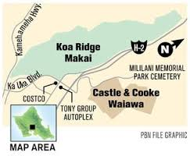 | 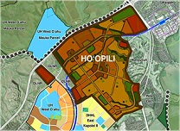 |  | 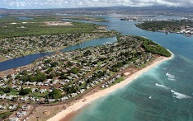
Koa Ridge – They are going to build 3,500 single family homes on 575 acres between Mililani and Waipio. | Ho’opili – They are building 11,000 houses on 1500 acres of land near Kapolei on the Ewa Plain. |  | Hoakalei – They are building 1,800 new homes in the resort community of Hoakalei located near Ewa Beach.
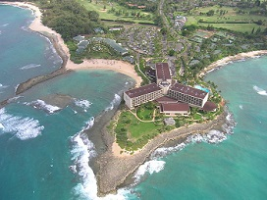 |  | 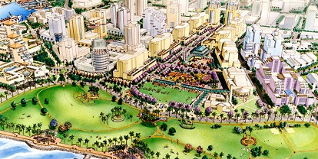
Turtle Bay – There are plans to develop the North Shore and the Turtle Bay Resort area. There are many protesters and people who want to “keep the country - country”. |  | Kakaako – There are big plans for the area between downtown and Waikiki. A wide range of low-rise residences and high-rise towers, green spaces, walking paths and unique retail stores.
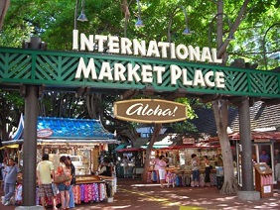 |  | 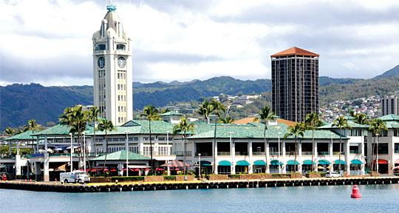
International Market Place – It is closed! A Saks Fifth Avenue department store will anchor a retail complex currently being built at this location. Only two things from the original will remain: the name and the old Indian banyan tree. |  | Aloha Tower - Hawaii Pacific University now owns it and plans to redevelop it into student dormitories along with retail and restaurant spaces. 17 tenants must leave by March 17, 2014 - 4 others are staying, including The Cab, Gordon Biersch, the Star of Honolulu and Hooters restaurant.

Comments: The traffic is going to get much worse. I’m for keeping the country-country. I hope our water and sewer systems can support all this development. One good thing is they are keeping Hooters!
#7 – Landfills
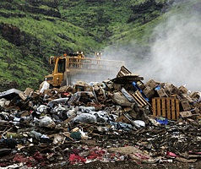 | Problem: Oahu has only one landfill called “Waimanalo Gulch Landfill” located near Kapolei. It opened in 1989 and covers approximately 200 acres. Oahu generates roughly 1.6 million tons of waste each year. 1.2 million of this is either reusable waste or can be used to create (H-POWER) energy. That leaves 400,000 tons of waste going to the landfill which is quickly reaching capacity and should have been closed a long time ago. Our government has not found a new location to build a new landfill. Nobody on this island wants a dump in their backyard. Approximately 200 acres Approximately 200 acres  Solution: Just find an isolated spot on city or state property and build the landfill – somewhere far away from Mililani.

#8 – Natural Disasters
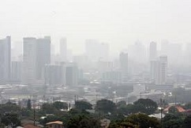  Honolulu VOG | 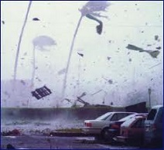  Hurricanes | 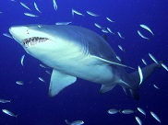  Shark Attacks
Problems: Hawaii has a lot of natural disasters. Besides the ones shown above, we have things like earthquakes, tsunamis, tropical storms, floods, droughts, and volcano eruptions.
VOG (volcanic smog) is a form of air pollution that results when sulfur dioxide and other gases and particles emitted by an erupting volcano react with oxygen and moisture in the presence of sunlight. The Kīlauea volcano, on the Big Island of Hawaii has been erupting continuously since 1983. When there are southern winds, the VOG moves up and covers all of the Hawaiian islands.
There has been only two major hurricanes to hit Hawaii since I moved here in 1970:
Iwa in 1982 and Iniki in 1992 – Both caused major damage to Kauai and moderate damage to Oahu. There has been dozens of close calls including Hurricane Fernanda (1993), Daniel (2000), Darby (2004), Flossie (2007) and Felicia (2009).
There were a record 14 shark attacks in 2013 (2 deaths) – most of them in the waters near Maui. Some people want the state to hunt and kill all the sharks near Hawaii beaches.
Comments: You can’t do anything about preventing natural disasters but you can be prepared for them. I also think our state and city governments are doing a good job in tracking and keeping the public up-to-date when one does occur. If you are worried about shark attacks, stay out of the ocean. People go into the ocean in Hawaii millions of times every year and only a few drown or get attacked by a shark. Just leave them alone – the ocean is their home.

By now, we should all know that there are “downsides” to living in Hawaii. It is the price we pay for living in this beautiful state. Some people call it “The Paradise Tax”. I plan to stay as long as I can pay my bills and have enough money left over for a few cold brews.

bigdrifter44@gmail.com

