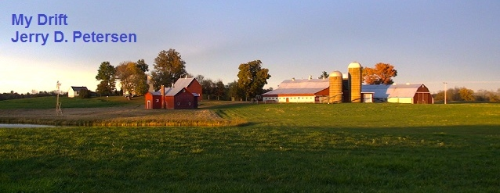

 | The American Farmer  8 April 2015 | 197-2015-04

Next time you are at the Supermarket, take a moment to look around at all the food items and give thanks to the hard working men and women who are the American’s farmers. Think about it------ what would you do if there were no food stores? Most of us would starve to death! So, in this article I’m going to honor the farmers and ranchers and fisherman who are responsible for growing the crops, raising the cattle, and catching the fish that eventually end up on our dinner table.

When I was a young man, I enjoyed listening to Paul Harvey on the radio. His views on things were similar to mine. I remember a show back in 1978 called “So God Made a Farmer”.

"Hello, Americans," he barked. "This is Paul Harvey! Stand byyy for Newwws!"

In his heyday, which lasted from the 1950s through the 1990s, Mr. Harvey's twice-daily soapbox-on-the-air was one of the most popular programs on radio. Audiences of as many as 22 million people tuned in on 1,300 stations to a voice that had been an American institution for as long as most of us could remember. He personalized the radio news with his right-wing opinions, but laced them with his own trademarks: a hypnotic timbre, extended pauses for effect, heart-warming tales of average Americans and folksy observations that evoked the heartland, family values and the old-fashioned plain talk one heard around the dinner table on Sunday. He railed against welfare cheats and defended the death penalty. He worried about the national debt, big government, bureaucrats who lacked common sense, permissive parents, leftist radicals and America succumbing to moral decay. He championed rugged individualism, love of God and country, and the fundamental decency of ordinary people.

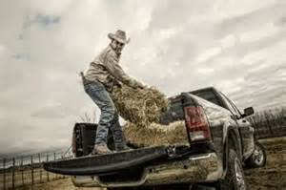

Agriculture is a major industry in the United States, which is a net exporter of food. There are approximately 2.2 million farms, covering an area of 922 million acres for an average of 418 acres per farm. Although agricultural activity occurs in most states, it is particularly concentrated in the Great Plains, a vast expanse of flat, arable land in the center of the United States and in the region around the Great Lakes known as the Corn Belt.

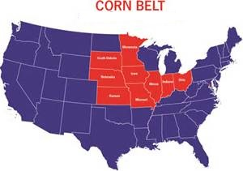
CORN is KING!! The United States produces about 40% of the world’s corn. Here is a chart that shows the variety of uses for corn:

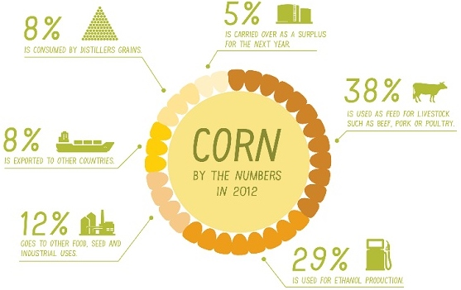

Here is what the fields look like for the four biggest crops grown in the United States:

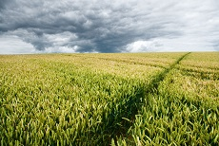  Corn Field | 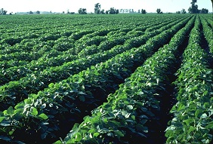  Soybean Field
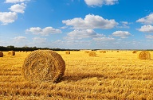  Hay Field | 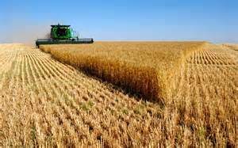  Wheat Field
The top twenty agricultural products grown and produced in the United States

Crop Acres Harvested | States that Produce the Most

1  2  3  4  5  6  7  8  9  10  11  12  13  14  15  16  17  18  19  20 | Corn (grain)  Soybeans  Hay  Wheat  Cotton  Sorghum (grain)  Barley  Rice  Sunflower  Canola  Green Beans  Peanuts  Sugar Beets  Potatoes  Oats  Sugar Cane  Peas  Lentils  Tobacco  Flaxseed | 87,375,000  76,104,000  56,260,000  48,991,000  9,427,000  4,955,000  3,244,000  2,678,000  1,841,000  1,729,000  1,690,000  1,608,000  1,204,000  1,133,000  1,045,000  899,000  621,000  450,000  336,000  336,000 | Iowa, Illinois, Nebraska and Minnesota  Illinois, Iowa, Minnesota and Indiana  Kansas, Texas, Nebraska and Oklahoma  Kansas, Oklahoma, Texas and Nebraska  Texas, California, Arizona and Mississippi  Kansas, Texas, South Dakota and Oklahoma  North Dakota, Idaho, Montana and Washington  Arkansas, California, Louisiana and Mississippi  North and South Dakota, Minnesota and Kansas  North Dakota, Idaho and Montana  Illinois, Michigan, New York and Wisconsin  Georgia, Texas, Alabama and Florida  California, Colorado, Idaho and Michigan  Idaho, Washington, Wisconsin and Colorado  South and North Dakota, Wisconsin and Minnesota  Florida, Louisiana, Hawaii and Texas  Washington, Idaho, and Oregon  Washington, Idaho, Montana, and North Dakota  North Carolina, Kentucky and Georgia  North Dakota and Minnesota

Fruits and Vegetables

Oranges | 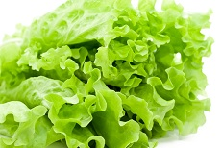  Lettuce

California produces more than half the nation’s fresh fruits and fresh vegetables. More than half of all vegetable production in the United States depends on irrigation, in widespread use in California’s vast agricultural valleys. California plants and produces about 80% of the nation’s broccoli, spinach, lettuce, fresh tomatoes, and most other vegetables.

California is the leading producer of strawberries, grapes, oranges, peaches, and pretty much all fruits except apples where Washington State accounts for most of the nation’s supply. Florida grows a lot of oranges, though available fresh, most are used to make orange juice. One of the most popular fruits among the American public is bananas but most of these are imported from other countries - South America, Central America and the Caribbean. Did you know that a large portion—more than half—of all fruit consumption in the United States is in the form of fruit juices? It is true.

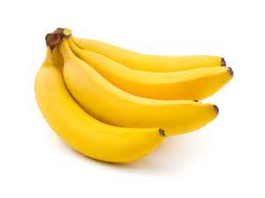  Bananas | 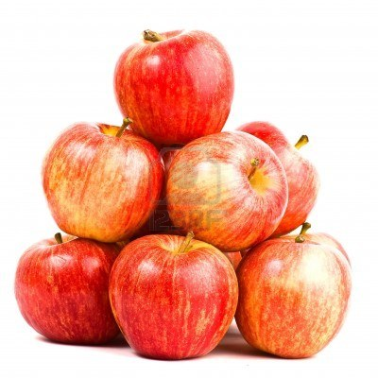  Apples | 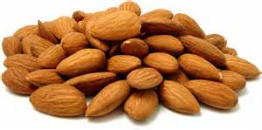  Almonds

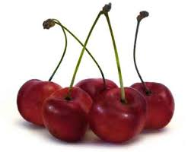  Cherries | My favorite fruits to eat raw are cherries, apples, and bananas. Washington, California and Oregon are the primary sweet cherry producing states, accounting for about 97 percent of the quantity produced nationwide. The primary tart cherry producing state is Michigan, which accounts for nearly 90 percent of tart cherry production.

Nuts
California grows about 80% of the most popular nuts sold in the United States. These are almonds, pecans (my favorite nut), and walnuts.

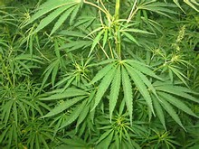  Marijuana Plants | What states grow the most marijuana? California grows more marijuana (more than 20 million plants) legally and illegally than the next three biggest growers combined which are Tennessee (7 million plants), Kentucky (6.5 million plants), and Hawaii (5.5 million plants). The two states with the most users are Delaware and Hawaii with about 12% of adults smoking the stuff. The technical name for marijuana is Cannabis. Other names used are pot, weed, reefer, ganja, and Maui Waui. The marijuana grown in Hawaii is recognized as being the best quality.

Agriculture in Hawaii
The primary crops are sugarcane, pineapple, macadamia nuts and Kona coffee. Below are some pictures and a little history of each.

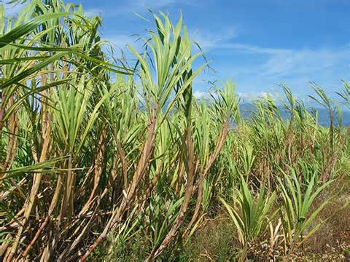  Sugar Cane Field | 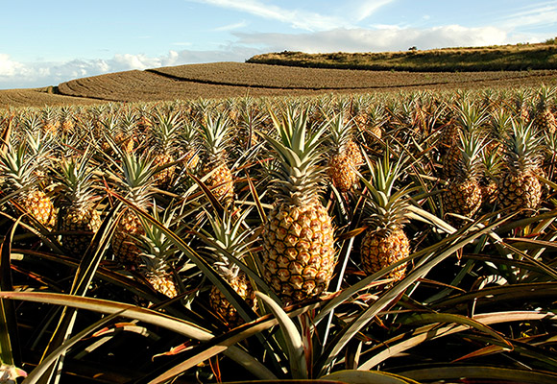  Pineapple
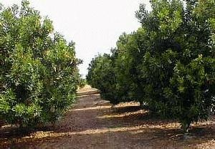  Macadamia Nut Trees | 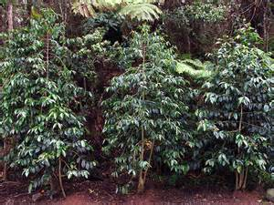  Kona Coffee Bean Trees

Sugarcane was thriving in Hawaii long before Captain Cook came to the islands in 1778. But it wasn’t until 1834 that the first sugar plantation went up on Kauai. Hawaii was the perfect climate for this crop. The industry boomed. By 1959, one out of every twelve people in the work force, was employed by the sugar industry. Today, sugar is still being grown in Hawaii. But, times have changed and most processing mills have closed. Most of Hawaii’s sugar is processed, packaged and marketed out of California.

Pineapple was brought to the islands by King Kamehameha the First’s Spanish advisor, Don Francisco de Paula y Marin in 1813. It quickly became one of the largest and most profitable crops on the islands. In 1898, Alfred W. Eames of California formed what would become Del Monte Fresh Produce. In 1901, James Drummond Dole formed Dole Hawaiian Pineapple Company. In 1909, Maui Land and Pineapple was formed. These three companies would become giants in the pineapple industry. By 1930, nine million cases of pineapple were exported out of Hawaii by eight different canneries. In the 1960s, Hawaii was responsible for 80 percent of the world’s pineapple. Today, pineapple is still grown in Hawaii, but again times have changed. Currently, Hawaii produces only two percent of the world’s pineapple.

The macadamia nut tree was brought to Hawaii from Australia in 1882. For about forty years, they were raised as ornamental trees because of their beauty. It is now one of the most popular crops to come out of the Hawaiian Islands. The first macadamia nut plantation was set up in 1921 and today, Hawaii supplies 90 percent of the world’s macadamia nuts through its 700 farms and eight processing plants.

In 1828, the first coffee tree was planted in Kona on the Big Island of Hawaii by a missionary. Thus, the exquisite taste of the coveted cup of Kona coffee had begun. In the 1930s, coffee became a commercial crop in Hawaii. Today, there are 715 small coffee farms in the state. Hawaii is the sole U.S. provider of coffee to the world.

Fish
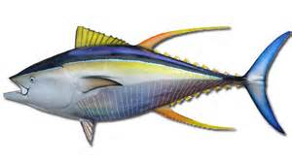  Yellow Fin Tuna | Yearly, the US harvests about 5 million tons of fish from wild fisheries and another 500,000 tons from aquaculture. This makes the United States the fifth leading producer of fish after China, Peru, India and Indonesia with about 4% of the world total. Alaska is the only state to have coastlines on three different seas: Arctic Ocean, Pacific Ocean and Bering Sea. Over half of the nation’s commercially harvested fish come from Alaska, nearly four times more than the next largest seafood producing states located in New England and on the Gulf Coast.
Livestock and Poultry

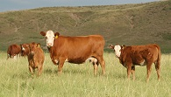  Cattle | 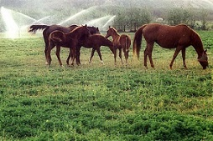  Horses
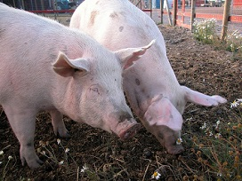  Hogs | 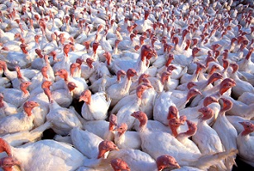  Turkeys
Most of us like a good steak now and then. We also eat a lot of chicken and like to have turkey on Thanksgiving and Christmas. I like to drink a lot of milk and eat other dairy products like pecan ice cream - all of which requires milk cows. Here are some statistics:

Type and Estimated Number | States that have the Most

Cattle and Calves  Hogs and Pigs  Chicken Broilers  Sheep and Lambs  Egg Laying Hens  Dairy Cows  Turkeys  Horses  Goats  Honeybee Colonies | 90 Million  67 Million  1.6 Billion  6 Million  355 Million  10 Million  240 Million  9.2 Million  2.6 Million  2.5 Million | Texas, Nebraska, Kansas, Iowa and Colorado  Iowa, North Carolina, Minnesota and Illinois  Georgia, Alabama, Arkansas and North Carolina  Texas, California, Colorado, Wyoming and Utah  Iowa, Ohio, Pennsylvania, Indiana and California  California, Wisconsin, New York and Idaho Minnesota, No. Carolina, Arkansas and Virginia  Texas, Oklahoma, Kentucky and Tennessee  Texas, Tennessee, California, and Georgia  California, North and South Dakota and Montana

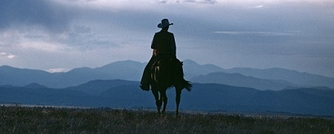
The American Rancher and Cowboy

Being a rancher or a cowboy is a hard lonely job and it is getting more difficult to make a living. Cattle ranchers are suffering through a third straight year of drought, wildfire, and rising costs. The vast majority of cattle ranchers in the United States have 500 head or fewer, and the situation for them is described as unlike any since the Dust Bowl of the 1930s. The result is a U.S. cattle herd at its lowest level since the 1950s and razor thin profit margins for ranchers. The journey from calf to supermarket shelf involves ranchers, stockers, feedlots, slaughterhouses, and consumers. All are being squeezed.

In 1870, 75 percent of the US population was employed in agriculture. Today, less than 2 percent of the population is directly employed in agriculture. There are about 1,200,000 farmers, ranchers and other agricultural managers and an estimated 760,000 agricultural workers who are legally employed in the US. There are a lot of illegal aliens working in the fields in California and other places. The median pay is less than $10 per hour or less than $20,000 per year. There are about 520,000 people under age 20 working on farms owned by their family.

Agriculture Safety and Health

Agriculture ranks among the most hazardous industries due to the use of chemicals and risk of injury. Farmers are at high risk for fatal and nonfatal injuries, work-related lung diseases, noise-induced hearing loss, skin diseases, chemical-related illnesses, and certain cancers associated with chemical use and prolonged sun exposure. In an average year, 516 workers die doing farm work in the U.S. Every day, about 240 agricultural workers suffer lost-work-time injuries, and about 5% of these result in permanent impairment. Tractor overturns are the leading cause of agriculture-related fatal injuries and account for over 90 deaths every year.

Farming is one of the few industries in which families (who often share the work and live on the premises) are also at risk for injuries, illness, and death. Agriculture is the most dangerous industry for young workers, accounting for 42% of all work-related fatalities of young workers in the U.S. An average of 108 youth, less than 20 years of age, die from farm-related injuries every year. Unlike other industries, half of the young victims in agriculture were under age 15. For young agricultural workers aged 15–17, the risk of fatal injury is four times the risk for young workers in other workplaces. Agricultural work exposes young workers to safety hazards such as machinery, confined spaces, work at elevations, and work around livestock.

Yes, farming and ranching are hard jobs and I have never had any desire to do this type of work for a living. I grew up on a small farm in Utah and I saw how hard my mother and dad had to work in order to maintain the place. I had chores to do (like milking the cow) and helping in the yard and garden. I know first-hand how hard this kind of work can be.

So, I would like to give my thanks and pay tribute to American’s farmers who’s hard work results in all the great food we have to eat.

bigdrifter44@gmail.com

