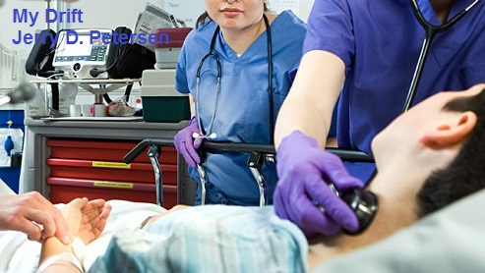

 | A Trip to the ER  10 Jun 2015 | 204-2015-11

Hopefully you are better prepared than I was when an emergency happens and you must take somebody or be taken yourself to the Hospital Emergency Room (ER). You know that people in my age group (most of you) already have one foot in the grave and trips to the ER will happen to most of us. I hope the information in this article will help when you get really sick or injured and end up at the ER.

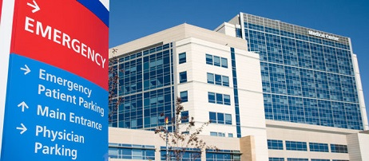

Very Important Information
I will tell you more about my trips to the ER later in this article but for now, pay attention, the information I’m about to present could save your life or the life of a loved one. At the very least, it will save you valuable time, trouble, and reduce the stress. As most of us know, hospitals are not a fun place to be – there are a lot sick people in there! Most emergency rooms are not established with the elderly patient in mind. You may have to wait for hours in a noisy, uncomfortable environment, and answer the same questions repeatedly. Being well-prepared for an emergency is not only a comfort, it's a practical necessity.

Here is what we all need to have ready to go in case of an emergency:

1. List of Current Meds
Be sure to have a complete, current list ready to go. Make sure the list includes doses and the times the medication should be taken. There is normally no need to bring the medication itself, since hospitals prefer to dispense their own.

2. List of Allergies
Note any medication or food allergies, including type of reaction and the required treatment.

3. Description of diagnoses
Keep a paper with a list of all medical conditions handy. Also include how each condition is currently being treated.

4. Doctors/Specialists Names and Phone Numbers
Take the time to compile a list of your doctors, phone numbers, and what condition they treat.

5. Insurance Cards/Information
Bring Medicare and/or private insurance cards with you to the ER. Also document any supplemental plan information. Most hospitals want to see the original cards.

6. Photo Identification
Driver’s license or another official photo ID is usually required.

7. Legal Documents
Include copies of your loved one's living will, health care proxy, and “Do Not Resuscitate (DNR)” order, if applicable. Having these documents on hand is essential in a critical situation. If you don't know your senior's wishes this is a great time to start the conversations as opposed to being in the midst of a crisis. It is also helpful to discuss having a legal power of attorney.

8. Emergency Contacts
You'll want to have both the names of emergency contacts along with their contact information for family and close friends who may want to know about you or your loved one's condition.

9. Glasses and Hearing Aid (if needed)
It's easy to overlook these, but they're critical to ensure clear communication and help your loved one feel more at ease. If he or she has a spare pair or needs extra batteries, keep them in the emergency bag.

10. Pen and Paper
It's especially hard to remember information when stressed, so have a pad and pen handy to take notes, focusing on the medical staff's explanation of the problem, treatment, and next steps, etc.

11. Comfort Items
Keep these to a minimum to avoid clutter and/or confusion. However, a favorite book or a warm blanket in case it is cold may be a welcome comfort during this distressing time.

You have all of these items ready to go – RIGHT? I’m betting you are like me and have nothing ready for an emergency.

Let’s talk about a legal document that all seniors need to have.

ADVANCE HEALTH CARE DIRECTIVE

YOUR ADVANCE DIRECTIVE FOR FUTURE HEALTH CARE is a legal document that tells loved ones, family members, friends, and doctors what your health care wishes are so that they won’t have to guess what you want if you no longer can speak for yourself.

Why do we seniors need an Advance Directive?
Medical technology makes it possible for patients with little or no hope of recovery to be kept alive for months or even years. This makes it important for you to discuss what kind of care you want before illness or an accident occurs. You can say whether or not you want to be kept alive by machines that breathe for you or feed you even if there is no hope you'll ever get better.

Specify the person you want to make decisions for you when you cannot.
This person (called your agent) does not have to be an attorney. It can be a family member or friend. Unless you limit your agent's authority, your agent has the right to accept or refuse any kind of medical care and testing, discharge or select doctors, and see all medical records.

Specify your wishes for comfort care.
You can indicate whether you want medicine for pain or where you want to spend your last days. You can also give spiritual, ethical and religious instructions.

How can I ensure that my advance directive is honored?
Share copies and talk with people who will be involved in your care. Ask your doctor to make your advance directive part of your medical records.

How to make your advance directive legal?
Ask two (2) witnesses to sign and date the form. Both must be people you know. They cannot be health care providers (like a doctor, nurse or social worker), employees of a health care facility, or the person you choose as an agent. One of the two persons cannot be related to you or have inheritance rights.
- - Or- -
Notary Public. If you do not have 2 witnesses, your advance directive must be notarized.

Okay, let’s get our Advance Health Care Directive filled out as soon as possible. But first, you need to do a few things to make sure this directive gets filled out the way you really want it. Follow the checklist below and you should be all set.

CHECKLIST
□ Talk with family members, friends, spiritual advisors, physicians, other health-care providers and other trusted people about what would be important to you if you become terminally or irreversibly ill or injured and you can no longer communicate your health-care decisions or other wishes.
□ Ask someone you trust and whom you can count on to be your health-care agent and discuss your wishes with this person. Select an alternate health-care agent in case your agent is unable to serve.
□ Complete the Hawaii Advance Health Care Directive form. The latest Hawaii (updated in Feb 2015) directive form can be found at the following website: http://kokuamau.org/resources/advance-directives
Note: Each state has their own Advance Health Care Directive form.
□ Have two qualified witnesses or a notary witness your signature.
□ Inform family members, spouse, parents, children, siblings, friends, physicians and other health-care providers that you have executed an advance health-care directive and that you expect them to honor your instructions. Keep them informed about your current wishes.
□ Give copies of the document to your health-care agent, health-care providers, family, close friends, clergy or any other individuals who might be involved in caring for you.
□ Place the executed document in your medical files. Keep a copy of the directive at home with the other item you will need if you ever have to go to the hospital Emergency Room (ER).
□ When you renew your driver’s license or state I.D, you may designate that you have an advance directive by putting (AHCD) on it.
□ Make plans to review the document on a regular basis—make a new document, if necessary, and keep people informed of any changes.
□ Do it today!

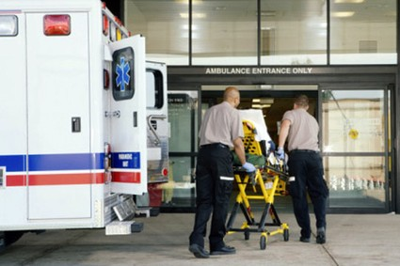 | 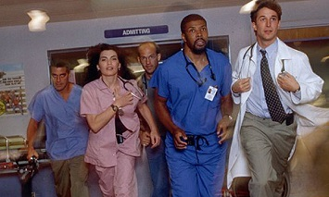

My Trip(s) to the ER
In the past couple of years, it seems like the island of Oahu has been getting more and more VOG (volcanic smog) emanating from the erupting Kilauea Volcano on the Big Island. It has blanketed Oahu, 200 miles to the northwest, on a regular basis. The normal wind direction for the Hawaiian Islands is from the Northeast which we call the Trade Winds. These winds are our natural air conditioning system. They are the reason for our great Hawaii weather. However, VOG comes up the island chain when the wind switches direction and comes from the South.

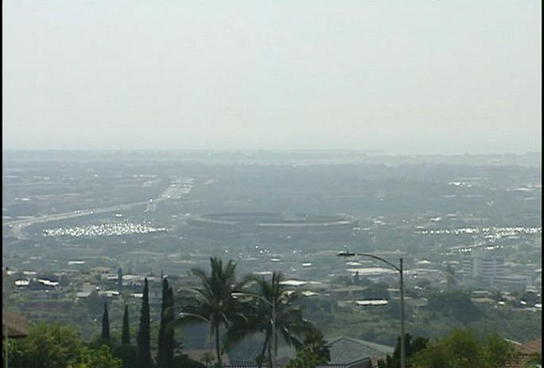
A picture of Aloha Stadium looking toward Honolulu and Diamond Head

Friday, 8 May 2015
The VOG is sending a lot of people with respiratory problems to the doctor and to hospital emergency rooms. My wife, Patsy, has Asthma and Heart Disease that is affected by the VOG every time it comes to Oahu. She usually stays in the house with the windows closed with the fans and air purifiers blasting. She uses an Asthma inhaler when she has a hard time breathing. This routine has worked over the years but on Friday, 8 May 2015, she called me at work and said she could not breathe and was coughing up yellow mucus with blood in it. She called her primary care doctor, Clive Otsuka, for an appointment that day. Dr. Otsuka prescribed a strong steroid inhaler, a nebulizer to help her breathe, and an antibiotic for the infection. I went to COSTCO to fill this prescription that same day.

Saturday / Sunday, 9-10 May 2015
These new medicines seemed to be helping and she was able to get her hair done and cook dinner on Saturday, 9 May 2015. Sunday was Mother’s Day. Our daughter Tracy called from Erie, PA and our son and family come to the house to deliver presents and pick up some food (turkey, mashed potatoes, etc.) leftover from the night before. Patsy was short of breath and tired but she made it through the day. We all (Patsy, me, and our dogs Monty and Patti) went to bed early.

Monday, 11 May 2015
The next thing I knew, it was 2:30AM and Patsy was waking me up saying she needed to get to the hospital. She could not breath, could hardly talk, and was not walking too well. I jumped up immediately, got dressed, and went to the bathroom. I grabbed her purse and helped her to the car. Patsy has a hard time getting into my truck even when she is feeling good so we needed to take her Lexis. You might find this hard to believe but we purchased this car in 2011 and this would be my first time driving it – 2:45AM in the morning, I’m very nervous with a very sick wife slouched over in passenger seat. I push the button to start the car and nothing happens. I’m used to inserting and turning a key to start my truck. So, after pushing the button several times, she asks me if I have my foot on the brake. How in the world I’m I supposed to know these things? Finally, we are on the way to the hospital but I’m not sure which one. Patsy’s hospital is Kuakini located in Honolulu about 45 minutes away. We decided that she might not made it for that long and we headed for Wahiawa General Hospital 15 minutes away.

When we reached the hospital at 3AM, I discover that the emergency room was being remodeled and the normal entrance was closed. I had to drive around the block to find out where to go in. I parked right where the sign says, “Ambulances Only” and run in to get help. A couple of ER attendants come out with a wheel chair and we finally got my wife into the ER. While they were getting her hooked up with some oxygen, I’m called to the counter to provide the required information. The first things they wanted to see was her insurance cards and driver’s license. I start to fill out the forms when I can hear sirens close by and I’m told to move the car immediately – there is an incoming ambulance. I ran outside to find the ambulance already there honking the horn and yelling at me to get that car out of the way – I do it. When I go back in the ER, the doctor pulls me to the side and tells me that they think my wife has suffered a heart attack and she needs treatment as soon as possible. This is when he asks me if she has an Advanced Health Care Directive? When I say no, the doctor asks us questions about her wishes in case of a life or death situation. The doctor also wanted to know what medical conditions my wife had, what medicines she was taking, and to provide a list of her doctors. I had no idea what medicines she was taking so the doctor told me to go home and gather up all of her medicines and bring them right back to the ER.

Patsy has a table in the living room she uses for her medical stuff. On one side of the table is her diabetes and blood pressure testing equipment along with a daily log she keeps. On the other side of the table is about 30 bottles of various medicines and vitamins along with two daily pill organizers. I throw all the pill bottles and the two pill organizers into a plastic bag. I make sure the dogs are ok | 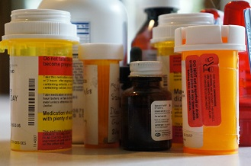
and head back to the hospital. Patsy doesn’t look good and is barely conscious but the doctor goes through all of the meds in the plastic bag to determine what she is taking, the dosage, and the time of day she take it. There were 3 or 4 bottles of medicines that she no longer takes. I have no idea why they were still on the table. Next, they moved her to the intensive care unit (ICU) and tell me to go home since they will be conducting tests all morning and not allowing visitors.

BIRTHDAY BOY AND GIRL
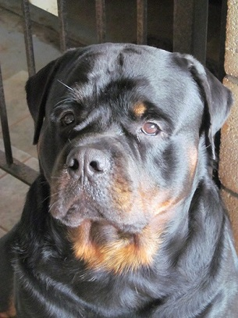
Monty | Tracy

I call our son Mike and our daughters Tracy and Toni. Tracy lives in Erie, PA and it is her birthday today. I wished her a happy birthday and then give her the bad news about her mother. It was also our male Rottweiler Monty’s birthday – he is 4 years old. Patsy planned to cook him a big New York Steak for his birthday. I also call Patsy’s primary care doctor (Clive Otsuka) to let him know what was going on and to cancel Patsy’s appointment.

When I went back to the hospital in the afternoon, the doctor tells me that Patsy is in very critical condition and will probably need heart surgery for a collapsed artery. But first they need to get the fluids out of her lungs and get the infection under control. Apparently, an asthma attack triggered all of these problems – cannot breathe, infection, fluids in the lungs and around the heart, cough, and a collapsed heart artery. The doctor called it congestive heart failure and told me that they don’t perform heart surgery at Wahiawa General Hospital. When she is stable, they will need to transport her to Queens Medical Center or Kuakini Medical Center. Since Patsy had heart bypass surgery at Kuakini in 1999 and her doctors are close by, we picked Kuakini Hospital. It was time for me to go home to feed the dogs and to get some sleep.

Tuesday, 12 May 2015
When I go to the hospital in the morning, the nurse tells me that Patsy is doing much better after they removed two liters of fluids from her lungs and other organs plus getting the infection under control. She was even well enough to eat something. The big issue now is the heart. It was damaged by the failure and possible heart attack – one artery had collapsed.

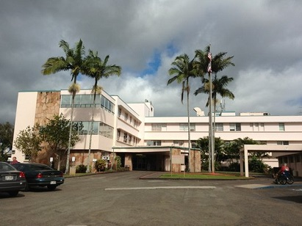 | 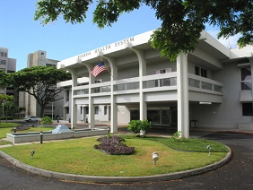
Wahiawa General Hospital | Kuakini Medical Center

They moved her from Wahiawa General Hospital to Kuakini Medical Center in the afternoon by ambulance. They put her in the Cardiopulmonary Unit. When I visited that evening, I asked her if they had the sirens blasting on her trip to Honolulu. She said, “Yes.”

Wednesday, 13 May 2015
This morning they are running various tests on her heart. The two primary tests were the computerized tomography (CT) scan that combines a series of X-ray images and uses computer processing to create cross-sectional images of the blood vessels and a coronary angiography where they put dye in the blood to pin point blockages in the heart. Based on the results, her heart doctor (Steven Azuma) performed surgery later in the day to put in the required stents in her heart arteries. Patsy started feeling better almost immediately after the surgery. When I visited that evening, she told me that she wanted to go home the next day.

Thursday, 14 May 2015
Patsy called me in the morning to tell me that Dr. Azuma said she could go home at about noon. So I took the Lexis to the hospital expecting to take her home at about noon. When I arrived at her hospital room, the nurses were helping her walk down the hallway. When she come back, she was a little out of breath but said she felt good. We did have a small problem, however, since the hospital doctor said he was not going to release her and wanted more tests conducted. He also wanted her to see a lung doctor which he recommended. Patsy decided that the Kuakini doctors were trying to take over from her regular doctors and she didn’t like that. She told the doctor that she was not going to answer any more questions, she was not going to have any more tests, she would see a lung doctor if Dr. Otsuka recommended one, and she was going home. About this time she took out and off all the monitoring tubes and went into the bathroom to get dressed. The nurse attempted to explain the situation and fact that the hospital needed to release her or else she would be listed as an “uncooperative patient”. About this time, Patsy gets a phone call from the head hospital doctor who says they are preparing her release papers and she can go home at 2PM.

It appeared that Patsy was back to normal! They give her some verbal and written instructions and took her down to the front of the hospital in a wheel chair. I went to get the car and picked her up to go home. She complained about the doctors at Kuakini all the way home and said she didn’t want to go back to that hospital ever again.

When we got home, she called her friend Yuki (who has similar problems) and talked mostly about her treatment at Kuakini Hospital. Next she called our daughter Tracy in Pennsylvania (who had offered to come home and help care for her) to see if she could come to Hawaii. Tracy said yes and would try to get flights setup right away. Our dogs were very happy to see Patsy come home and they were even more happy when they each got a belated Monty birthday steak.

Friday, 15 May 2015
Patsy said she had about six hours sleep – more than she had had in months. She was feeling good. Later she made the required doctor appointments with Dr. Otsuka (general), Dr. Azuma (heart), and Dr. Ng (kidneys). Tracy called and said she was arriving on Monday at about 2PM. I notified my office that it looked like I could come back to work on Monday.

Saturday / Sunday, 16-17 May 2015
Patsy seemed to be doing okay over the weekend but I noticed that she was starting to cough on a regular basis. She also started showing signs of being out of breath when walking around the house. She told me that she didn’t have a cold and thought her new medication was causing the cough. She said that she was okay.

Monday, 18 May 2015
I went to work on Monday morning but I was worrying about my wife’s condition – I could hear her coughing in the night. I went home early about noon. Tracy flies in today and will rent a car and be home sometime in the late afternoon. Actually her flight was early and she got home about 2:30PM. Monty remembers Tracy from her vacations here and he really likes her. Our girl Rottweiler Patti could not get close to Tracy or else Monty would jump on her and growl. Patsy and Tracy sit in the family room and get caught up on everything going on. Later, Patsy sends me to Zippy’s to get her a turkey dinner. Tracy goes with me because she misses the local food and she wants to see what is available. She orders a beef curry plate and I get a bowl of chili with crackers.

Tuesday, 19 May 2015
I go to work in the morning but about 7AM I get a call from home telling me that Patsy is having trouble breathing again and Tracy is taking her to Wahiawa General Hospital ER. She is not as bad this time but the doctor tells us that it appears to be another congestive heart failure. Later that morning they move her to a regular private hospital room on the second floor.

Wednesday / Thursday, 20-21 May 2015
Patsy is coughing constantly and says she cannot breathe when laying down flat. So, most of the time she is sitting up in bed or on the edge of the bed. It is hard to get any sleep under these conditions. On Thursday morning when I go to visit I notice four nurses and attendants in her room. I’m wondering what is going on hoping it is nothing serious. I get to the room and my wife is sitting in a chair I have not seen before. The nurse in charge tells me that Patsy fell out of bed onto the floor and could not get up. They had just got her into the chair a little while before I got there – she didn’t seem to be hurt. She said that she slowly slid off of the bed on her feet but lost her balance and went down the rest of the way. Patsy said she was on the floor for 4 or 5 minutes waving at people going by her room before the hospital staff come to help her. They found a more comfortable chair and now she spends most of the time in the chair so she can breathe and not fall off the bed again.

Friday / Saturday, 22-23 May 2015
She seemed to be feeling a little better today and she asked me to go buy a nice comfortable easy chair for the family room. She wanted a rocking chair with an Ottoman (footstool) – not a recliner. It had to be made of high quality leather and either black, dark brown, or a gray color. Patsy thinks that she may need to sleep on this chair in the future (after she gets released) when she has breathing problems. The chair she was currently using is just a straight back dining table chair with a cushion on the seat.

So, after I leave the hospital, I go looking at chairs. I go to Home World in Aiea and Ashley Furniture in Salt Lake area of Honolulu. All of the chairs I saw that she might like, I took a picture of them with my iPhone. Saturday morning I showed my wife all of these pictures and she picked out one she liked the best. I took Tracy along with me to the furniture store so that I don’t
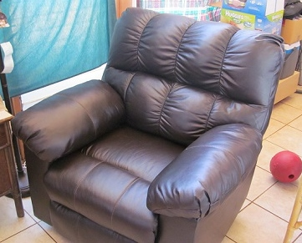 | mess up this purchase too bad and to help me get the chair home in my truck and setup correctly. The chair my wife picked out was actually a recliner and not made of real leather. We finally found one that met most of the conditions – It rocked but also had an electric recliner feature. We decided that she didn’t have to use this feature if she didn’t want to. I
bought this chair. The other problem was it didn’t come with a footstool and neither store had one in the right color – dark brown. We are still looking for one. This chair alone cost more than a thousand dollars.

Sunday, 24 May 2015
Patsy said I didn’t need to come to the hospital today since both Tracy and Mike were going to visit. She preferred that I stay home with the dogs. Tracy showed Patsy a picture of the chair and thinks that she likes it. I took the dogs for a ride, cleaned the pool, and did some washing. Tracy finished cleaning the house – it looks good. Tracy offered to take me out to dinner and we went to Ruby Tuesday’s for burgers and beer. We sit at a table in the bar area where I could watch the last quarter of the NBA playoff game between Cleveland and Atlanta. The food was good and we had a good time.

Monday, 25 May 2015
Today is Memorial Day. We are having a family together at our house. Mike barbecued steaks, shrimp, and hot dogs (for me and the grandkids). Mike’s wife Tif brought some food items and made rice at our house. We had beer and wine plus ice cream and red velvet cake for dessert. Everybody including the dogs had a great time. However, this was first family together since we purchased our home in 1975 that my wife Patsy was not present. We all missed her.

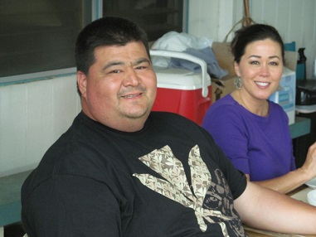
Mike and Tracy eating at our outside table

Kayla and Nick Playing in the Pool | Our Dog Patti Playing with the Kids

Tuesday, 26 May 2015
After letting the dogs out to do their business and feeding them, I went to work for a half of day. I found a dark brown footstool online at Sears so stopped at Pearl Ridge Sears store to see if they had it. They didn’t but said they could order it and it would be here in about 30 days. That is too long so I didn’t buy it.

When I got home, Tracy had already left for the hospital. Patsy’s condition has improved a little and they had her up and walking around the hospital. The doctor is trying to regulate her oxygen level which is too low. There is still a small amount of water (or fluids) in her lungs that they can’t seem to get out. This is causing her dry cough and restricting her breathing when she lays flat on the bed. She may need an oxygen tank at home when they release her so she can breathe normally. However, there is still no release date.

Wednesday, 27 May 2015
I worked in the morning and come home about 11AM. Tracy went to the hospital and I cleaned up the yard a little bit. Two big Rottweilers can generate a lot of poop and you need to pick it up almost every day. When Tracy returned to the house she said Patsy was about the same. Doctors were checking to make sure she doesn’t have blood clots in her legs. They also took another x-ray of the chest to check the lungs for fluids and to find out if she has Pneumonia.

This is going home day for Tracy. She packed her bags and left the house about 4PM heading for the airport. Tracy has been a huge help the past 8 or 9 days. She cleaned the entire house and did most of the visiting at the hospital. Her being here also allowed me to go to work most days. Life for me and the dogs just became more difficult.

Thursday, 28 May 2015
Patsy called me at about 5AM to tell me she has Pneumonia and to bring a warm blanket, a sweater, and another box of Kleenex to the hospital. She said it gets cold at night and the hospital blankets are not warm enough. I showed her the picture of the footstool Sears is selling online and she told me to buy it. She can always use her old one until it comes in about 30 days.

Tracy called me to let me know that she arrived safely in Buffalo, NY and would be driving her own car to Erie, PA which is about 2 hours away. I give her the latest update on Patsy. Now that they are treating her with antibiotics for Pneumonia, the earliest she could be leaving the hospital is Monday.

Friday, 29 May 2015
Patsy called me at 5AM to tell me that she needs a clean sweater. They got blood all over the one she was wearing when they changed the IV needle. This is the second day in a row that has happened. The good news is she was not coughing so much and she was able to get 2 or 3 hours of sleep. She is hoping that the hospital will release her on Saturday or Sunday. She give me a list of about 10 things she wanted me to buy for her to eat when she comes home. Patsy calls me about 7PM and asks me to bring her two diet 7-Ups and one Lipton Green Tea. The doctor told her she was well enough to have the diet drink of her choice. I make a quick ran to the hospital since visiting hours end at 8PM. While there, the male patient in the next room is screaming “NURSE” “NURSE” – “I’M BLEEDING”. Patsy said that this guy screams and hollers all night long and the nurses have been ignoring him. Hospitals are not fun places – especially at night.

Saturday, 30 May 2015
Great news!! Patsy calls me and says the doctor told her that if the chest x-ray looks good and her oxygen level stays up after her walk, she can go home tonight. At about 6PM Patsy calls me and tells me to come get her – the hospital is releasing her. She tells me to bring her going home clothes (that Tracy got ready) and a trash bag for her blanket, pillow, and other personal stuff. She also tells me to bring my truck and the little step thing so that she can get in. It has been raining and she doesn’t want the Lexis to get dirty.

Monty and Patti are waiting by the gate. I help her to a chair before letting the dogs get to her. Monty jumps up on her and starts licking her face. Monty is Patsy’s baby! Monty won’t let Patti get near her. Once all the greetings are done, we get her in the house and to her brand new easy chair. I think she likes it. I turn on our two air purifiers and get her some ice for her cup. Once things appear to be okay, I go take a shower and go to bed. I sure hope Patsy don’t have any breathing problems in the night – I’ve been to the ER and the hospital too many times already.

There are a few pictures of Patsy on the next page.

bigdrifter44@gmail.com

Some Pictures

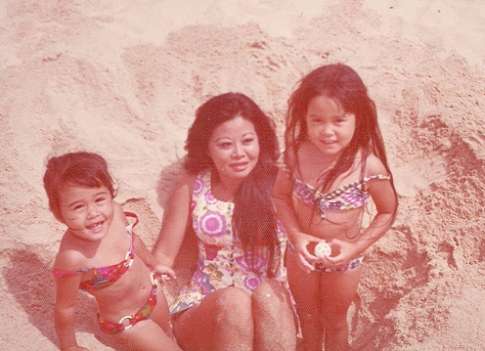 |  | 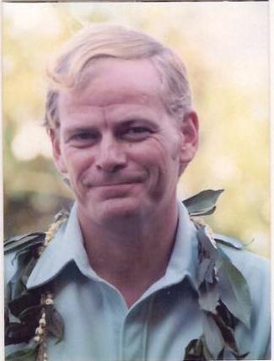 | 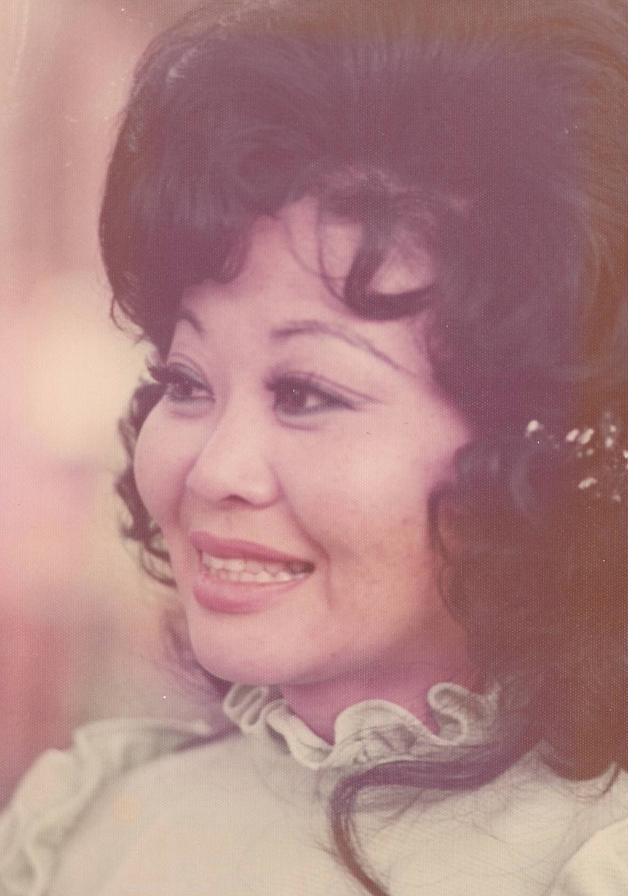
Patsy at the Beach with Toni and Tracy | Patsy and me on our Wedding Day

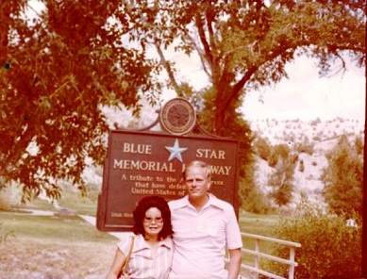 | 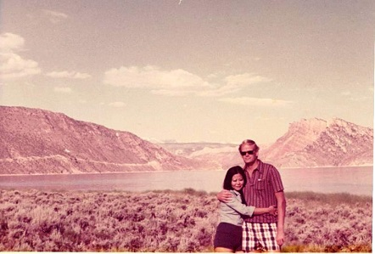
Patsy and me at a small park up Spanish Fork Canyon, Utah | Patsy and me at Flaming Gorge Reservoir on the Utah and Wyoming Border

 | 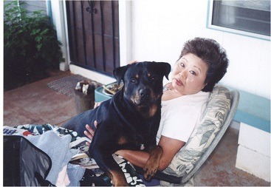
Patsy with my brother Scott doing a little target shooting out west of Utah Lake | Our previous Rottweiler Kudo with Patsy after her 1999 heart surgery

