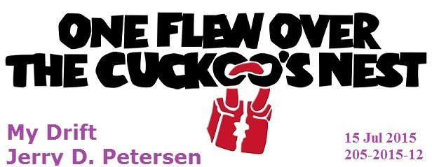

The other night I watched “One Flew over the Cuckoo's Nest” again for at least the 20th time. In fact, I try to watch it every time it is on TV during my TV watching hours of 5-10PM. I think it is one of the greatest movies ever made. Whenever I get thinking about crazy people, I always remember this movie. Just in case you never saw it or can’t
remember what it was about, I will provide you with the plot, a few pictures, and a little bit about the primary cast members that are shown below.

Cast
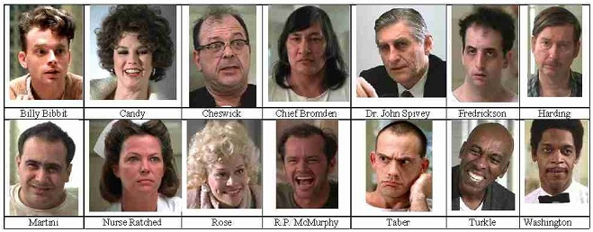

The Setting
The movie is set in an Oregon mental asylum in the year 1963. Randle Patrick "Mac" McMurphy (Jack Nicholson), an anti-authoritarian criminal serving a 6 month sentence on a prison farm for statutory rape of a 15-year-old girl, is transferred to a mental institution for evaluation. McMurphy is delivered to the asylum wearing handcuffs. When he attempts to greet a very tall Native American, called Chief Bromden, he is met with a blank stare and no response. Billy Bibbit, the youngest patient in the ward who has a marked stutter, informs McMurphy that Bromden is a deaf-mute. When the hospital psychiatrist, Dr. Spivey, meets with McMurphy, he tells him that the prison officials believe he is faking mental illness and informs him that the hospital staff will be evaluating him to determine whether he should be returned to complete his sentence or remain at the asylum. Although he does not show any overt signs of mental illness, McMurphy hopes to avoid hard labor and serve the rest of his sentence in a more relaxed hospital environment - So he acts crazy.

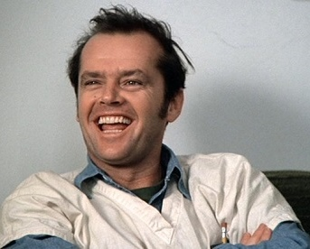  McMurphy | 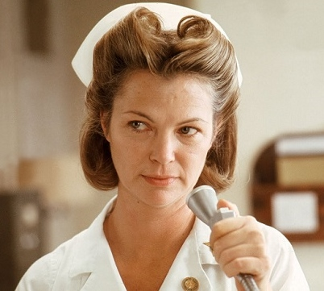  Nurse Ratched

The men’s ward is run by steely, unyielding Nurse Mildred Ratched (Louise Fletcher), who employs subtle humiliation, unpleasant medical treatments and a mind-numbing daily routine to suppress the patients. McMurphy finds that the patients are more fearful of Ratched than they are focused on becoming functional in the outside world. McMurphy establishes himself immediately as the leader; his fellow patients include Billy Bibbit (Brad Dourif), a nervous, stuttering young man; Charlie Cheswick (Sydney Lassick), a man disposed to childish fits of temper; Martini (Danny DeVito), who is delusional; Dale Harding (William Redfield), a high-strung, well-educated paranoid; Max Taber (Christopher Lloyd), who is belligerent and profane; Jim Sefelt (William Duell), who is epileptic; and "Chief" Bromden (Will Sampson), a silent Native American of imposing stature believed to be deaf and mute.

The Daily Routine
Nurse Ratched maintains firm control over everything in her ward. In the day room, calm music blares from a record player, as she and her assistant, Nurse Pilbow, hand out the daily medications to the patients. McMurphy arrives at Ratched’s ward just as she is leading the daily group therapy session in which she urges the men to discuss the marital and sexual problems of Harding, a well-spoken, educated patient who suspects his wife of infidelity. The men are at first reluctant to speak up, but Ratched encourages them to talk. Due to the intrusive nature of the discussion, Harding becomes upset, causing tension to rise within the group. The session ends with loud arguments that prompt the orderlies to physically remove some of the patients out of the room to restore the peace.

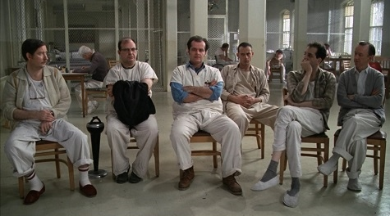
Daily Group Therapy Session

McMurphy encourages his fellow patients to play blackjack, instead of their usual pinochle, using cigarettes to represent dimes. When McMurphy asks Ratched to turn down the music so the men can hear each other, Ratched refuses, explaining that the older men who are hard of hearing would not be able to enjoy it. McMurphy balks at taking his medication, but Ratched convinces him to cooperate by offering to administer the medicine in another way.

Watching the World Series
At the next group session, McMurphy suggests changing the work detail, so that the men can watch the opening game of the World Series on television. Ratched patiently explains that making changes would disturb the men in the ward who take a long time adjusting to a schedule. She suggests taking a vote, but most of the men are reluctant, even fearful, of voting against her will. McMurphy gets only two votes. Later, in the “tub room” of the asylum, McMurphy suggests that they leave the asylum to watch the game at a bar, but the men explain that they are locked in. McMurphy bets them that he can get them out and attempts to lift a large marble washing station with which he plans to break open a window, but finds it way too heavy. When he finally gives up, he tells the others that at least he tried.

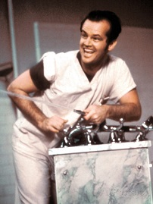  Marble Washing Station | 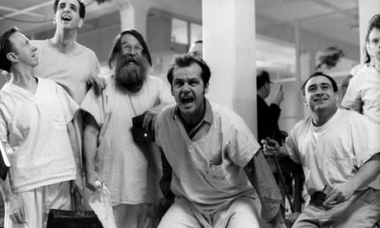  Watching the World Series on a Blank TV Screen

The next day in group session, Nurse Ratched mercilessly presses Billy Bibbit about a girlfriend, his mother, and his first suicide attempt until Cheswick comes to the hapless Billy’s defense. Cheswick joins McMurphy in demanding that they watch the World Series, and they force another vote. When all the men in group raise their hands, Nurse Ratched informs them that the “chronics”—the most severe, withdrawn patients—also must vote. McMurphy tries in vain to get any of these catatonic lost souls to respond, and Nurse Ratched adjourns the meeting. Belatedly, the Chief raises his hand to break the tie, but Nurse Ratched refuses to count his vote. Although she appears to have won, McMurphy sits in front of the dark television screen and begins to call the baseball game play-by-play. The other men join him in wonder, cheering imaginary hits and runs under his contagious enthusiasm. Nurse Ratched demands that they stop shouting, but for once she cannot control them.

The Basketball Game
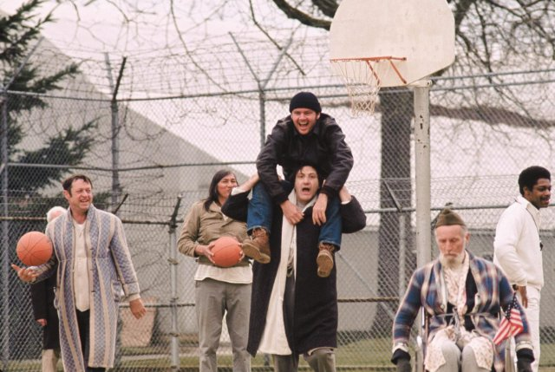 | McMurphy's lessons on basketball are effective, and he is able to successfully coach and organize games with the patients against the guards. With his statuesque height, Chief Bromden steals the show, standing at one end of the court with hands held high in the air to dunk baskets, and disallowing baskets at the opponent’s end of the court.
Fishing Excursion
As the men are preparing to go on an outing, McMurphy impulsively asks Bromden to help him over the barbed wire fence that runs around the hospital. On the other side, he hides in the empty bus until the men board, then he drives the bus away, leaving the asylum staff behind. After picking up Candy and Rose, friendly prostitutes with whom he is acquainted, he takes the | 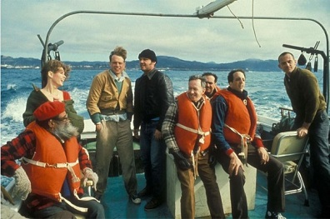
men to the Marina where he convinces the harbor master to let them charter a boat. He introduces himself and his cohorts as doctors from the mental institution. He teaches the men how to bait a hook and puts Cheswick in charge of the ship’s wheel. McMurphy tells them: "You're not nuts, you're fishermen!" and they begin to feel faint stirrings of self-determination. When the fishing trip ends, they return to the waiting hospital staff and police who accompany them back to the nut house.

Electroshock Therapy
A few days later, McMurphy learns that Nurse Ratched and the doctors have the power to keep him committed indefinitely. Sensing a rising tide of insurrection among the group, Ratched tightens her grip on everyone. During one of her group therapy sessions, Cheswick's agitation boils over and he, McMurphy, and the Chief wind up brawling with the orderlies. They are sent up to the "shock shop" for electroshock therapy. While McMurphy and the Chief wait their turn, McMurphy offers Chief a piece of gum, and Chief murmurs "Thank you...Ah, Juicy Fruit." McMurphy is delighted to find out that the Chief is neither deaf nor mute, and that he stays silent to deflect attention. After the electroshock therapy, McMurphy shuffles back onto the ward feigning brain damage, before humorously animating his face and loudly greeting his fellow patients, assuring everyone that the ECT only charged him up all the more.

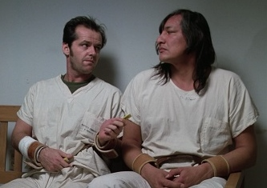 | 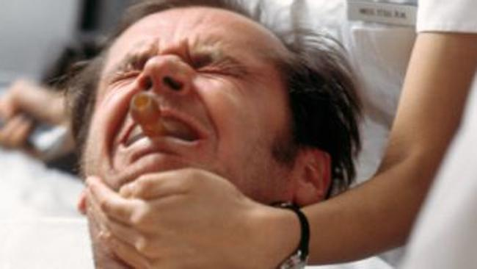

The Christmas Party
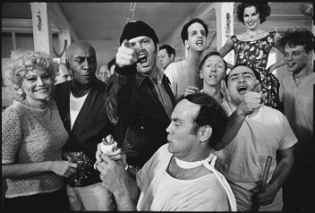 | As the struggle with Ratched takes its toll, and with his release date no longer a certainty, McMurphy plans an escape. He phones Candy (Mews Small) to bring her friend Rose (Louisa Moritz) and some booze to the hospital late that night. They enter through a window after McMurphy bribes the night orderly, Mr. Turkle (Scatman Crothers).
McMurphy and the girls invite the patients into the day room for a Christmas party; the group breaks into the drug locker, puts on music, and enjoys a drunken orgy rampage.

At the end of the night, McMurphy and the Chief prepare to climb out the window with the girls. McMurphy says goodbye to everyone, and invites an emotional Billy to escape with them; he declines, saying he is not yet ready to leave the hospital—though he would like to date Candy in the future. McMurphy insists Billy have sex with Candy right then and there. Billy and Candy agree and they retire to a private room. The effects of the alcohol and pilfered medication kick in and take their toll on everyone, including McMurphy and the Chief, whose eyes slowly close in fatigue.

McMurphy Chokes Nurse Ratched
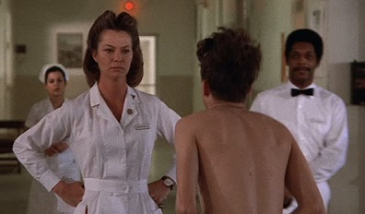  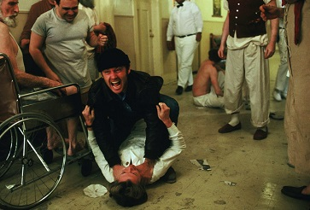 | Nurse Ratched arrives the following morning and discovers the scene: the ward completely upended and patients passed out all over the floor. She orders the attendants to lock the window, clean up, and conduct a head count. When they find Billy and Candy, the other patients applaud and, buoyed, Billy speaks for the first time without a stutter. Ratched then announces that she will tell Billy's mother what he has done. Billy panics, his stutter returns, he starts punching himself and then locks himself in the doctor's office. Locked inside, Billy kills himself. McMurphy, enraged at Ratched, chokes her nearly to death until orderly Washington knocks him out.

Sometime later, the patients in the ward play cards and gamble for cigarettes as before, only now with Harding dealing and delivering a pale imitation of McMurphy's patter. Ratched, still recovering from the neck injury sustained during McMurphy's attack, wears a neck brace and speaks in a thin, reedy voice. The patients pass a whispered rumor that McMurphy dramatically escaped the hospital rather than being taken "upstairs" for extensive electroshock therapy.

The Chief Escapes
Late that night, Chief sees McMurphy being escorted back to his bed, and initially believes that he has returned so they can escape together, which he is now ready to do since McMurphy has made him feel "as big as a mountain". However, when he looks closely at McMurphy's unresponsive face, he is horrified to see lobotomy scars on his forehead. Unwilling to allow McMurphy to live in such a state, the Chief smothers McMurphy to death with his pillow. He then carries out McMurphy's escape plan by lifting the watering station console off the floor and hurling the massive fixture through a grated window. Chief climbs through the window and runs off into the distance, with Taber waking up just in time to see him escape and cheering as the others awake.

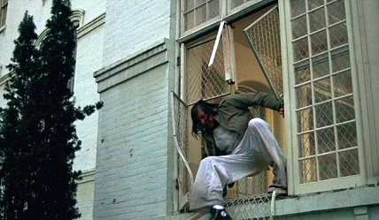

THE END

Movie Statistics and Awards
Film Release Date  Running Time  Distributed by  Budget to Make  Box Office Take  Screenplay by | Nov 19, 1975  133 minutes  United Artists  $3 Million  $120+ Million  Lawrence Hauben  Bo Goldman | Directed by  Produced by  Music by  Starring | Milos Forman  Saul Zaentz  Michael Douglas  Jack Nitzsche  Jack Nicholson  Louise Fletcher

The “One Flew over the Cuckoo's Nest” film was based on the 1962 novel “One Flew over the Cuckoo's Nest” by Ken Kesey. The film is one of three to ever win all five major Academy Awards (Best Picture, Actor in Lead Role, Actress in Lead Role, Best Director, and Best Screenplay) following “It Happened One Night” in 1934 and not repeated until 1991 by “The Silence of the Lambs”.

Yes, “One Flew over the Cuckoo's Nest” was and still is a great movie.

bigdrifter44@gmail.com

