My Drift | Jerry D. Petersen | BIG FISH  December 4, 2013  (170-2013-20)

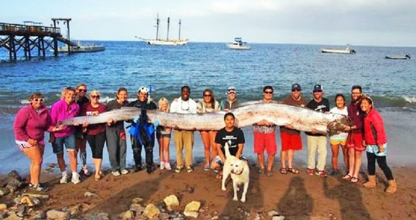

Giant Oarfish

The picture of the 18-foot long Giant Oarfish that recently washed ashore in California was all over the Internet. I have never heard of this fish before and besides it looks more like a big snake than a fish. So, I did some research and here is what I learned about the Giant Oarfish and other big fish.

The Giant Oarfish is the world's longest bony fish. It can reach lengths of 36 feet and weights of about 600 pounds. Its shape is ribbon-like, narrow laterally, with a dorsal fin along its entire length, stubby pectoral fins and long, oar-shaped pelvic fins, from which its common name is derived. Its coloration is silvery with dark markings, and its fins are red. Its physical characteristics and its undulating mode of swimming have led to speculation that it might be the source of many "sea-serpent" sightings. The Oarfish stays in deep ocean water and is not fished commercially. People who have tried eating the Oarfish say that fish meat texture is gooey and tastes terrible.

Most of us know that the Blue Whale is the largest known animal (or fish) to ever swim in the ocean. The Blue Whale reaches lengths of 100 feet and weights of about 170 tons (340,000 pounds). But, Whales (like Dolphins) are marine mammals and are not a fish. Marine mammals are warm blooded, do not have gills, and have to come to the surface to breathe fresh air. Yes, they are mammals just like us humans. I will write more about Whales some other day.
How do fish breathe under water? Humans and fish both breathe the same oxygen that's in the air. But the difference is that fish get their oxygen from the water. How? They have sets of thin flat lacy things called gills instead of lungs. They suck water into their mouths and then push it out through these gills which are located on either side of their mouth. As the water flows out, their gills pick up the oxygen in water so they can breathe.

What is the difference between saltwater fish and freshwater fish? Freshwater fish live in lakes, rivers and streams with fresh water, while saltwater fish live in oceans and seas with salt water. This difference is really the key to all other differences between the two types of fish. Because of the process of osmosis, which dictates that water flows from areas of low salinity to high salinity, saltwater fish lose water to their environment and constantly have to drink to maintain the balance and remain healthy. Freshwater fish, in contrast, have more salt in their bodies than in the surrounding water. They do not have to drink, but rather absorb water through their cells. Fact: 60% of all fish species live in saltwater.

There are some fish like the Salmon and the Bull Shark that can survive in both saltwater and freshwater. Salmon are born in freshwater rivers, then swim to the ocean where they spend most of their lives before returning to fresh water rivers to reproduce (spawn) and die. River sharks like the Bull Shark are born in the ocean but can thrive in both saltwater and freshwater and can travel far up rivers. They have even been known to travel as far up the Mississippi River as Illinois. They are also found in the Ohio River. Although there have been few recorded freshwater attacks, Bull Sharks are probably responsible for the majority of near-shore shark attacks in the Gulf of Mexico and Atlantic coast states.

The largest fish in the world is the Whale Shark.  The whale shark is a slow-moving filter feeding shark and the largest known fish species. They can grow up to 46 feet long and weighing 66,000 pounds or more. Yes, the whale shark holds many records for sheer size in the animal kingdom, most notably being by far the largest living non-mammal, rivalling many of the largest dinosaurs in weight. The whale shark is found in tropical and warm oceans and lives in the open sea with a lifespan of about 70 years. | 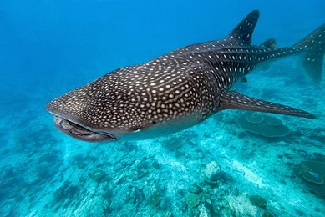  Whale Shark

The second largest fish in the world is the Basking Shark.  The basking shark like the whale shark is a plankton-eating (small and microscopic organisms drifting or floating in the sea) using its greatly enlarged mouth and highly developed gill rakers. This species is found in all the world's temperate oceans and will migrate to warmer water during the winter. They can grow to over 40 feet long and weighing up to 40,000 pounds. Commercially, it is fished for food and fishmeal, the hide for leather, its liver for oil, and for its fins for shark fin soup. | 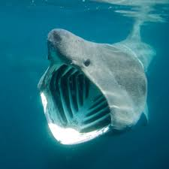  Basking Shark

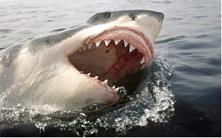  Great White Shark | The most feared fish in the ocean is the Great White Shark. It can be found in the coastal surface waters of all the major oceans. The great white shark is mainly known for its size, with the largest individuals known to exceed 20 feet in length and 5,000 pounds in weight. This shark has a life span of over 30 years. The great white shark is regarded as the "ultimate predator" of the seas because it has no natural predators. The blockbuster film “Jaws” by Steven Spielberg depicted the great white shark as a "ferocious man eater".

The biggest and most feared fish in Hawaii waters is the Tiger Shark. The Tiger Shark is a relatively large attaining a length of up to 16 feet and weighing 2,000 pounds. It is found in many tropical and temperate waters, and it is especially common around central Pacific islands. Its name derives from the dark stripes down its body which resemble a tiger's pattern, which fade as the shark matures. So far this year (2013), there have been 12 shark attacks (one was fatal) in Hawaii – half of them in Maui waters and all of them by Tiger Sharks. | 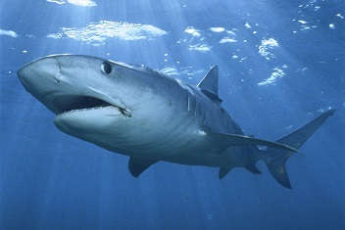  Tiger Shark

As you might have guessed, sharks are the biggest fish swimming around in the ocean.

There are two (2) primary classes of fish in the ocean – Bony and cartilaginous. Around 400 million years ago, fish evolved into two very different ‘classes’. One of them is cartilaginous, which includes sharks, rays and chimeras. This class of fish have skeletons made of cartilage. The other class is bony because these fish have skeletons made of bones. Although the two groups once shared a common ancestor, there are several major biological differences between them. There are about 25,000 living species of the bony fish with only 1,100 species of cartilaginous fish.

The Ocean Sunfish is the heaviest bony saltwater fish. The Ocean Sunfish is the heaviest known bony fish in the world. It can weigh up to 5,000 pounds. The species is native to tropical and temperate waters around the globe. It resembles a fish head with a tail, and its main body is flattened laterally. Sunfish can be as tall as they are long (6 to 10 feet) when their dorsal and ventral fins are extended. Sunfish are considered a delicacy in some parts of the world, including Japan, the Korean peninsula and Taiwan. | 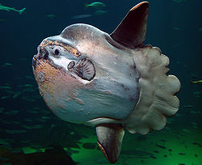  Ocean Sun Fish

Biggest game fish in the world are the Blue Marlin, Swordfish, and Atlantic Bluefin Tuna.

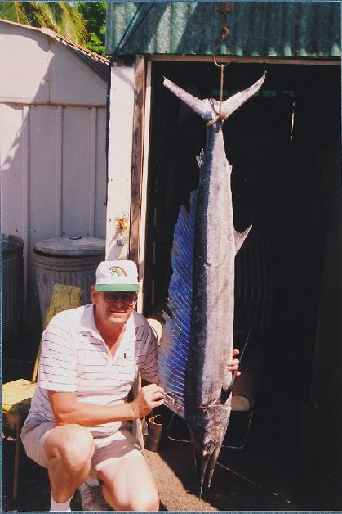  My Biggest Fish – a Blue Marlin | 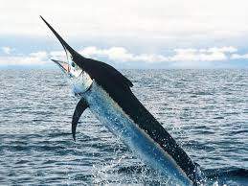  Swordfish  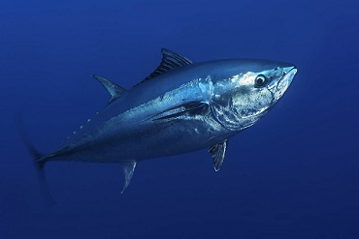  Atlantic Bluefin Tuna

Blue Marlin has an elongated body, a spear-like snout or bill, and a long, rigid dorsal fin which extends forward to form a crest. The larger species can reach 16 feet in length and 1800 pounds in weight. Marlins are very fast swimmers, reaching speeds of about 70 miles per hour. They are popular sporting fish in tropical areas. More Blue Marlin fish are caught by rod and reel in the Hawaiian Islands than anywhere in the world. Over 60 fish of over 1,000 pounds have been caught in Hawaiian waters, including the two largest marlin ever caught on rod and reel: a 1,805 pound fish caught from Oahu by Capt. Cornelius Choy and a 1,656 pound fish caught off Kona by angler Gary Merriman aboard the Black Bart, skippered by Capt. Bart Miller, in March 1984. The town of Kona on the leeward coast of the Big Island of Hawaii is internationally known for its blue marlin fishing, the skill and experience of its top skippers (many of which are also skilled lure makers) and its long-standing Hawaiian International Billfish Tournament (HIBT). A large fleet of sport fishing vessels operates out of Honokohau Harbor. Blue marlin skippers in the Hawaiian Islands employ both lure fishing and live-baiting techniques. The Marlin I caught weighed a little more than a hundred pounds.

Swordfish characterized by a long sharp bill. They are a popular sport fish of the billfish category, though elusive. Swordfish are elongated, round-bodied, and lose all their teeth and scales by adulthood. These fish are found widely in tropical and temperate parts of the Atlantic, Pacific and Indian Oceans, and can typically be found from near the surface to a depth of 1,800 feet. They commonly reach 10-14 feet in length and can weigh up to 1,400 pounds. Contrary to popular belief, the "sword" is not used to spear, but instead may be used to slash at its prey to injure the prey to make for an easier catch. But mainly, the swordfish relies on its great speed and agility in the water to catch its prey. It is undoubtedly among the fastest fish with speeds up to 60 miles per hour. Swordfish are vigorous, powerful fighters. When hooked or harpooned, they can be very dangerous to humans. They have been known to run their swords through fisherman and the planking of small boats.

Atlantic Bluefin Tuna are native to both the western and eastern Atlantic Ocean, as well as the Mediterranean Sea. Atlantic Bluefin have become extinct in the Black Sea. The Atlantic Bluefin Tuna is a close relative of the other two Bluefin Tuna species—the Pacific Bluefin Tuna and the Southern Bluefin Tuna. The Atlantic Bluefin Tuna may exceed 1000 pounds in weight, and rival the blue marlin and swordfish as the largest game fish. Throughout recorded history, the Atlantic Bluefin Tuna has been highly prized as a food fish. Besides their commercial value as food, the great size, speed, and power they display as apex predators has attracted the admiration of fishermen, writers, and scientists. The Atlantic Bluefin Tuna has been one of the world's most lucrative commercial fisheries that are heavily targeted for the Japanese raw fish market, where all Bluefin species are highly prized for sushi and sashimi.

Freshwater Fish

#1 Beluga  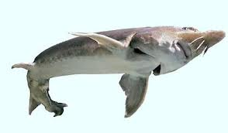 | The Beluga or European Sturgeon is found primarily in the Caspian and Black Sea basins, and occasionally in the Adriatic Sea. Because they continue to grow throughout their lifetime (which can last for 118 years), the Beluga is the world's largest freshwater fish and as a rival in size to the Ocean Sunfish among all bony fish. Some of these monsters have been found which are nearly 24 feet long and weigh over 3,400 pounds. Heavily fished for
the female's valuable roe—known as beluga caviar— the beluga numbers have been greatly reduced by overfishing and poaching, prompting many governments to enact restrictions on its trade. The beluga is a large predator which feeds mostly on other fish. Fish up to 40 pounds are ingested. They also eat waterfowl and seal pups. Due to its aggressive behavior and large mouth, it is a potential man-eater, but no attacks have been confirmed.

The White Sturgeon is easily the largest freshwater fish in North America. It can grow to an incredible length of 20 feet and weigh up to 1,400 pounds. Found along the west coast of North America, and as far north as the Aleutian Islands, sturgeon are ancient fish which have kept the same form | #2 White Sturgeon  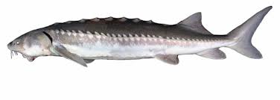
for at least 175 million years. Due to their size, sturgeon are a popular target for fishermen and there is concern among conservationists that they may be overfished. In fact, some populations are even classified under the Endangered Species Act of 1994.

#3 Mekong Gant Catfish  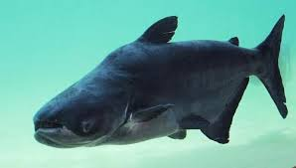 | The Mekong Giant Catfish is a species of catfish in the shark catfish family native to the Mekong basin in Southeast Asia. In Thai folklore, this fish is regarded with reverence, and special rituals are followed and offerings are made before fishing it. The Mekong giant catfish is perhaps the most interesting and most threatened species in the Mekong River. For this reason, conservationists have chosen it as a sort of "flagship" species to
promote conservation on the Mekong. With recorded sizes of up to 11 feet long and 660 pounds, the Mekong Giant Catfish currently holds the position of the world's third largest freshwater fish.

The Arapaima freshwater fish is found in the Amazon River in Brazil – It is the biggest fish in South America. These giant fish are as ancient as they are large. Capable of growing to a length in excess of 10 feet long and weighing over 400 pounds. Arapaima have been around for about 5 million years and are considered living fossils. These fish are also incredible leapers, and can propel themselves above the water if they feel threatened. Unfortunately, record-sized Arapaima are difficult to come by today since they are so widely hunted. | #4 Arapaima  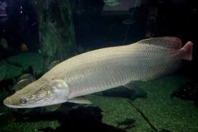

#5 Alligator Gar  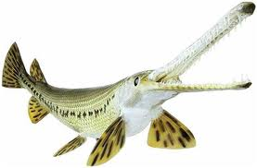 | Due to a dual row of large teeth and a snout like an alligator, these carnivorous fish might be the scariest thing lurking in the rivers of North America. Measuring as long as 10 feet and weighing up to 350 pounds, Alligator Gars are fish right out of a horror movie. They can even survive out of water for as long as two hours. Found in the lower Mississippi River basin and in the waters of all the Gulf Coast states, these fish tend to swim near the surface or among reeds where they can ambush prey. Despite their intimidating appearance, they are passive toward humans.

The Nile Perch is Africa's largest freshwater fish. Reaching six feet in length and weights over 400 pounds, these fish have mammoth mouths. Due to their popularity among fishermen, the Nile Perch has unfortunately been introduced to many non-native lakes and has become a dangerous invasive species. This has been especially tragic in Lake Victoria, where several hundred native species have been driven to extinction due to Nile Perch eating them. | #6 Nile Perch  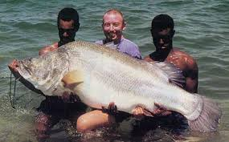

Big Fish in Utah
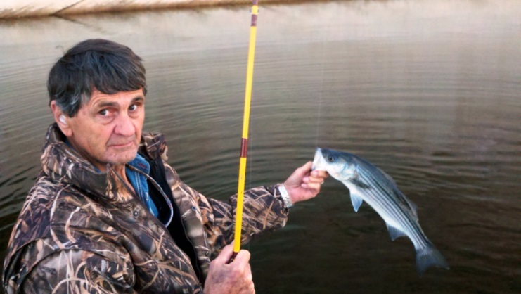
Picture on the left - That’s me with a Rainbow Trout I caught fly fishing on the Provo River in 2010. The picture above is my good friend Lew Deveraux with a Striped Bass he caught at Lake Powell. Lew is a good fisherman and the person who taught me how to fly fish.
Okay, these fish are not that big but while growing up in Utah, I thought a 3 pound trout was a real BIG fish – I still do. One thing for sure, a trout from the cold waters of Utah tastes a lot better than that gooey Giant Oarfish and most of those other monsters.
Below are the records for big fish caught in the state of Utah:
Species | Weight | Length | Location
Lake Trout  Striped Bass  Brown Trout  Carp  Channel Catfish  Northern Pike  Rainbow Trout | 51 lbs. 8 oz.  48 lbs. 11 oz.  33 lbs. 10 oz.  32 lbs. 8 oz.  32 lbs. 0 oz.  26 lbs. 3 oz.  26 lbs. 2 oz. | 45 Inches  43 Inches  42 Inches  40 Inches  40 Inches  35 Inches  30 Inches | Flaming Gorge Reservoir  Lake Powell  Flaming Gorge Reservoir  Lake Powell  Utah Lake  Yuba Reservoir  Flaming Gorge Reservoir

Fishing is good for the soul!!
bigdrifter44@gmail.com

http://bigdrifter.com/

