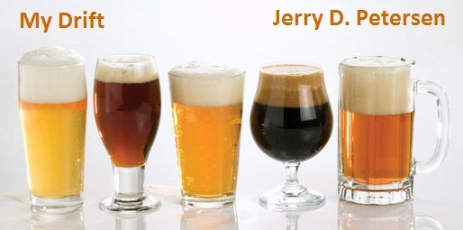

 | BEER  October 19, 2011 | 1471111

Finally, I’m writing about a subject that I should know a thing or two about since I have consumed 32,072 beers so far in my lifetime. No, I haven’t been keeping count – that total is based on a conservative estimate of two six-packs a week for 53 years. In my earlier years I drank a lot more than that and now in my old age, I drink less than that most weeks. Yes, beer has been my drink of choice since I became old enough to drink. As you will learn in this column, beer has many beneficial qualities and in some ways, it is a miracle drug.

It is now a proven fact that beer -- yes, BEER -- can provide the same or better health benefits as wine. No matter what type of ale or beer you prefer, studies show that drinking beer in moderation (2 drinks a day for men and 1 drink a day for women) will reduce your chances of stroke, heart and vascular disease, and help you stay healthy in many different ways that I will tell you about.

HEALTH BENEFITS OF BEER
 | Heart Disease. One reason beer reduces the risk of cardiovascular diseases is because it contains vitamin B6 which protects the heart by preventing the build-up of a compound called homocysteine – an amino acid that causes heart attacks. Beer has a thinning effect on blood and prevents formation of clots, which cause blocks in coronary arteries. Moderate beer consumption also reduces the risk of inflammation, the primary cause of hardening of the arteries. Beer consumption also boosts the level of “good cholesterols” by 10-20% thus reducing the risk of coronary diseases.
 | Stroke. Beyond helping you get heart healthy, moderate drinking also may help prevent the formation of blood clots that can block arteries in the heart, neck and brain, according to the Harvard School of Medicine. Those blockages are a cause of the most common kind of stroke which is an ischemic stroke.
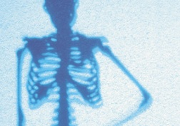 | Bones. Moderate beer consumption is shown to increase bone density, preventing the risk of fractures and osteoporosis. Beer is found to be high in potassium and low in sodium content. It is a rich source of magnesium which results in reduced risk of kidney stones. The silicon present in beer is readily absorbed by the body, explaining the protective effect of beer against osteoporosis.
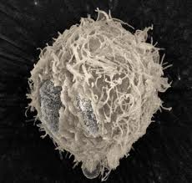 | Cancer. Beer contains anticancer compounds such as Xanthohumol that are found in the hops used in the brewing. These have been identified to play a major role in prevention of cancer, including prostate cancer. (Pictured at left is a prostate cancer cell) Beer is also a good source of polyphenols that are found in the grains used for beer fermentation and these are also effective in fighting against cancer.
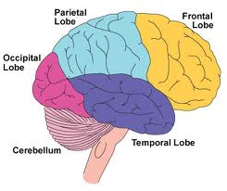 | Brain. Is beer good for your brain? Yes, a research report published in the Journal of the American Heart Association showed that moderate drinking is associated with better cognitive function in both men and women. Likewise, a another study in the Journal of the American Medical Association stated that adults over 65 who consume between one and six alcoholic beverages each week have a lower risk of dementia than non-drinkers and heavier drinkers.
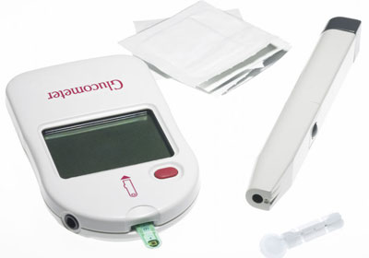 | Diabetes. Studies have shown that people with diabetes who drink moderately are able to reduce their risk of coronary heart disease, their biggest killer. Research also indicates that a light drinking habit may help protect men and women from developing Type 2 diabetes. This may be a result of increased insulin sensitivity or anti-inflammatory effects.
 | Feeling Healthier. People who drink beer or wine report fewer instances of ill health than those who abstain, according to numerous studies. Not only do beer drinkers feel healthier, they also are happier.  Staying Alive. More than 50 studies have shown there's an inverse association between moderate drinking and total mortality for middle-aged and older adults. The lowest risk of death appears to occur when people consume one to two drinks per day, likely a result of the protective effects against coronary heart disease and stroke.

I’m not done. Here are more health benefits of drinking beer:
- Beer aids the digestive system with stimulation of gastrin, gastric acid, and pancreatic enzymes.
- The risk of kidney stones is decreased 40% in middle-aged beer-drinking men, as compared to non-beer-drinkers.
- Beer increases the potency of vitamin E which is a major antioxidant in the body, vital in maintenance of healthy skin - all this helps slowdown the ageing process.
- Beer is nutritious and contains several important vitamins.
- Beer is fat-free and cholesterol free.
- Beer has a relaxing effect on the body thereby reducing stress.
- Beer can help you sleep better.
- Beer has been proven to have positive effects on elderly people. It helps to promote blood vessel dilation, improves blood circulation and makes urination easier.

In other words, beer is good for about any health condition you can name. I can’t figure out why more doctors don’t prescript one or two beers a day to all of their patients? Maybe they would lose too much business!

I like to tell the story about a scientific study using beer-drinking rats. This study was published about 25 years ago in a magazine called Psychology Today. I cut out the article and kept it for years. Basically, there were two groups of rats, both groups were the same age and were fed the same food but one group was given beer and the other group was given water to drink. Well, as you have probably already guessed, the group of rats that drank beer lived five times longer than the group that drank water. That study was enough proof for me!! I was going to drink my share of beer so I could live a longer and happier life. It has worked good so far. | 

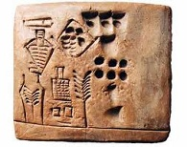  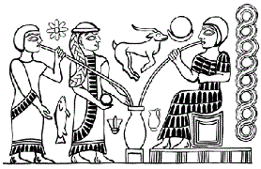 | Beer was the first alcoholic beverage known to humans. Around 6,000 years ago, ancient Chinese civilizations were brewing a beer-like substance known as Kui. About this same time in ancient Mesopotamia (in what is now Iran), clay tablets indicate that brewing was a fairly well respected occupation, and that the majority of brewers were women. Early pictures show a lot of women drinking the beer they brewed. Beer was part of the daily diet of Egyptian Pharaohs over 5,000 years ago. The role of beer in Egyptian society was far greater than just a drink. Often, beer was prescribed to treat various illnesses. Beer was considered to be the most proper gift to give to Egyptian Pharaohs, and it was also offered as a sacrifice to the gods. It appears that the Egyptians taught the Greeks the beer brewing process and it spread to the rest of Europe from there.
Historians theorize that human's fondness for beer was a primary factor in our evolution away from a society of nomadic hunters. Yes, we decided it was more fun to stay in one place and grow grain to make beer than running around in the woods with a spear looking for wild animals. In fact, the first product humans made from grain and water was beer long before we learned how to make bread.

Nearly every culture developed their own version of beer using different grains:
China used wheat - Africa used millet, maize or cassava - Japan used rice - Russians used rye - Egyptians used barley - South America used corn.

Beer was one of the most common drinks during the middle ages. It was consumed daily by all social classes in the northern and eastern parts of Europe where grape cultivation was difficult or impossible. Though wine of varying qualities was the most common drink in the south (France and Spain), beer was still popular among the lower classes. Since the purity of water could seldom be guaranteed, alcoholic drinks were a popular choice, having been boiled as part of the brewing process. Beer also provided a considerable amount of the required daily calories we humans need. Beer was really popular in Germany and England where the per capita consumption was 60–66 gallons a year.

How to make Beer: Here are ingredients and the basics of the brewing process:
- Malted barley (or another grain) is soaked in hot water to release the malt sugars.
- The malt sugar solution is boiled with hops for seasoning.
- The solution is cooled and yeast is added to begin fermentation.
- The yeast ferments the sugars, releasing CO2 and ethyl alcohol.
- When the main fermentation is complete, the beer is bottled with a little bit of added sugar to provide the carbonation.
- Some brewers add a clarifying agent to make the beer appear bright and clean.

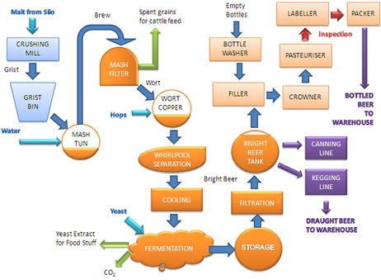
The Brewing Process
Easy, huh?? Yes, making beer is quite easy but making “great” beer is very difficult. I can remember when my dad used to make beer. I was young but I tried some and it was okay but not great beer.
Here is some more information on how brewers control the alcoholic content, the color, the number of calories, and the bitterness (taste) of beer:

Alcoholic Content:
Beer ranges from 3% alcohol by volume (abv) to around 14%. The pale lagers that most consumers are familiar with fall in the range of 4–6%. For example, Bud Light and Coors Light have an alcohol content of 4.2% abv and regular Coors or Budweiser have an alcohol content of 5% abv. The quantity of fermentable sugars and the variety of yeast used to ferment are the primary factors that determine the amount of alcohol in the final beer.

There are five states (Utah, Colorado, Kansas, Minnesota, and Oklahoma) that have laws stating that the alcoholic content of beer sold in stores and bars cannot exceed 3.2% by weight (this is actually 4% by volume). I will tell you this, “It is impossible to tell the difference between a Coors Light in Utah and one in Hawaii.”

Light or Dark Color:
Beer color is determined by the color and type of malt. Very dark beers, such as stout, use dark malts that have been roasted longer. It is not always true that light colored beers contain less alcohol and more water than dark beers.

Reduced-calorie Beer:
Reducing the calorie content of beer is done by a large reduction of its carbohydrate content and a small reduction of its alcohol content. The major “Light” beers (Bud Light, Coors Light, and Miller Lite) all have about 100 calories per 12 ounce can or bottle. A regular Coors or Budweiser have about 145 calories.

Taste or Bitterness:
Hops contain several characteristics that brewers desire in beer. Hops contribute a bitterness that balances the sweetness of the malt. Hops have an antibiotic effect that favors the activity of brewer's yeast and aids in the length of time that a foamy head created by carbonation will last.

Here are a few more Beer History Facts with my comments:

Noah's provisions included beer on the Ark (that was 4500 years ago) – I know that beer would be the first thing I stocked up on if I was going on a long boat ride.

By 1200 AD, beer brewing was firmly established as a commercial enterprise in Germany, Austria, and England.

German's preferred cold temperature lagers (bottom-fermentation) stored in caves in the Alps.

The English preferred mild temperature ales (top-fermentation) stored in cellars.

Clarifications are in order:
Lagers and Beers are the same thing – Ale is different.
Ale is taken from the top of the fermentation barrel and contains less or no hops.
Beer is taken from the bottom of the fermentation barrel and contains lots of hops.
Comment: I’m sure glad America took after the Germans when it came to beer!!
I like my beer cold!

Columbus found the Indians making beer from corn when he discovered America in 1492.

Beck's Brewery was founded in 1553 in Germany and is still brewing “great” beer today.

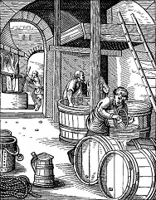 | The first commercial brewery in America opened in New Amsterdam (New York City - Manhattan) in 1612 after colonists advertised in London newspapers for experienced brewers.  George Washington and Thomas Jefferson had their own private brew houses in 1786. About this time, Samuel Adams started operating a commercial brewery.  Soldiers in the revolutionary army received rations of a quart of beer a day.  Up to around 1800, beer and bread had been the mainstays of the ordinary person's diet for centuries. Yeasts used in making beer during this time were exactly the same as those used in making bread.

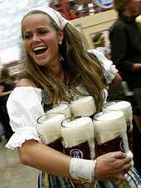 | 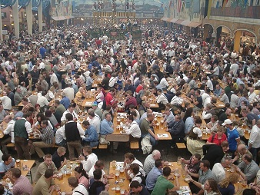
Beer Girl | Munich Fair Drinking Area

Oktoberfest is a 16–18 day beer festival held annually in Munich, Bavaria, Germany, running from late September to the first weekend in October. It is one of the most famous events in Germany and is the world's largest fair, with more than 5 million people attending every year. (See pictures above) The Oktoberfest is an important part of Bavarian culture, having been held since 1810. Many other cities around the world also hold Oktoberfest celebrations, modeled after the Munich event.

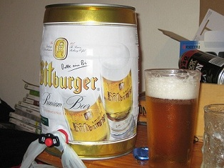 | Whenever I think about Germany, I think about my friends Dave and Emmy (who used to live in Germany) and Andy and Judy (who still live in Germany) and the good time we had when me and my old boss Art went TDY to Germany many years ago. We drank a lot of that great German beer. I have been to a few October Fests in Honolulu and always had a good time. I would like to attend the big one in Germany but probably will never make it. I’m writing this article in October thinking that this was “October Fest” month and therefore “Beer month”. But now I find out that Oktoberfest is held mostly in September and I have been spelling it wrong all these years.

In 1842, the first golden lager was produced in Pilsen, Bohemia (Czech Republic).

In 1850, German immigrant brewers introduced cold maturation beers to the US (Anheuser-Busch, Miller, Coors, Stroh, Schlitz, and Pabst roots begin here).

The modern era of brewing in the US began in the late 1800's when commercial refrigeration (1860), automatic bottling (1892), pasteurization (1876), and railroad distribution were all available.

By 1910, there were approximately 4,000 breweries in the US.

Only 160 breweries survived Prohibition – The “Prohibition of alcohol” law (1920 to 1933) prohibited the manufacture, transportation, import, export, sale, and consumption of alcohol and alcoholic beverages. You can bet a lot of people went back to making their own beer in their homes.
The beer can was invented in 1935. The beer bottle has been around since the 16th century. Before that, people drank beer from any type of container available at the time.
Did you know that Coors and Millers Brewing Companies merged in 2008 and have been known as MillerCoors since then? I didn’t know that!! I must have been drinking beer when that happened. The joint venture has the responsibility of selling brands such as Miller Lite, Miller High Life, Miller Genuine Draft, Coors, Coors Light, Molson Canadian, and Blue Moon beer in the United States.
And did you know that in December, 2009, Belgian-Brazilian Inbev purchased Anheuser-Busch for a total value of $52 billion, which created the world’s largest beer company named Anheuser-Busch InBev? Budweiser (Anheuser-Busch) is the biggest brewer of beer in the US. Bud Light has actually been the top seller since 2008 with regular Budweiser coming in second. After that, Miller Lite and Coors Light are not far behind. Budweiser fact: It is an American-style lager introduced in 1876 by Adolphus Busch and it is made with up to 30% rice in addition to hops and barley malt.
I really hate to report this but China has passed the US as the biggest producer of beer (by volume). Yes, China now makes about 22% of all beer produced in the world compared to the US who makes about 20%.

Draught (Draft in the US) is beer from a keg. This is the most common method of dispensing beer in bars around the world. A metal keg is pressurized with carbon dioxide (CO2) gas which drives the beer to the dispensing tap or faucet.

Beer Consumption per Capita (The countries in dark blue drink the most)
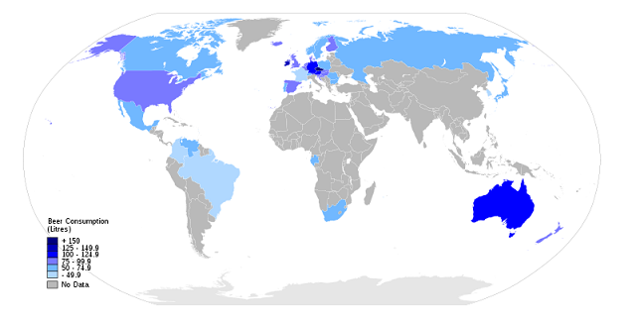 | - Czech Republic  - Ireland  - Germany  - Austria  - Australia  - England  - Poland  - Denmark  - Finland  - Luxembourg  - Slovakia  - Spain  - United States

Different Types of Beer:
There are three main types of beer. These are top-fermenting, bottom-fermenting and spontaneous-fermenting beers.

Top-fermenting (Ales)
Bitter - The distinctive style of draught ale in England and Wales is generally served in pubs.
Killian's Irish Ale - A soft, slightly sweet reddish ale from Ireland.
Light Ale - In England, this term indicates a bottled "not so bitter" light colored Ale.
Old Ale - A strong, well matured, rich and dark ale usually sold during the winter as a seasonal beer in England.

Bottom-fermenting (Lagers)
American Lager – This is basically the main style of beer in America such as Budweiser and Coors.
Pilsner (Pils) - This is a type of pale lager developed in the city of Pilsen, Bohemia, in today's Czech Republic.
Stout - This is a dark beer made using roasted malt or barley and is typically 7% or 8% alcohol.
Black beer - This is a very dark strong tasting, bitter-chocolate lager which is primarily made and drank in Eastern Germany.
Dry beer – This is a beer so clean and dry that it has little taste. This type of beer was first produced in Japan by the Asahi Brewery in l987.
Ice beer - The brew is frozen during maturation to produce a purified beer, with the ice crystals removed to increase the strength.
Malt liquor - In the United States, this is a strong lager, often made with a high amount of sugar to produce a thin but potent brew.
Marzen - A full-bodied copper-colored lager (6% alcohol) which is drank at Oktoberfest.

Spontaneous or wild fermenting (Lambics)
Kriek – A Belgian beer that uses secondary fermentation that is stimulated by adding cherries to give a dry, fruity flavor and a deep color.

All this talk about beer got me thinking about the different brands of beer I have drunk during my long beer-drinking career. Here is a partial list:

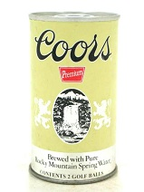 | 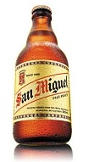 | 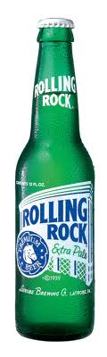 | 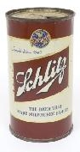 | 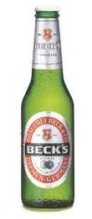 | 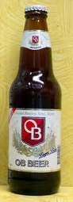 | 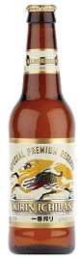
Utah | Spain | PA | East Coast | Germany | Korea | Japan
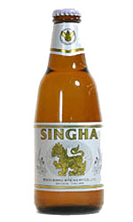 | 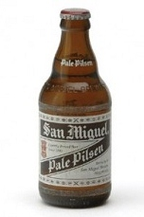 | 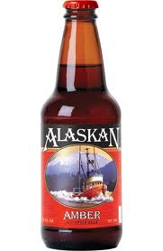 | 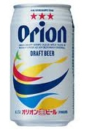 | 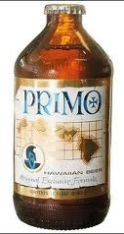 | 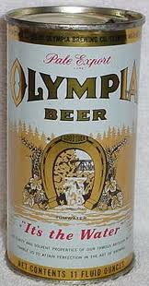 | 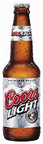
Thailand | Philippines | Alaska | Okinawa | Hawaii #1 | Hawaii #2 | Hawaii #3

Yes, I have been drinking Coors light for several years now but I pretty much like all beer. I hope you all have learned something new about beer – I know I have learned several things. I have learned that I need to increase my weekly intake of beer by two to take advantage of beer’s optimum health benefits. I will end this column with two beer related pictures (I like horses and trains) and a warning.

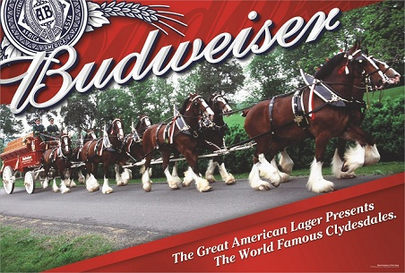 | 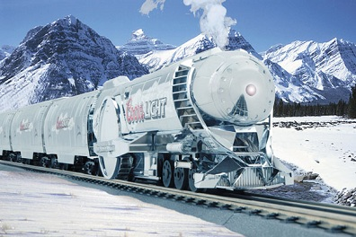

WARNING: Too much beer can cause liver damage, get you into trouble with the law (a DUI) and with your spouse.

Okay, let’s go find a bar and have a few cold brews.

bigdrifter44@gmail.com

http://bigdrifter.com/

