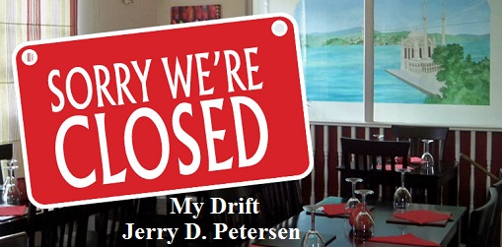

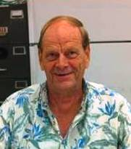 | Oahu Bars and Restaurants That Have Closed  15 Aug 2015 | 208-2015-15

Two more Oahu restaurants bite the dust! Kenny's Restaurant, an institution in the Kam Shopping Center in Kalihi for some 49 years, served its last meal on July 5, 2015.

The beloved Pearl City Flamingo Restaurant on Kamehameha Highway will close after 65 years on Sunday, July 12, 2015. The owners cited the Honolulu rail construction as the primary reason. The restaurant is probably best known for its oxtail soup and banana pie, and has remained a local favorite from the start. The small bar in the back was a very popular place to go get a cold drink after work. I even stopped there a few times.

Headlines like this are becoming common in Hawaii:
SIX RESTAURANTS CLOSING LEAVING 150 JOBLESS
Closing are the Sizzler Salt Lake, Sizzler Koko Marina, the Yum Yum Tree Westridge near Pearl Ridge, Jolly Roger Drive-In on Dillingham, Jolly Roger Drive-In at Waialae and Monterey Bay Canners in Ward Center.

Here are Some Small Business Statistics
We have about 120,000 Small Businesses in Hawaii that employ 260,000 workers which is about 1/2 of the total Hawaiian Workforce.

Most Small Businesses are sole proprietors. There are 57,000 male owned businesses, 37,000 female owned businesses and 20,000 that are owned by both. There were 68,000 minority owned businesses and 10,000 small businesses owned by Veterans. Wow...lots of numbers but it is easy to see where the emphasis is in Hawaii's economy. Our population is about 1,400,000 which helps put these numbers in perspective.

Hawaii is the very worst state to conduct business!
Granted, it may be tough to conjure up much sympathy for America's most spectacular state. But strip away the fabulous beaches, palm trees, hula dancers and surfers, and Hawaii is just one state trying to compete with 49 others, while facing a host of built-in disadvantages.

It is in the middle of the ocean, more than 2,000 miles away from the mainland and the bulk of U.S. resources. The same factors that make Hawaii an expensive place to live—think over $4 for a loaf of bread or a gallon of gas—also make it an expensive state to govern, and in which to do business. Just for your info, the top three states for doing business are 1. Texas, 2. Minnesota and 3. Utah.

Opening up a new restaurant and/or bar in Hawaii is risking business! However, it is not quite as bad as some Internet sites would have you believe where they say 9 out of 10 restaurants go out of business in the first year. Here are the real statistics compared against all Small Businesses.

Percent That Failed Before:  1 year  5 years  10 years | Restaurants and Bars  60%  80%  90% | All Small Businesses  30%  50%  67%

There are about 3700 Restaurants and Bars in the state of Hawaii with about 2500 of these located in Honolulu and the island of Oahu. It seems like as fast as one restaurant or bar closes, another one opens up somewhere in the state. Apparently, there are a lot of people willing to give this business a try and they all think they are going to succeed.

Why do restaurants, nightclubs, and bars fail so often?
- Bad Location
- Owners Unwilling to Work Hard Enough
- Inexperienced Owners
- Bad People Management
- Hiring Unreliable Employees
- Bad Customer Service
- Lack of Accounting Skills
- Not Paying Required Taxes
- State and Federal Government Red Tape
- Not Watching their Cash Flow
- Too High of Payroll
- Poor Food Quality
- Not Advertising
- Owners Run Out of Money

There have been hundreds of restaurants and bars come and go in the 45 years I have been living in Hawaii. I’m going to list some of the more famous ones and a few not so famous ones where I have had a meal or two and a few drinks. I’m pretty sure that my readers have been to some of these restaurants, nightclubs, and bars. I hope this list will bring back some good memories. If I have missed any obvious ones, please let me know.

Legend:  No Asterisks  One Asterisk  Two Asterisks  Three Asterisks  Four Asterisks  Five Asterisks | Never been to the restaurant, nightclub or bar  Have been to the place only one or two times  Have been there a few times (less than 10)  Have been there many times (10 to 19)  Have been there many-many times (20 to 39)  Have been to the bar more times than I can count (40+)

bigdrifter44@gmail.com

URL References:
http://tastyislandhawaii.com/2013/08/28/oahu-bars-nightclubs-memorialized/

http://tastyislandhawaii.com/2013/03/23/oahu-eateries-memorialized/

http://hcadhawaii.org/index.php?option=com_content&view=article&id=15&Itemid=11

http://showandtellhawaii.staradvertiserblogs.com/2009/07/24/where-have-all-those-icons-gone-ah-memories/
LIST OF RESTAURANTS, NIGHTCLUBS, AND BARS
ON OAHU THAT HAVE CLOSED

Name of Bar or Restaurant | Location | Comments
A
Aarons | Atop the Ala Moana Renaissance Hotel | Previously was Nicholas Nickolas - Scenic views of Honolulu and Ala Moana Beach and Ocean.
Alakea Bar & Grill  ** | 1192 Alakea St. - Downtown Honolulu | Closed in 2002 - A downtown institution for decades - Genoa Keawe’s band hideout.
Ali’i Grill (and Lunch Wagons)  ** | Downtown Honolulu on Bishop Street – Close to HPU | Owned and operated by my son Mike from 2006 to 2009. He sold it due to the long hours, hard work, and very little profit.
Alley Cat  *** | Downtown Honolulu bar down a small alley next to the Hawaii Theater | I used to go there in the early 70s to play pool and hangout.
Andy’s Drive-In  * | Oneawa St., Kailua | Open from 1957-1999. Sold 3,600 burgers on opening day at 17¢ each.
Arthur’s | Foster Tower Hotel, Waikiki | Known for fine (expensive) dining continental cuisine; earned several awards for culinary excellence.
Annabelle’s | Top of the Ilikai, Waikiki | Disco nightclub popular with the young crowd - Currently Sorento's.
Aquarium Bar  ** | Ala Moana Shopping Center, under escalator, behind Muntz Stereo | Back in the 1970s, there were only a couple of bars in the shopping center – I used to stop in there once in a while.
Atlantis | Pacific Beach Hotel, Waikiki | Nightclub that opened in 1979 and rivaled the nearby Point After

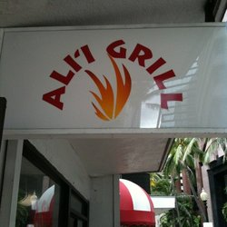 | 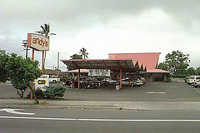 |  | 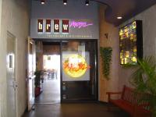
ALI’I GRILL | Andy’s Drive-In | Brew Moon

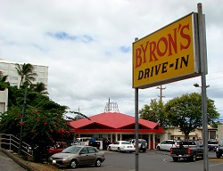 | 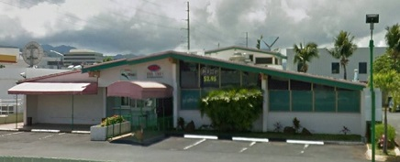
Byron’s Drive-In | Beacon’s Restaurant & Bar
B
Baba Louie’s | Waipio Gentry Shopping Center | Brudda Noland and the gang played there during the mid 80’s / Currently Nancy’s Kitchen
Beacon’s Restaurant & Bar  *** | Across from Pearlridge Shopping Center, Aiea | Busy place with good food. We used to go there once in a while when I was working at Ft. Shafter.
Big Island Steak  House  * | Aloha Tower Marketplace – Second floor | I went in there a couple of times for drinks. Rumor has it that this area of Aloha Tower is haunted.
Bill Lederer’s Bar & Hotel  **** | Hotel & Nuuanu in the Chinatown district | Used to be the most popular saloon in Hawaii. I used to go there after work to play pool. Many of people there were guys that dressed up as women. Currently, it is a police substation.
The Black Orchid | Restaurant Row | Opened by Tom Selleck and Larry Manetti of ‘Magnum P.I.’ fame; restaurant by day, club by night / eventually became the World Café.
The Black Cat | Hotel near Richards Street across from the Armed Services “Y” | A whiskey bar that sold a shot of whiskey for a quarter.
The Black Rose | Near A’ala Park on College Walk - Downtown | The owner was a Japanese lady named Aki who treated the customers very well. Her fare included king crab legs, prime rib, lobster, bacon-wrapped scallops, ribeye steaks, fried chicken, etc.
Bobby McGee’s | Waikiki - Across the street from the Honolulu Zoo | A popular 1980’s nightclub – Used to sell toilet bowl souvenir mugs.
Bob’s Big Boy Restaurant  ***** | In Mapunapuna next to the Ceridian (now Kaiser) building - close to Fort Shafter | Closed due to a fire in 2009 and never reopened. I went there often to eat (Breakfast, lunch, and dinner) while working at Shafter and for Ceridian.
Brew Moon Restaurant & Bar  ** | Ward Center, Kaka’ako | I used to meet my old boss Art Lopkoff at this Microbrewery for lunch and drinks.
The Brown Derby  * | Chinatown on Nuuanu near Beretania Street | Louis Armstrong played there – Owner got in trouble for selling heroin.
Burgers on the Edge  * | Kapahulu Ave. in Kapahulu Safeway Plaza | Customer designed specialty burgers. I went there once and my special burger was nothing special.
Buzz’s Original Steak House | 2535 Coyne St., Mo’ili’ili in Honolulu | Owned by Bobby Lou and Buzz Schneider. Popular place but for some reason I ever went there.
Byron’s Drive-In  ** | By the Honolulu Airport | A 24 hour “greasy spoon”, featuring plate lunches, burgers, sandwiches, breakfast, and specialties.

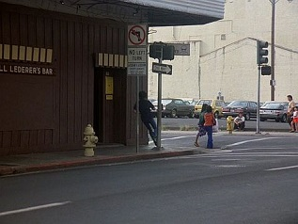 | 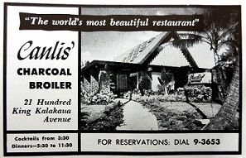
Bill Lederer’s Bar & Hotel | Canlis’ Charcoal Broiler Restaurant
C
Canlis’ Charcoal Broiler Restaurant | 2100 Kalahaua Ave. in Waikiki | Waitresses wore Kimonos and it was billed as the world’s most beautiful restaurant. Opened in 1947 and stayed in Canlis family until it was sold to Japanese investors in mid-80s.
Chai’s Island Bistro  * | Aloha Tower Market Place next to Hooters | HPU purchased most of the Aloha Tower for dorms. Only Hooters and Gordon Biersch Brewery Restaurant are still open.
Cheerleader’s  ***** | Moanalua Shopping Center by Navy-Marine Golf Course and the Salt Lake area by old COSTCO | This was one of my favorite bars for many years while I was working at Shafter. Had a pool table and a good-looking bartender.
Chi Chi’s | Westridge Shopping Center, Aiea | Mexican fare by day, nightclub by night.
The Chowder House | Ward Warehouse | Known to be a regular stop for President Barack Obama.
The Cock’s Roost  * | Waikiki International Marketplace | A Spencecliff restaurant and bar where Carlos Santana performed before he became famous.
Columbia Inn  *** | Kapiolani Ave. by the Newspaper building | One of the most famous restaurants / bars in Honolulu for 60 years. I went there many times for lunch and drinks. Currently a BMW dealership.
Crouching Lion Inn  *** | Kaaawa, Kam Hwy right around a bend | This was actually my favorite place to go when traveling around the island of Oahu. Good American food with a great view.
Crow’s Nest  *** | Waikiki (above the Jolly Rodger) | One of my favorite bars when I lived in Waikiki in 1970.

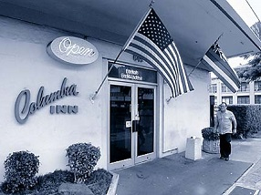 | 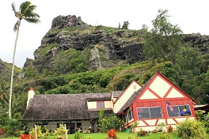
Columbia Inn | Crouching Lion Inn

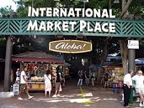 | 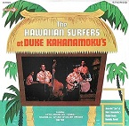 | 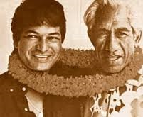
International Market Place | Duke Kahanamoku’s | Don Ho and Duke

D
Dancers  ** | Sand Island Access Rd. | Gentlemen’s club – I went there a few times in my younger years.
Davy Jones Locker  ** | Waikiki Reef Hotel | “Underwater Bar” to drink and watch the people swimming in the pool.
Dixie Grill  ** | Ward Ave & Halekauwila Street | BBQ & bar - catchy letterbox sign in front.
Don Ho’s Island Grill  *** | Aloha Tower Marketplace | Originally opened by the late and great Don Ho - Hawaii regional cuisine – Great bar by the waterfront.
Duke Kahanamoku’s  * | Waikiki International Market Place | The place was named for the renowned Olympian athlete - Its top entertainer was Don Ho and it was a spot to catch him singing “Tiny Bubbles”.
The Dunes  ** | Airport area on Nimitz Highway | Owned by Jack Cione - Featured a naked waiter and had acts as famous as Sammy Davis, Jr. It later became Gussie L’Amours.
Dunkin Donuts  *** | Statewide | I used to stop at the Dunkin Donuts in Pearl City to pick up donuts.

E
Eastside Bar & Grill  * | University Ave. in Puck’s Alley | Sport bar and grill – Popular with UH students - Previously Magoo’s Pizza
Elephant & Castle  ***** | Ka’ahumanu Rd. (across the street from Gyotaku), Aiea | English Pub and restaurant – Good place to hang out and play pool and darts.

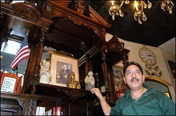 | 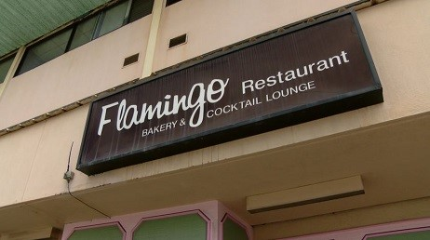
Elephant & Castle | Flamingo Restaurant and Bar

F
Fast Eddie’s | Kailua | The only nightclub in the area and was popular with servicemen from nearby Kaneohe Marine Corps Air Station
Fisherman’s Wharf  ** | Kewalo Basin, Kaka’ako | Popular place for tourists to go eat – I took my mother there once. There is also a sleazy little bar on the bottom right side which I visited a few times.
Flamingo Chuckwagon and all other Flamingo Restaurants  *** | Ward & Kapiolani Kapiolani  Kaneohe  Pearl City | Family buffet featuring Prime Rib – I went there to eat and drink a couple of times. In fact, I have been to all of the Flamingo restaurants – Good food.
Fort Shafter Skyview Terrace and other Oahu military clubs  ***** | Fort Shafter – The club was on a high ridge overlooking the airport, ocean, and Kalihi | See write up below.

MILITARY CLUBS ON OAHU
Military clubs were once considered as much a part of military life as the uniform. They were a place which fostered camaraderie since everyone there, whether they be on active duty or retired, has something in common with you by virtue of being in the military. Clubs used to be a place where off-duty personnel would go to hang out. However, military clubs aren't what they used to be - here are a few reasons why the "new" modern military is different from when I served my country in the Navy many years ago:
- There are more married people in the service today
- More military personnel are living off post
- The military and society in general's have an negative attitude toward alcohol (and smoking)
- More military personnel are pursuing healthier lifestyles

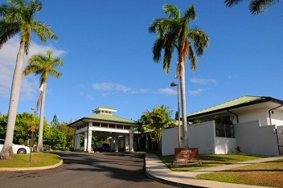 | 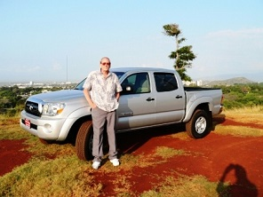
Fort Shafter - Hale Ikena Community Club | Fort Shafter Skyview Terrace Site  (Yes, that is me and my new truck)

In 1972, they built a new NCO Club up on the hill at Fort Shafter called the Skyview Terrace. It was a great club with a great view but it was so popular that it took away much of the Officer’s Club’s business. I used to go to both clubs. Actually, the Officer's Club had two buildings - one was called the Roundhouse Restaurant and the main building had both the Officer's club and the Golf Course 19th Hole Bar. In the mid-1970s, the 19th Hole was very busy on Friday nights because this was when they had the strippers in there dancing. But then some officer's wives complained and they stopped this great entertainment. Next, due to a 1987 federal law that stated all military clubs had to be self-supporting, one of the two main clubs on Shafter had to close! Well, you can’t close the club where the Generals go! So the Army (in all their wisdom) closed down the popular NCO Skyview Terrace. They later tore down the Officer’s Club and built a new Community Club called the Hale Ikena. Later in 2000, they tore down the already closed Sky View Terrace and announced that this is where they are going to build the new USARPAC Headquarters Building.

In 1990, the Army had nine clubs (officer and enlisted) on Oahu. Now they are all gone - closed, tore-down, or converted to Community Clubs. All of the services here reported that patronage in their clubs has dropped. Twenty one (21) military clubs (9 Army, 7 Navy, and 5 Air Force) were closed on Oahu alone. In 1997, the Army shut down the 52-year-old Cannon Club, located on the slopes of Diamond Head - this was once a special place to eat and drink with a great view of Waikiki and the Pacific Ocean. Today, only Hickam Air Force Base maintains a segregated membership-only officers and enlisted club system. The Army and Navy did away with clubs catering separately to officers and enlisted soldiers in 1996.

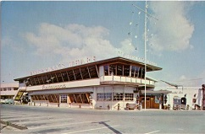 | 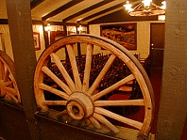
Fisherman’s Wharf | Flamingo Chuckwagon
G
“G’s” Bar & Grill  *** | 94-889 Waipahu St  Waipahu, HI | “G’s” was owned and operated by a Korean lady named Grace. This is where my part-time job boss and some employees used to go eat, drink, and watch sports. I went a few times and they do have the cheapest beer in town ($2.50 a bottle). The bar just closed as I’m writing this article.
Gibson Bar  * | Chinatown Hotel Street | Swing and Jazz Club
Glades  * | Chinatown Hotel Street | “Boys will be Girls” revue live shows – I have to admit that I did go to a couple of these performances.
Gussie L’Amours  ** | Airport area on Nimitz Highway | Live bands (some very well-known such as the Talking Heads and Stray Cats); oil wrestling; mechanical bull riding, etc. – I did go there to ride the bull but I only lasted about 3 seconds.

Historic Downtown Honolulu (Chinatown and Hotel Street): In the 1940s, Chinatown was the epicenter of Honolulu’s entertainment scene. Dance halls catered to plantation workers and military personnel. Nine theaters and 19 brothels operated in greater Chinatown as well as about 50 bars and numerous tattoo parlors. Clubs like the Swing Club, Casino Club, the Paradise Club, the Blue Note, Brown Derby, Two Jacks, Tradewinds, Gibson’s Bar and the Playroom featured swing and jazz. Sarah Vaughn, Ella Fitzgerald, Louis Armstrong and Duke Ellington all played in Honolulu. By the 1960s, all of the brothels, dance halls, and most of the theaters were closed down. However, many of the bars stayed in business until the mid-1990s and longer.

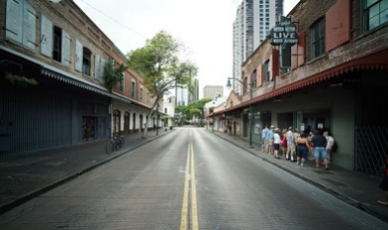 | 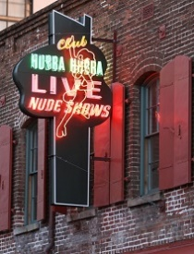
Downtown Hotel Street | Club Hubba Hubba
H
Haiku Gardens Restaurant  ** | 46-336 Haiku Rd, Kaneohe | Haiku Gardens offers views second to none, award-winning food infused with local flavors, and a staff full of aloha. Great place to take family and visitors. I have been there several times – the first time with my mother and my family. Currently is Haleiwa Joe’s.
Happiness Lounge  ** | Ala Moana Blvd., Kaka’ako across from the Gold Bond Building | This is a hostess Korean bar featuring Vietnamese food, karaoke & satellite TV. Since I used to work part-time at the Gold Bond Building, some days I needed a cold beer before going home.
Hawaiian Hut  * | Ala Moana Hotel, Atkinson Dr., Kaka’ako | Spencecliff restaurant & Tiki bar; became a club with live entertainment in its later years.
Honey’s Place  * | Kamehameha Hwy, Kaneohe | Live Hawaiian music, food and drink, owned and operated by Honey Ho, Don Ho’s mother - first gig for Don Ho. It is currently the site of a bank.
House of Hong  * | Lewers St., Waikiki | Billed as “The World’s most beautiful Chinese Restaurant”; Cantonese cuisine; rich art of the Orient. One of the few Chinese restaurants I have been to.
Club Hubba Hubba  *** | Chinatown Hotel Street | Honolulu's most infamous strip club finally “bit the dust” in late 1990s. There were lots of girls – dancers, porn actresses, and strippers – who have performed here.

My Hubba Hubba Experience: I actually spent a lot of time at Club Hubba Hubba in the early 1970s. No – It’s not what you are thinking. I was not a sex fiend sitting in showroom watching strippers day and night. It was a little known fact that one of the best pool tables on the island of Oahu was located in the front lobby area of the Club Hubba Hubba. You could find many of the best Hawaii local pool players there every day. Well, I thought that I was pretty good back in those days so that is where I went to play pool on a regular basis. They sold beer and the scenery wasn’t that bad. What more could you ask for?

Hungry Lion | Corner of Nu'uanu Avenue and School Street in the Nuuanu Shopping Plaza | After 27 years, the restaurant in Nu'uanu known for its mascot and a giant banyan tree rising through the dining room closed (Feb 2003) after losing battles with the tough economy and even tougher landlord.

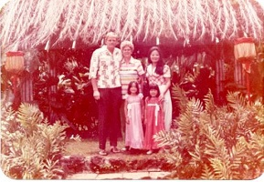 | 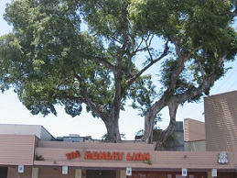
Haiku Gardens | Hungry Lion Restaurant

I
Infinity Nightclub | Sheraton Hotel, Waikiki | During the 1960s and 1970s, this was one of the most popular nightclubs on the island. The Kasuals & Phaze VII bands performed there.

J
The Jazz Cellar  ** | Imperial Hawaii Hotel, Lewers St., Waikiki | Live music and dancing. I went in this place 2 or 3 times while I was living at the Reef Tower Hotel on Lewers Street.
John Dominis | 43 Ahui St, Honolulu, HI near the Kaka’ako Water Front Park | One of Honolulu's best Italian restaurants closed on 1 Dec 2010 after 31 years. Built over a saltwater pond featuring hammerhead sharks, stingrays, and reef fish.
Jolly Roger Drive-Inn  ** | One on Dillingham Blvd. and one at Waialae Ave. | Featured signature sandwiches Suzie-Q, Teri-King and the memorable bacon double cheeseburger.
Jumbo’s Drive-In  **** | Mapunapuna (near Servco Toyota and Fort Shafter) | I went to Jumbo’s often to get my breakfast - usually on my way to work

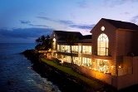 | 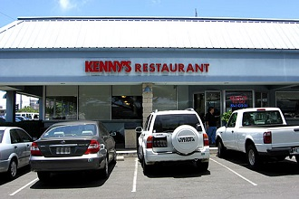
John Dominis | Kenny's Restaurant
K
Kalihi Bowling Alley  Kam Bowling Alley  *** | North King Street  Across the road form Kam Shopping Center | Two of the many bowling alleys to close on the island of Oahu. The Kalihi Bowling Alley had a large bar area that I used to visit. It is now a Nissan car dealership.
Kapiolani Coffee Shop  * | Next to Aloha Motors, where the Convention Center is now | Featured Ox Tail Soup, Pig Feet Soup, and Fried Rice.
Kapono’s | Aloha Tower Marketplace | Waterfront restaurant/Bar with live music - club founded by Henry Kapono Ka’aihue.
Keone’s | Lewers Street, Waikiki | Jimmy Borges personal after-hours club.
Kelly’s Coffee Shop and Bronco Bar  ***** | Nimitz Hwy, Airport Area | 24 hour diner, pastry shop, and country and western bar. There are not a lot of cowboy bars in Hawaii. Yes, I spent a lot of time at the Bronco Bar.
Kenny's Restaurant  ** | Kam Shopping Center in Kalihi | Serving great food (especially the fish) for more than 49 years. Owner decided to sell in large part due to health reasons.
King’s Bakery  *** | 1936 King St, Mo’ili’ili | A coffee shop & bakery; famous for their Portuguese Sweet Bread & fried noodles. I went here many times after the bars closed.
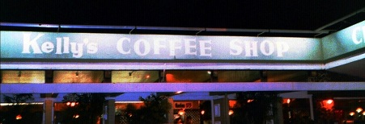
Kelly’s Coffee Shop and Bronco Bar
L
La Hacienda | Koko Marina, Hawaii Kai | Popular place for Mexican cuisine and a view of the Marina
Lauhala Room  ***** | On South King near Times Supermarket and across the road from Zippy's McCully | Well, this is the bar I went to almost every night during my single years in Hawaii. It is also the bar that I met my wife Patsy who was the bartender there. They also had a good pool table. This bar was within walking distance from my apartment located across from the Central Union Church on Beretania Street.
Little George’s  ***** | Ala Moana Blvd (across the Gold Bond Building) | Little George’s had both fine dining (specializing in steak & lobster) and a great bar. I went to the bar often when I was working part-time for Electronics Accounting Systems (EAS) in the Gold Bond Building.
Lynn’s Delicatessen | Ala Moana Center | A great place to get a Pastrami Sandwich and Potato Salad.

M
Maile Room | Kahala Hilton |  |  | Baseball great Joe DiMaggio was one of the first guests to dine there back in the 60’s when it opened.
Mama’s Mexican Kitchen  ** | 378 N. School St. (between A’ala & Liliha) |  |  | Good Mexican food – I have eaten there several times – I like the tamale, refried beans, Mexican rice, and a margarita.
McCully Chop Sui | McCully & S. King St |  |  | A local landmark for more than 50 years closed its doors at the end of 2006 – Owner said the lease expired.
Mekong and Mekong II | Kapahulu Avenue and South King Street |  |  | Thai Cuisine – Opened in 1977 and went out of business in 2012.
Merry Monarch | Beachwalk and Kalakaua Ave, Waikiki |  |  | Live bands
Moose McGillycuddy’s  *** | Pucks Alley near the University of Hawaii |  |  | Best hamburgers in town. My friend Donald Chong and I used to go there to eat lunch and drink beer.
M’s Ranch House  * | Aina Haina - East O’ahu |  |  | Known as just the Ranch House. Great food – Good place to go for a special occasion.
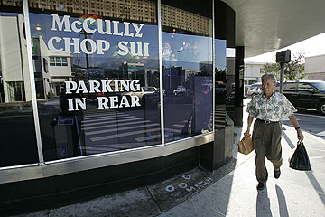 |  |  | 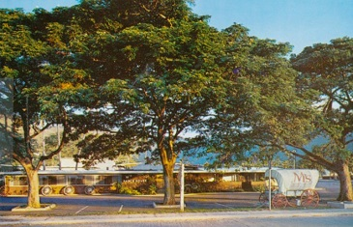
McCully Chop Sui |  |  | M’s Ranch House
N
New York Deli | 1137 11th Ave Kaimuki | American Deli Sandwiches – The pastrami sandwich comes with 11 oz. of meat, potato salad and a big deli pickle.
Nickolas Nicholas | Ala Moana Renaissance Hotel | Amazing views overlooking Ala Moana Beach Park, Honolulu and the Leeward Coast sunset, fine dining with an extensive wine list.
Nick’s Fishmarket | Kalakaua Ave, Waikiki | Nick’s Fishmarket served its last customers in its 41-year history on Feb 5, 2009. The restaurant’s 38 employees were out of work.

O
The Oasis  * | Old Waialae Rd. | Japanese Food and floor shows.
Ocean Club  * | Restaurant Row, Kaka’ako | Honolulu’s upper “yuppie club” - took over where Studebaker’s left off. Currently M Night Club.
Oceania Floating Restaurant  * | Aloha Tower Pier 6 | The world’s largest floating restaurant - Chinese cuisine.
Orson’s Bourbon House | Kailua | Andy Wong restaurant - said to be the best restaurant on the Windward side - closed 1997

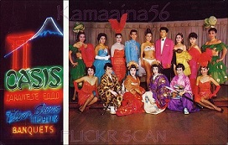 | 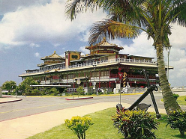
The Oasis | Oceania Floating Restaurant

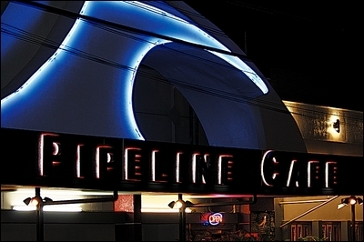 | 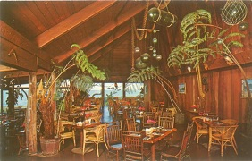
Pipeline Cafe | Pat’s at Punalu’u
P
Palama Inn | Kalihi |  | Served lots of Japanese and Filipino dishes. Famous for making a mean pork adobo and miso tako and sashimi.
Pat’s at Punalu’u  ** | Kam Highway in Hauula |  | Fine dining by the sea. I stopped there a few times for drinks and to go to the bathroom.
Pearl City Tavern  ***** | Waimano Home Road & Kamehameha Hwy, Pearl City |  | Tavern opened in 1936 and closed in 1993 - House specialties were steaks, live Maine lobsters and banana drinks at the live Monkey Bar. I loved this place and stopped there often to watch the monkeys. Currently a Dodge new car dealership.
Pieces of Eight  *** | Lewers Street, Waikiki |  | Steak & lobster eatery; in the 1970s, there was a piano bar upstairs and a game room downstairs. I spent a lot of time at this place when living across the street at the Reef Towers.
Pipeline Café | Pohukaina St., Kaka’ako |  | Popular place for young people with live music & dancing - currently BJ Penn Gym.
Planet Hollywood | Waikiki |  | Theme restaurant opened by Bruce Willis, Sylvestor Stallone and Arnold Schwarzenegger.
Players Sports Bar  ** | Alakea Street & Beretania Street |  | A downtown sport bar featuring attractive servers.
The Playroom  ***** | Downtown just off of Hotel Street |  | This was my favorite downtown bar in the early 70’s when I was single. There were 2 pool tables, a shuffle board, and dart boards. The manager was a big Hawaiian man who became my friend.
Point After | Hawaiian Regent Hotel which later became the Waikiki Marriot |  | A very popular nightclub that became the Eurasia nightclub and is currently a Spa.
Pure Platinum | Kuhio Ave., Waikiki |  | Gentleman club – Good place to go watch several strippers and spent a lot of money. Previously Club Deja Vu; currently the Maddog Saloon.
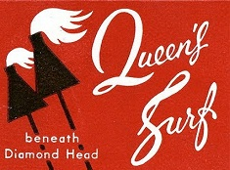 |  | 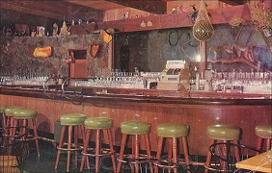
Queen’s Surf |  | Pearl City Tavern
Q
The Queen’s Surf Restaurant and Barefoot Bar  * | Across from Kapiolani Park at Waikiki Beach | This place is famous with the older generation that visited Waikiki – Including me! But it came to a sad end when it was condemned and torn down by Frank Fasi and the city in 1971 to open up that part of the beach to the public.

R
Red Baron’s Pizza  *** | Kamehameha Shopping center | Great pizza! Our Shafter office used to go there for lunch regularly. Masa Genka was our boss then and he loved the Anchovy Pizza with beer. Many times we never made it back to work.
Club Red Rose  * | 1646 Kona St – Ala Moana Area | Stripper Club known for lewd, immoral and unlawful conduct from the ladies that worked there.
The Round House  ** | Below Anna Miller’s adjacent to Pearlridge Center, Aiea | Popular Restaurant and Tiki Bar.

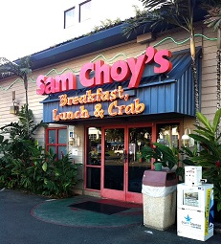 | 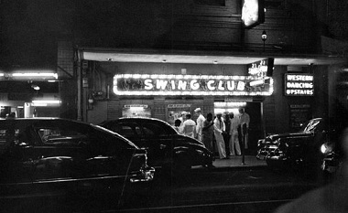
Sam Choy’s | Swing Club (in the 1940s)
S
Sam Choy’s Breakfast, Lunch & Crab  ** | Nimitz Hwy (next to Zippy’s and across the road from City Mill) | Hawaii regional cuisine; opened in 1997, closed in 2013 along with the neighboring Aloha Beer Company
Sam Snead’s Tavern  **** | Navy-Marine Golf Club House – 2nd Floor | Good place to eat and get a few drinks after golfing. I liked the bartender Elle who always treated me good.
The Sandbox  *** | Sand Island Access Rd. | Hawaii’s home of country western music; Eddie Kamae played there; original Sons of Hawaii played their first pro gig there. I went there several times – They also had pool tables.
Senor Frog’s | Royal Hawaiian Shopping Center | Mexican restaurant & cantina bar; after hours nightclub.
The Shack Waikiki  * | First floor of the Waikiki Trade Center | Sports Bar featuring burgers and Hawaiian themed decor; live local music & dance club during late night hours.
Shakey’s Pizza Parlor  ** | All locations statewide:  Keeauomoku St, Kaneohe,  Waimalu &  Schofield Barracks | Shakey’s decor was that of a large open warehouse with a rustic, dark-lit look; seating were long communal wooden park benches; their pizza cooks would spin pizza dough by the entrance – I liked their pizza
Shipwreck Kelly’s  *** | Lewer’s St., Waikiki | Another of my favorite bars while living in Waikiki.
Sizzler  **** | All Sizzlers State-wide  Kailua – Aiea -  Kapalama - Salt Lake -  Waipahu | The owner of Hawaii’s five Sizzler restaurants abruptly ceased operations on Aug 1, 2013. They went bankrupt. About 120 employees were impacted by the shutdown of the restaurants. I liked the food at the Sizzler.
Sloppy Joe’s & Fat Tuesday  * | Aloha Tower Marketplace | This nightclub closed in January 1996 after a dispute over back rent. The 10,000-plus-square-foot spot was re-opened by Buffalo Bud's which also closed in June 1997.
South Seas  *** | Nimitz Hwy & Lagoon Dr. near the Airport | This attractive round restaurant was popular with the Fort Shafter crowd. It also had a nice bar. It is currently a Kia car dealership.
Stop Lite  * | Keeaumoku Street | Best adult entertainment in Honolulu – it was an adult circus show.
Stuart Andersons  ** | Ward Warehouse | Nice place to have lunch and a few drinks.
Studebaker’s | Restaurant Row, Kaka’ako | Failed just like almost every other bar and restaurant in what they now call Restaurant “Death” Row.
Sunset Grill  * | Restaurant Row | Served contemporary American food – I ate there a couple of times - currently a medical office.
Swing Club | Hotel Street | Originally a swing and jazz club but by the 1960s had evolved into a bar for Blacks featuring nude dances and pornographic movies. This famous bar closed in 2000. The current tenant moved in as Bar 35.

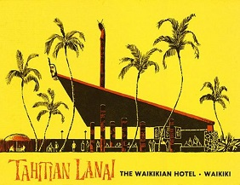 | 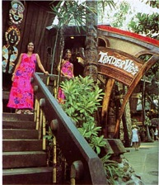
Tahitian Lanai | Trader Vic’s
T
Tahitian Lanai  * | Hilton Hawaiian Village, Waikiki | The complete embodiment of what Waikiki should be today, but is now a distant memory. Open in 1957 and closed in 1997.
Territorial Tavern  ** | Bishop St., downtown Honolulu | Home of Booga, Booga comedy group and the Beamer Brothers.
Texas Paniolo ‘s Bar  * | Waikiki | Country and western bars don’t last long in Hawaii.
T.G.I. Friday’s  * | King & Ward Ave. & Kuhio Avenue in Waikiki | The shutdown came suddenly in June 2007. I never went to the TGIFs in Hawaii but did enjoy going there in Japan.
Three Coins  * | Wahiawa | A good family restaurant just like Dot’s. Currently is a Zippy’s.
Tops Restaurant  ** | Ala Moana Blvd. and Ena Road in Waikiki | Good place to go eat after the bars close.
Trader Vic’s  * | Waikiki International Marketplace Waikiki | Interesting tiki bar and restaurant – good place to take tourists.
Top of the I  * | Ilikai Hotel Waikiki | Fine dining with a view. Currently is an upscale rooftop Italian restaurant called Sarento's at the Top of the Ilikai.
Trappers | Hyatt Regency, Waikiki | One of Waikiki's most elegant showrooms in its day (1976-91) – also where local jazz acts performed.
Two Jacks  * | Lower Hotel Street – Downtown Honolulu | Live jazz music.

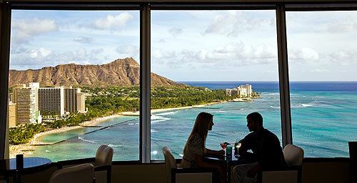
Top of the Ilikai
V
Venus Nightclub | Kapiolani Blvd. (adjacent to Ala Moana Center) | Had drag & male review shows; A dance club - Currently Bar Seven
Victoria Station  * | Downtown Honolulu, next door to Kress right across the street (where Union Plaza is today) | Steak house, hamburgers and fries seasoned in a (at the time) very unique way (paprika, salt and pepper). There was British red phone booth inside.
Village Inn  * | Waialae Ave, Kahala | A family restaurant. Was previously Tony Roma’s, then became Chin’s.

W
Waianae Drive Inn | Farrington Hwy. (Just past Waianae Mall, next to the Adventist Church) | Da’ best Hamburger Curry Stew, Laulau & Mac Salad in town.
Waikiki Tavern | Ewa end of Kuhio beach | Food downstairs, and a booze place upstairs.
The Warrior Lounge  * | Hale Koa Hotel, Waikiki | This casual quiet indoor lounge was an excellent place for our military and guests to have a drink and relax.
Waterfront Café  * | Aloha Tower Marketplace | Bar and grill restaurant by day and a nightclub by night - Previously was Sloppy Joe’s & Fat Tuesdays.
Wiki Wiki Drive Inn  * | Corner of Harding and King Street | A good place to go eat before the first segment of H1 Freeway was built from Waialae Ave. in Kaimuki to Ward Street near downtown.
Wisteria  ** | King St, Moi’ili’ili | Very popular place for local and Japanese cuisine – The site is currently a 7-Eleven.
Wo Fat | Corner of Hotel and Maunakea Street, Chinatown, Honolulu | The 123-year-old Wo Fat was Hawaii’s oldest and most famous Chinese restaurant when it closed in 2005 – Site is currently an open market.
Woolworth Coffee Shop  * | Was located in both the Ala Moana Center & Kahala Mall | One of many shopping center restaurants to close in recent years.
World Café  * | Restaurant Row, Kaka’ako | In 1997 they moved to the Nimitz Business Plaza in a large back area warehouse. They survived for a while, then closed to become Volcano Night Club. They then closed as well.

Restaurant “Death” Row's Dearly Departed:
The following Restaurants have failed: Baci, Black Orchid, Blue Zebra, Boomerang's, Carnaval Las Palmas, Jose's Restaurante Mexicana Y Cantina, Kengo's Seafood, Manzo's Trattoria, Meritage Restaurant, Ocean Club, Phillip Paolo's Italian Restaurant, Rose City Diner, Studebaker's, Sunset Grill, World Cafe, and Yanni's. The only successful restaurants are Ruth’s Chris, Hiroshi and Vino.
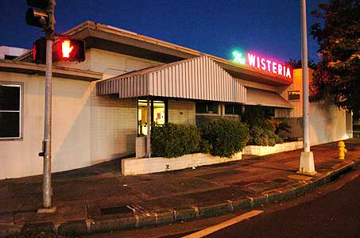 | 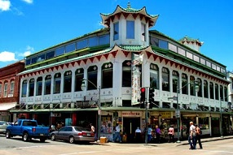
Wisteria Restaurant | Wo Fat Chinese Restaurant
Y
Yacht Harbor Tower Restaurant | Near Ala Moana Beach Park | Had great food & service with Bob Nelson on piano.
The Yum Yum Tree  * | All three locations:  Ward Center, Kahala Mall & Kailua | Family restaurant that was part of the Jolly Roger chain that closed down.

Z
The Zebra Room  **** | Kalakaua Ave., between Young & Beretania | This bar was just around the corner from where I lived in the early 1970s. It opened at 6AM and we used to meet there before going golfing for a couple of early morning cold ones.

